

**HO CHI MINH NATIONAL UNIVERSITY**

**UNIVERSITY OF INFORMATION TECHNOLOGY**

**REPORT**

**INFORMATION SYSTEM ANALYSIS AND DESIGN**

**TOPIC**

**BUILDING AN ONLINE PET SUPERMARKET SYSTEM**

**Lecturer’s Name:** Mrs. Cao Thị Nhạn

Mr. Dương Phi Long

**Member:**

Trần Nhật Khuê 19521713

Nguyễn Thị Xuân Thủy 19522327

Lê Ngọc Tuấn 19522466

Lê Thanh Giang 20521260

Ho Chi Minh City, 2022

TABLE OF CONTENT

**THANK YOU** 1

**CHAPTER 1: INTRODUCTION** 2

**1.1 Introduction** 2

**1.3 Objectives of project** 3

**1.4 Scope of project/Limitation of the study** 3

**1.5** **Developer tools & Technology** 4

**CHAPTER 2: REQUIREMENT SPECIFICATION** 5

**2.1 Situation survey/Survey of current situation** 5

**2.1.1 Interview** 5

**2.1.2 Survey of the organization/Current organizational situation** 7

**2.1.3 Survey of business processes, major activities** 8

**2.2 Software requirements** 9

**2.2.1 Function requirements** 9

**2.2.2 Non–function requirements** 11

**CHAPTER 3: ANALYSIS AND DESIGN** 13

**3.1 Use-case Diagram** 13

**3.1.1 List of actors** 16

**3.1.2 List of use-case** 16

**3.2 Use-case specification and activity diagram** 17

**3.2.1 Log in (for admin)** 17

**3.2.2 Log out(for admin)** 20

**3.2.3 Coupons management** 21

**3.2.3.1 View coupons** 21

**3.2.3.2 Insert coupons** 22

**3.2.4 Category management** 25

**3.2.4.1 Insert category** 25

**3.2.4.2 Update category** 27

**3.2.4.3 View category** 29

**3.2.5 Supplier management** 30

**3.2.5.1 Insert supplier** 30

**3.2.5.2 Update supplier** 33

**3.2.5.3 Delete supplier** 35

**3.2.5.4 View supplier** 36

**3.2.5.5 Filter supplier** 38

**3.2.5.6 Search supplier** 38

**3.2.6 Customer management** 40

**3.2.6.1 Insert customer account** 40

**3.2.6.2 View customer information** 43

**3.2.6.3 Change customer account status** 44

**3.2.6.4 Filter customer** 46

**3.2.6.5 Search customer** 47

**3.2.6.6 Update customer information** 49

**3.2.7 Order management** 52

**3.2.7.1 View order** 52

**3.2.7.2 Update order status** 53

**3.2.7.3 Search order** 56

**3.2.7.4 Filter order** 57

**3.2.8 Product management** 58

**3.2.8.1 Insert product** 58

**3.2.8.2 Filter product** 61

**3.2.8.3 Search product** 62

**3.2.8.4 View product** 63

**3.2.8.5 Update product** 64

**3.2.9 Employee management** 67

**3.2.9.1 Insert employee** 67

**3.2.9.2 Delete employee** 69

**3.2.9.3 Search employee** 70

**3.2.9.4 Filter employee** 72

**3.2.9.5 View employee** 73

**3.2.9.6 Update employee** 74

**3.2.10 Statistical and report** 77

**3.2.10.1 Export revenue report** 77

**3.2.10.2 Export products report** 78

**3.2.10.3 Export customer report** 79

**3.2.11 Log in(for users)** 80

**3.2.12 Log out(for users)** 83

**3.2.13 Register(for users)** 84

**3.2.14 Personal account management** 86

**3.2.14.1 View account** 86

**3.2.14.2 Update account** 88

**3.2.15 Cart management** 91

**3.2.15.1 View cart** 91

**3.2.15.2 Update number of product** 92

**3.2.15.3 Update cart** 95

**3.2.15.4 Delete cart** 97

**3.2.15.5 Payment** 98

**3.2.16 Orders management** 101

**3.2.16.1 View order** 101

**3.2.16.2 Cancel order** 102

**3.2.17 Purchase history management** 104

**3.2.17.1 View purchase history** 104

**3.2.18** **Product information** 106

**3.2.18.1 Search products** 106

**3.2.18.2 View product** 108

**3.2.18.3 View product detail** 109

**3.2.19 Checkout** **Error! Bookmark not defined.**

**3.3 Sequence diagram and class diagram** **Error! Bookmark not defined.**

**3.3.1 Log in (for admin)** **Error! Bookmark not defined.**

**3.3.1.1 Sequence diagram** **Error! Bookmark not defined.**

**3.3.1.2 Class diagram** **Error! Bookmark not defined.**

**3.3.2 Log out (for admin)** **Error! Bookmark not defined.**

**3.3.2.1 Sequence diagram** **Error! Bookmark not defined.**

**3.3.2.2 Class diagram** **Error! Bookmark not defined.**

**3.3.3 Coupons management** **Error! Bookmark not defined.**

**3.3.3.1 Insert coupons** **Error! Bookmark not defined.**

**3.3.3.2 Delete coupons** **Error! Bookmark not defined.**

**3.3.3.3 Update coupons** **Error! Bookmark not defined.**

**3.3.3.4 Coupon Class Diagram** **Error! Bookmark not defined.**

**3.3.5 Category management** **Error! Bookmark not defined.**

**3.3.5.1 Sequence diagram** **Error! Bookmark not defined.**

**3.3.5.1.1 Insert category** **Error! Bookmark not defined.**

**3.3.5.1.2 Update category** **Error! Bookmark not defined.**

**3.3.5.1.3 View category** **Error! Bookmark not defined.**

**3.3.5.2 Class diagram** **Error! Bookmark not defined.**

**3.3.6 Supplier management** **Error! Bookmark not defined.**

**3.3.6.1 Sequence diagram** **Error! Bookmark not defined.**

**3.3.6.1.1 Update supplier** **Error! Bookmark not defined.**

**3.3.6.1.2 Insert supplier** **Error! Bookmark not defined.**

**3.3.6.1.3 Delete supplier** **Error! Bookmark not defined.**

**3.3.6.1.4 View supplier** **Error! Bookmark not defined.**

**3.3.6.1.5 Filter supplier** **Error! Bookmark not defined.**

**3.3.6.1.6 Search supplier** **Error! Bookmark not defined.**

**3.3.6.2 Class diagram** **Error! Bookmark not defined.**

**3.3.8 Customer management** **Error! Bookmark not defined.**

**3.3.8.1 Sequence diagram** **Error! Bookmark not defined.**

**3.3.8.1.1 Insert customer account** **Error! Bookmark not defined.**

**3.3.8.1.2 View customer information** **Error! Bookmark not defined.**

**3.3.8.1.3 Lock customer account** **Error! Bookmark not defined.**

**3.3.8.1.4 Update customer account** **Error! Bookmark not defined.**

**3.3.8.1.5 Filter customer** **Error! Bookmark not defined.**

**3.3.8.2 Class diagram** **Error! Bookmark not defined.**

**3.3.9 Order management** **Error! Bookmark not defined.**

**3.3.9.1 View order** **Error! Bookmark not defined.**

**3.3.9.3 Update order status** **Error! Bookmark not defined.**

**3.3.9.5 Filter order** **Error! Bookmark not defined.**

**3.3.9.2 Class Diagram** **Error! Bookmark not defined.**

**3.3.10 Product management** **Error! Bookmark not defined.**

**3.3.10.1 Sequence diagram** **Error! Bookmark not defined.**

**3.3.10.1.1 Insert product** **Error! Bookmark not defined.**

**3.3.10.1.2 Search product** **Error! Bookmark not defined.**

**3.3.10.1.3 Update product** **Error! Bookmark not defined.**

**3.3.10.1.4 Filter product** **Error! Bookmark not defined.**

**3.3.10.2 Class Diagram** **Error! Bookmark not defined.**

**3.3.8 Employees management** **Error! Bookmark not defined.**

**3.3.8.1 Sequence diagram** **Error! Bookmark not defined.**

**3.3.8.1.1 Insert employee** **Error! Bookmark not defined.**

**3.3.8.1.2 Delete employee** **Error! Bookmark not defined.**

**3.3.8.1.3 Search employee** **Error! Bookmark not defined.**

**3.3.8.1.4 Filter employee** **Error! Bookmark not defined.**

**3.3.8.1.5 View employee** **Error! Bookmark not defined.**

**3.3.8.1.6 Update employee** **Error! Bookmark not defined.**

**3.3.8.2 Class diagram** **Error! Bookmark not defined.**

**3.3.9 Statistical and report** **Error! Bookmark not defined.**

**3.3.9.1 Sequence diagram** **Error! Bookmark not defined.**

**3.3.9.1.1 Export revenue report** **Error! Bookmark not defined.**

**3.3.9.1.2 Export products list** **Error! Bookmark not defined.**

**3.3.9.1.3 Export customer product** **Error! Bookmark not defined.**

**3.3.9.2 Class of statistical and report** **Error! Bookmark not defined.**

**3.3.10 Log in (for users)** **Error! Bookmark not defined.**

**3.3.10.1 Sequence diagram** **Error! Bookmark not defined.**

**3.3.10.2 Class diagram** **Error! Bookmark not defined.**

**3.3.11 Log out (for users)** **Error! Bookmark not defined.**

**3.3.11.1 Sequence diagram** **Error! Bookmark not defined.**

**3.3.11.2 Class diagram** **Error! Bookmark not defined.**

**3.3.12 Register (for users)** **Error! Bookmark not defined.**

**3.3.12.1 Sequence diagram** **Error! Bookmark not defined.**

**3.3.12.2 Class diagram** **Error! Bookmark not defined.**

**3.3.13 Personal account management** **Error! Bookmark not defined.**

**3.3.13.1 Sequence diagram** **Error! Bookmark not defined.**

**3.3.13.1.1 View account** **Error! Bookmark not defined.**

**3.3.13.1.2 Update account** **Error! Bookmark not defined.**

**3.3.13.2 Class diagram** **Error! Bookmark not defined.**

**3.3.14 Cart management** **Error! Bookmark not defined.**

**3.3.14.1 Sequence diagram** **Error! Bookmark not defined.**

**3.3.14.1.1 View cart** **Error! Bookmark not defined.**

**3.3.14.1.2 Update cart** **Error! Bookmark not defined.**

**3.3.14.1.3 Delete cart** **Error! Bookmark not defined.**

**3.3.14.1.4 Payment** **Error! Bookmark not defined.**

**3.3.14.2 Class diagram** **Error! Bookmark not defined.**

**3.3.15 Orders management** **Error! Bookmark not defined.**

**3.3.15.1 Sequence diagram** **Error! Bookmark not defined.**

**3.3.15.1.1 View order** **Error! Bookmark not defined.**

**3.3.15.1.2 Cancel order** **Error! Bookmark not defined.**

**3.3.15.2 Class digram** **Error! Bookmark not defined.**

**3.3.16 Purchase history management** **Error! Bookmark not defined.**

**3.3.16.1 Sequence diagram** **Error! Bookmark not defined.**

**3.3.16.2 Class diagram** **Error! Bookmark not defined.**

**3.3.17 Product information** **Error! Bookmark not defined.**

**3.3.17.1 View product** **Error! Bookmark not defined.**

**3.3.17.2 View product detail** **Error! Bookmark not defined.**

**3.3.17.3 View trending product** **Error! Bookmark not defined.**

**3.3.17.4 Search products** **Error! Bookmark not defined.**

**3.3.18 Checkout** **Error! Bookmark not defined.**

**3.3.18.1 Sequence diagram** **Error! Bookmark not defined.**

**3.3.18.2 Class diagram** **Error! Bookmark not defined.**

**3.4 State diagram** 158

**3.4.1 Product state diagram** 164

**3.4.2 Order state diagram** 163

**3.4.3 User accounts state diagram** 164

**3.5 Mapping to Relational Model diagram from Entity class diagram** 165

**CHAPTER 4: IMPLEMENTATION AND TESTING** 166

**4.1 Introduction to the implementation environment** 166

**4.2 User Interface** 166

**4.2.1 Customer interface** 166

**4.2.1 Admin interface** 169

**CHAPTER 5: CONCLUSION** 177

**5.1 Project achievement** 177

**5.2 Limitations** 177

**5.3 Development direction** 177

# **THANK YOU**

Throughout the course of this semester, the group has always received the attention, guidance and dedicated help of teachers and teachers in the Information Systems department along with the help of friends around the city.

To complete this project first, the group would like to express their sincere thanks to the teachers of the University of Information Technology - National University of Ho Chi Minh City. Ho Chi Minh City and the Teachers of Information Systems have helped the authors have the basic knowledge as the foundation to implement this topic.

In particular, the group would like to express their deepest thanks and gratitude to Ms. Cao Thi Nhan (Lecturer in Theory of HTTT Design Analysis) and Mr. Duong Phi Long (Lecturer in practice of HTTT Design Analysis). The Teachers have directly guided the wholeheartedly, pointed out the mistakes that helped the team correct and contributed many valuable ideas to help the group complete the best possible project to report for this subject. During the one semester of the project, the group applied the basic knowledge that teachers have imparted and combined it with learning and researching new knowledge. Since then, the team has made the most of what they own and collect to complete the best project report. However, in the process of implementing the project, the group could not avoid shortcomings. Therefore, the group is eager to receive comments from teachers to improve the missing knowledge that the group has learned and is a tool for the group to be able to carry out other topics in the future.

Thank you very much, ladies and gentlemen!

# **CHAPTER 1: INTRODUCTION**

## **1.1 Introduction**

As the Physical and Spiritual life of human increasing overtime, the need of entertainment is associate along the side, keep up with the traditions and habits of having pets in the house in the past, Vietnamese people nowadays continue to promote this media and turn it into an elegant amusement.

According to scientists, when we are with a pet, our brain releases more oxytocin that helps lower blood pressure, reduce stress and anxiety. Dogs and cats are not simply animals, they are also like family members, well cared for and pampered. Pets also show the class, personality, lifestyle of their pet owners. As an example, pet owners have no hesitation in paying out an enormous number of credits for pets like pet’s service, pet’s food, pet’s toys

Taking that opportunity, our team conducted market research and implemented an online sales model in hopes of helping sellers find customers and buyers will find high-quality reputable sources.

## **1.2 Problems of project**

Recognizing the many limitations of the old trading system around the problem of people and buyers directly, thereby giving an overview and perfecting the solution in favor of both parties. Based on the information that we learn; the direct exchange of goods has some limitations as follows:

The purchase of the necessary items depends on the stores selling directly. However, the number of stores is still small and unevenly distributed will cause a shortage of supply for customers.

This traditional sales model has been around for a long time, but the pet market is still new, causing concerns about the inventory of retailers. The policy of resolving inventory still has some issues that have not been completely solved.

The product may not guarantee quality for several reasons such as the origin of non-standard sources, some items of inventory for as long as food will cause damage. The regular transportation of goods between sellers can cause spillage or damage

Stores sell separately and do not have synchronization with each other, when customers need to buy this product but cannot know which stores sell that product is annoying to the buyer. As a result, sellers are difficult to serve, and buyers are difficult to find.

Buyers must find the seller themselves, for the direct store, they must go to the place to be able to find the product they want, and customers cannot always spend time on that.

## **1.3 Objectives of project**

In this project, we aim to bring the most convenience to users in using as well as providing the full range of functions as follows:

* Information management of all kinds of products such as food, toys, medicines, clothing for pets.
* Manage user information including customers.
* Manage transaction information such as purchase history.
* Allowing the export of revenue reports.

## **1.4 Scope of project/Limitation of the study**

|  |  |
| --- | --- |
| Scope of the project | The product is built according to customer needs survey as well as having additional supplements to suit the market.  Support customers in finding products quickly and reliably with quality:  However, due to time constraints, humans, our team focused on the following key functions:   * Cart management   - Product’s name  - Price  - Quantity  - Price total   * Product management   - Product’s name  - Description of product  - Price   * Customer management * Customer’s name * Address * Phone number * Customer type * Employee’s management * Position * Employee’s name * Phone number * Ordering * Order * Cancel * Retrieval of information * Revenue report * Products list * Customer list   Database: Storage of customer, employee, product information |
| Work – product | - References  - Technical document  - Source code  - Test plan |
| Program language | - Front – end: HTML, CSS, JavaScript  - Back – end: PHP  - Database: MySQL in phpMyAdmin |

## **1.5** **Developer tools & Technology**

During the implementation of the project, the team used several software for learning and building topics including:

- XAMPP: XAMPP is a software that allows you to simulate a server hosting environment right on your computer, allowing you to run a demo website without having to buy hosting or VPS. XAMPP is good for web development XAMPP has built-in Apache, MySQL, PHP, FTP server, Mail Server.

- Visual Studio Code, NetBeans: IDE to build a website.

- Adobe Photoshop CS6, Adobe Illustrator CS6, Figma: Serves the design of the interface and processing components.

- StarUML: For the creation of Use-case diagrams, Activity diagrams, Sequence diagrams, Class diagrams, State diagrams.

# **CHAPTER 2: REQUIREMENT SPECIFICATION**

## **2.1 Situation survey/Survey of current situation**

### **2.1.1 Interview**

|  |  |  |  |  |
| --- | --- | --- | --- | --- |
| General Survey  System: An online pet supermarket  Creator: Le Ngoc Tuan Created Date: 20/04/2022 | | | | |
| Ord | Topic | Requirement | Start | End |
| 1 | System overview | In terms of products provided, suppliers, forms of payment, price, ... | 11/04/2022 | 17/04/2022 |
| 2 | System Functions | Purchasing functions, shopping carts, account registration, invoicing...  +Storage  +Calculations  +Lookup  +Statistical report  +Automation | 11/04/2022 | 17/04/2022 |
| 3 | Website interface | Some interface requirements | 11/04/2022 | 17/04/2022 |
| 4 | System service | Online support, products return, or customer information responses | 11/04/2022 | 17/04/2022 |

Table 1: Survey Strategy

|  |  |
| --- | --- |
| Survey form  System: An online pet supermarket | |
| Interviewee: Le Ngoc Tuan | Interviewer: Tran Nhat Khue |
| Place: | Start: 7:30 am 02/05/2022  End: 11 am 02/05/2022 |
| Details of the interview   * Introduction * Orverview about system * Survey plan * Topic 1: System overview * Topic 2: System Functions * Topic 3: Website interface * Topic 4: System service | Estimated Time:   * 5 mins * 15 mins * 3 hours |
| General Observe |  |
| Unexpected occurence |  |
|  |  |

|  |  |  |
| --- | --- | --- |
| Interviewer: Le Ngoc Tuan | 02/05/2022 |  |
| Question | Records |  |
| General | **Question** |  |
| Topic 1 | - Are you interested in or have knowledge about the following products for pets?  - Can you name some of the items that you think are necessary for pets? | Have interest and knowledge about some of the pet’s products like food, toys and pet’s daily products |
| -Are you interested in or have knowledge about the following reputable providers for pets?  -Can you name some reputable pet suppliers? | Some of the providers are well-known, like Royal Canin, Whiskas, KraMax,... |
| - Which of the following payments will you prioritize for your purchases? | -Online shopping: Direct payment  -Ordered: Pay when delivered |
| -If you want to buy pet items, would you prioritize average or luxury products?  -Will you prioritize the price of pet items or customer service? | -Average products for pet’s daily products  While choosing luxury food  -Prioritize the price more than the service |
| Topic 2 | -Can you name some of the database management systems you know about?  -What criteria do you usually rely on to evaluate which hosting service is best? | -Oracle, MongoDB, SQL Server, MySQL  -Have no problem getting to know the service, good security, fast processing speed |
| - What programming language would you recommend helping us implement website design, why did you choose that language? | -Front-end: JavaScript, HTML, CSS, …  Back-end: PHP  -Easy to use, Common for developers |
| - Can you list some of the functions that you think would make a difference to the website? | Compare the products depends on the price, quality, and supplier |
| Topic 3 | - What governing colors do you think that the website should have?  - Would you like to have a simple or complex design? | -The color shouldn’t be too bright  - The design shouldn’t be too complex while still having a great appearance |
| Topic 4 | - What would you like to advise when you first visit the website?  -Can you tell us some features of the service or design of the website that doesn’t really satisfy you? | -Optional, ordering process and payments  -Website operation system is not friendly |

### **2.1.2 Survey of the organization/Current organizational situation**

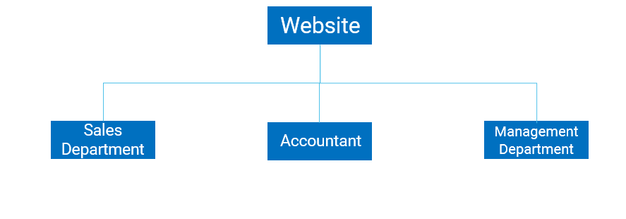

### **2.1.3 Survey of business processes, major activities**

* + - 1. **Sales Department**

Connect, contact the system of product supply stores, suppliers to enter information about products, product introductions, product prices, promotions of products.

Supplier information entry process

* + Input from the supplier system.
  + Process data money and store product information (quantity, price,...) transactions into the system's database. Help business optimize throughout the job and minimize the risk of errors or problems that may occur in the business process.
  + Pricing process
  + Based on the original price (from the supplier's system) or customizing the price in accordance with the profitability of the system and storing price information in the database.
  + Marketing process
  + Propose new strategies to promote the purchase or sale of products, services, or goods. Create conditions for the system to attract customers. Includes promotions, customer service, and search engine optimization.
  + Customer service process
  + Create a close connection between customers and provide timely information to customers about product information, quality, price and promotion. Provide all customer inquiries as soon as possible. The search engine optimization process focuses on optimizing system information that is always on search engines such as Google, Bing,... Help customers access the system better.  
     Manage customer information.
  + Customer information including account (full name, date of birth, phone number, email, address, username, password) stored on the system

**2.1.3.2 Accountant**

* + Make data-driven reports to support sales. The department oversees the system that carries out the process of calculating salaries and pay for employees and reports.
  + Pay process
  + Collect data on working hours at the Human Resources Department. Calculate the salary and bonus for each employee at the end of the month. Store data into the database.
  + Reporting process
  + Get data from the database. Create reports mainly on the total number of products, promotions, and customer traffic. Evaluate the report and pass it on to the board of directors.

**2.1.3.3 Management Department**

* Responsible for managing the operations of the entire store and the employees working at the store, in order to ensure sales and constantly increase customer satisfaction.
* Manage and take responsibility for all goods, employees, customers and store-related issues
* Check, assign jobs, motivate employees; pay attention and motivate employees to work.
* Train and track new employees in sales and customer care
* Ensure the quantity and quality of goods to meet customer needs
* Write a report on the business situation of the store by week/month
* Supporting the development of a strategy to develop in-store business activities together with the Board of Directors

## **2.2 Software requirements**

### **2.2.1 Function requirements**

|  |  |  |
| --- | --- | --- |
| Overview | | |
| Type of functional requirements | **Description** | **Explanation** |
| Data Storage | The System can allow the storage of all customers information, product information, and the related data | -[To](https://www.babla.vn/tu-dien/tieng-anh-tieng-viet/to) [ensure](https://www.babla.vn/tu-dien/tieng-anh-tieng-viet/ensure) [that](https://www.babla.vn/tu-dien/tieng-anh-tieng-viet/that) [the](https://www.babla.vn/tu-dien/tieng-anh-tieng-viet/the-sooner-the-better) [website](https://www.babla.vn/tu-dien/tieng-anh-tieng-viet/website) [operates](https://www.babla.vn/tu-dien/tieng-anh-tieng-viet/operate) [efficiently](https://www.babla.vn/tu-dien/tieng-anh-tieng-viet/efficiently)  [the](https://www.babla.vn/tu-dien/tieng-anh-tieng-viet/the-sooner-the-better) [system](https://www.babla.vn/tu-dien/tieng-anh-tieng-viet/system) needs [to](https://www.babla.vn/tu-dien/tieng-anh-tieng-viet/to) store [the](https://www.babla.vn/tu-dien/tieng-anh-tieng-viet/the-sooner-the-better) following information:  -Customer’s information: Customer’s ID, Customer’s name, address, gender, date of birth, customer’s phone numbers  -Products information: Product ID, Products [name](https://www.babla.vn/tu-dien/tieng-anh-tieng-viet/name), [Product](https://www.babla.vn/tu-dien/tieng-anh-tieng-viet/product)’s series, [description](https://www.babla.vn/tu-dien/tieng-anh-tieng-viet/description), [quantity](https://www.babla.vn/tu-dien/tieng-anh-tieng-viet/quantity),  [price](https://www.babla.vn/tu-dien/tieng-anh-tieng-viet/price), [size](https://www.babla.vn/tu-dien/tieng-anh-tieng-viet/size), [Product](https://www.babla.vn/tu-dien/tieng-anh-tieng-viet/product)’s [photo](https://www.babla.vn/tu-dien/tieng-anh-tieng-viet/photo-map)s.  -[Order](https://www.babla.vn/tu-dien/tieng-anh-tieng-viet/order) [information](https://www.babla.vn/tu-dien/tieng-anh-tieng-viet/information): [Order](https://www.babla.vn/tu-dien/tieng-anh-tieng-viet/order)’s [code](https://www.babla.vn/tu-dien/tieng-anh-tieng-viet/code),  [Product](https://www.babla.vn/tu-dien/tieng-anh-tieng-viet/product)’s [code](https://www.babla.vn/tu-dien/tieng-anh-tieng-viet/code), [quantity](https://www.babla.vn/tu-dien/tieng-anh-tieng-viet/quantity), [value](https://www.babla.vn/tu-dien/tieng-anh-tieng-viet/value), Order’s [status](https://www.babla.vn/tu-dien/tieng-anh-tieng-viet/status).  -[Promotional](https://www.babla.vn/tu-dien/tieng-anh-tieng-viet/promotional) [information](https://www.babla.vn/tu-dien/tieng-anh-tieng-viet/information): Promo’s [code](https://www.babla.vn/tu-dien/tieng-anh-tieng-viet/code),  [Promotion](https://www.babla.vn/tu-dien/tieng-anh-tieng-viet/promoter)’s [name](https://www.babla.vn/tu-dien/tieng-anh-tieng-viet/name),  [Promotion](https://www.babla.vn/tu-dien/tieng-anh-tieng-viet/promoter)’s [date](https://www.babla.vn/tu-dien/tieng-anh-tieng-viet/date), [value](https://www.babla.vn/tu-dien/tieng-anh-tieng-viet/value).  -[Order](https://www.babla.vn/tu-dien/tieng-anh-tieng-viet/order) [invoice](https://www.babla.vn/tu-dien/tieng-anh-tieng-viet/invoice) [information](https://www.babla.vn/tu-dien/tieng-anh-tieng-viet/information): [Invoice](https://www.babla.vn/tu-dien/tieng-anh-tieng-viet/invoice)’s [code](https://www.babla.vn/tu-dien/tieng-anh-tieng-viet/code), [Customer](https://www.babla.vn/tu-dien/tieng-anh-tieng-viet/customer)’s ID, [Invoice](https://www.babla.vn/tu-dien/tieng-anh-tieng-viet/invoice) amount, Bill date. |
| Information search | Search for [product](https://www.babla.vn/tu-dien/tieng-anh-tieng-viet/product)  [information](https://www.babla.vn/tu-dien/tieng-anh-tieng-viet/information),[orders](https://www.babla.vn/tu-dien/tieng-anh-tieng-viet/order), [customers](https://www.babla.vn/tu-dien/tieng-anh-tieng-viet/custom) | -The website can [search](https://www.babla.vn/tu-dien/tieng-anh-tieng-viet/search) [for](https://www.babla.vn/tu-dien/tieng-anh-tieng-viet/for)  Customer’s [information](https://www.babla.vn/tu-dien/tieng-anh-tieng-viet/information), orders, [and](https://www.babla.vn/tu-dien/tieng-anh-tieng-viet/and) [products](https://www.babla.vn/tu-dien/tieng-anh-tieng-viet/productive) [through](https://www.babla.vn/tu-dien/tieng-anh-tieng-viet/through) Customers' ID,  [Order](https://www.babla.vn/tu-dien/tieng-anh-tieng-viet/order) [codes](https://www.babla.vn/tu-dien/tieng-anh-tieng-viet/code), [Product](https://www.babla.vn/tu-dien/tieng-anh-tieng-viet/product)’s ID.  -[The](https://www.babla.vn/tu-dien/tieng-anh-tieng-viet/the-sooner-the-better) [website](https://www.babla.vn/tu-dien/tieng-anh-tieng-viet/website) [allows](https://www.babla.vn/tu-dien/tieng-anh-tieng-viet/allow) admins [to](https://www.babla.vn/tu-dien/tieng-anh-tieng-viet/to) [add](https://www.babla.vn/tu-dien/tieng-anh-tieng-viet/add) [new](https://www.babla.vn/tu-dien/tieng-anh-tieng-viet/new)  Customers, products, invoices [or](https://www.babla.vn/tu-dien/tieng-anh-tieng-viet/or) [delete](https://www.babla.vn/tu-dien/tieng-anh-tieng-viet/delete) [or](https://www.babla.vn/tu-dien/tieng-anh-tieng-viet/or) [edit](https://www.babla.vn/tu-dien/tieng-anh-tieng-viet/edit)  customer, product [information](https://www.babla.vn/tu-dien/tieng-anh-tieng-viet/information) .  -[The](https://www.babla.vn/tu-dien/tieng-anh-tieng-viet/the-sooner-the-better) [website](https://www.babla.vn/tu-dien/tieng-anh-tieng-viet/website) [allows](https://www.babla.vn/tu-dien/tieng-anh-tieng-viet/allow) [customers](https://www.babla.vn/tu-dien/tieng-anh-tieng-viet/custom) [to](https://www.babla.vn/tu-dien/tieng-anh-tieng-viet/to) [view](https://www.babla.vn/tu-dien/tieng-anh-tieng-viet/view) their [personal](https://www.babla.vn/tu-dien/tieng-anh-tieng-viet/personal) [information](https://www.babla.vn/tu-dien/tieng-anh-tieng-viet/information), [account](https://www.babla.vn/tu-dien/tieng-anh-tieng-viet/account) [information](https://www.babla.vn/tu-dien/tieng-anh-tieng-viet/information) as well as the [orders](https://www.babla.vn/tu-dien/tieng-anh-tieng-viet/order) they placed. |
| [Order](https://www.babla.vn/tu-dien/tieng-anh-tieng-viet/order) [processing](https://www.babla.vn/tu-dien/tieng-anh-tieng-viet/processing) | [Allow](https://www.babla.vn/tu-dien/tieng-anh-tieng-viet/allow) [processing](https://www.babla.vn/tu-dien/tieng-anh-tieng-viet/processing) [and](https://www.babla.vn/tu-dien/tieng-anh-tieng-viet/and)  [updating](https://www.babla.vn/tu-dien/tieng-anh-tieng-viet/update) [orders](https://www.babla.vn/tu-dien/tieng-anh-tieng-viet/order) | -[The](https://www.babla.vn/tu-dien/tieng-anh-tieng-viet/the-sooner-the-better) [website](https://www.babla.vn/tu-dien/tieng-anh-tieng-viet/website) [allows](https://www.babla.vn/tu-dien/tieng-anh-tieng-viet/allow) admins [to](https://www.babla.vn/tu-dien/tieng-anh-tieng-viet/to) [update](https://www.babla.vn/tu-dien/tieng-anh-tieng-viet/update) [the](https://www.babla.vn/tu-dien/tieng-anh-tieng-viet/the-sooner-the-better) [status](https://www.babla.vn/tu-dien/tieng-anh-tieng-viet/status) [of](https://www.babla.vn/tu-dien/tieng-anh-tieng-viet/of)[orders](https://www.babla.vn/tu-dien/tieng-anh-tieng-viet/order) ([processed](https://www.babla.vn/tu-dien/tieng-anh-tieng-viet/process), delivering, [delivered](https://www.babla.vn/tu-dien/tieng-anh-tieng-viet/deliver)). |
| [Revenue](https://www.babla.vn/tu-dien/tieng-anh-tieng-viet/revenue) [reports](https://www.babla.vn/tu-dien/tieng-anh-tieng-viet/report) [and](https://www.babla.vn/tu-dien/tieng-anh-tieng-viet/and) [statistics](https://www.babla.vn/tu-dien/tieng-anh-tieng-viet/statistics) | [Report](https://www.babla.vn/tu-dien/tieng-anh-tieng-viet/report) [templates](https://www.babla.vn/tu-dien/tieng-anh-tieng-viet/template), [statistics](https://www.babla.vn/tu-dien/tieng-anh-tieng-viet/statistics) | -[The](https://www.babla.vn/tu-dien/tieng-anh-tieng-viet/the-sooner-the-better) [system](https://www.babla.vn/tu-dien/tieng-anh-tieng-viet/system) must [export](https://www.babla.vn/tu-dien/tieng-anh-tieng-viet/export) [a](https://www.babla.vn/tu-dien/tieng-anh-tieng-viet/a) [revenue](https://www.babla.vn/tu-dien/tieng-anh-tieng-viet/revenue) [report](https://www.babla.vn/tu-dien/tieng-anh-tieng-viet/report)  [based](https://www.babla.vn/tu-dien/tieng-anh-tieng-viet/base) [on](https://www.babla.vn/tu-dien/tieng-anh-tieng-viet/on) [the](https://www.babla.vn/tu-dien/tieng-anh-tieng-viet/the-sooner-the-better)[n umber](https://www.babla.vn/tu-dien/tieng-anh-tieng-viet/number) [of](https://www.babla.vn/tu-dien/tieng-anh-tieng-viet/of) [invoices](https://www.babla.vn/tu-dien/tieng-anh-tieng-viet/invoice) [in](https://www.babla.vn/tu-dien/tieng-anh-tieng-viet/in) the delivered [state](https://www.babla.vn/tu-dien/tieng-anh-tieng-viet/state).  -[The](https://www.babla.vn/tu-dien/tieng-anh-tieng-viet/the-sooner-the-better) [system](https://www.babla.vn/tu-dien/tieng-anh-tieng-viet/system) must [produce](https://www.babla.vn/tu-dien/tieng-anh-tieng-viet/produce) [a](https://www.babla.vn/tu-dien/tieng-anh-tieng-viet/a) [report](https://www.babla.vn/tu-dien/tieng-anh-tieng-viet/report) [of](https://www.babla.vn/tu-dien/tieng-anh-tieng-viet/of) [the](https://www.babla.vn/tu-dien/tieng-anh-tieng-viet/the-sooner-the-better) [order](https://www.babla.vn/tu-dien/tieng-anh-tieng-viet/order)  [information](https://www.babla.vn/tu-dien/tieng-anh-tieng-viet/information) [that](https://www.babla.vn/tu-dien/tieng-anh-tieng-viet/that) [the](https://www.babla.vn/tu-dien/tieng-anh-tieng-viet/the-sooner-the-better) [customer](https://www.babla.vn/tu-dien/tieng-anh-tieng-viet/customer) [has](https://www.babla.vn/tu-dien/tieng-anh-tieng-viet/have) [placed](https://www.babla.vn/tu-dien/tieng-anh-tieng-viet/place)  [based](https://www.babla.vn/tu-dien/tieng-anh-tieng-viet/base) [on](https://www.babla.vn/tu-dien/tieng-anh-tieng-viet/on) [the](https://www.babla.vn/tu-dien/tieng-anh-tieng-viet/the-sooner-the-better) [customer](https://www.babla.vn/tu-dien/tieng-anh-tieng-viet/customer) [code](https://www.babla.vn/tu-dien/tieng-anh-tieng-viet/code) [and](https://www.babla.vn/tu-dien/tieng-anh-tieng-viet/and) [invoice](https://www.babla.vn/tu-dien/tieng-anh-tieng-viet/invoice) [code](https://www.babla.vn/tu-dien/tieng-anh-tieng-viet/code).  -[Calculates](https://www.babla.vn/tu-dien/tieng-anh-tieng-viet/calculate) [the](https://www.babla.vn/tu-dien/tieng-anh-tieng-viet/the-sooner-the-better) [list](https://www.babla.vn/tu-dien/tieng-anh-tieng-viet/list) [of](https://www.babla.vn/tu-dien/tieng-anh-tieng-viet/of) [orders](https://www.babla.vn/tu-dien/tieng-anh-tieng-viet/order) [with](https://www.babla.vn/tu-dien/tieng-anh-tieng-viet/with) [the](https://www.babla.vn/tu-dien/tieng-anh-tieng-viet/the-sooner-the-better) [highest](https://www.babla.vn/tu-dien/tieng-anh-tieng-viet/highest)  [amount](https://www.babla.vn/tu-dien/tieng-anh-tieng-viet/amount) [of](https://www.babla.vn/tu-dien/tieng-anh-tieng-viet/of) [money](https://www.babla.vn/tu-dien/tieng-anh-tieng-viet/money).  -[Statistics](https://www.babla.vn/tu-dien/tieng-anh-tieng-viet/statistics) daily [revenue](https://www.babla.vn/tu-dien/tieng-anh-tieng-viet/revenue), [monthly](https://www.babla.vn/tu-dien/tieng-anh-tieng-viet/monthly) [revenue](https://www.babla.vn/tu-dien/tieng-anh-tieng-viet/revenue). |

### **2.2.2 Non–function requirements**

|  |  |  |
| --- | --- | --- |
| Type of non-functional requirements | Description | Explanation |
| Confidential | The accessibility of the system | -Employees are allowed to view customer information,  customer invoices. However, invoices cannot be deleted or edited nor have their order status updated.  -Customers can only place an order once they are logged into their account. |
| User-friendly | Easy to use interface | -The interface needed to have a straightforward design, intuitively, functionally assigned to users so that users can easily  understand and access the website.  -Developers can customize the interface which suits the users most. |
| Updates | The System can easily update | -The website coding part needs to follow a certain pattern (3 layers) and must have certain rules (coding standard).  -The complex code must be presented visually, explained, and simplified. |

# **CHAPTER 3: ANALYSIS AND DESIGN**

## **3.1 Use-case Diagram**

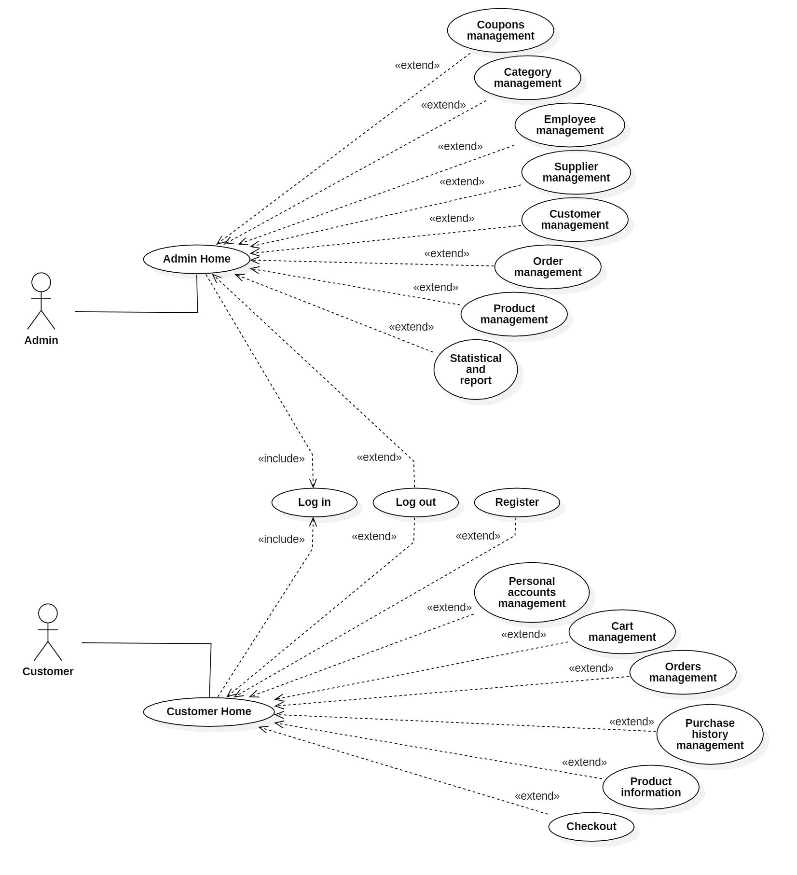

Diagram 1: Usercase in total

* Use-case of Admin

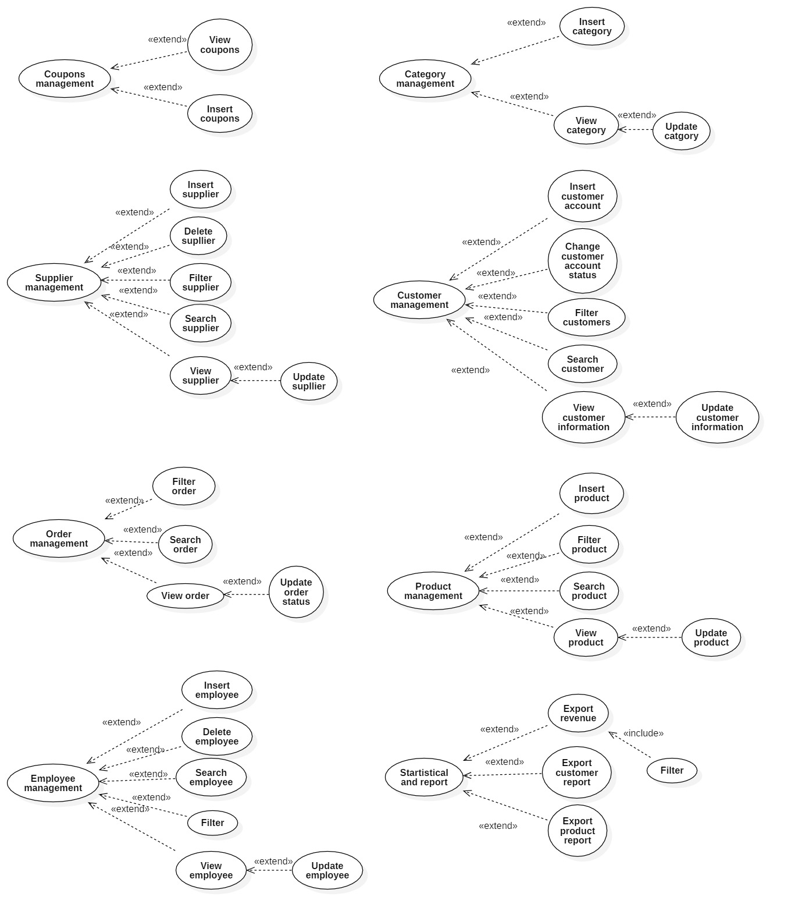

Diagram 2: Administrator user-case diagram in details

* Use-case of Users

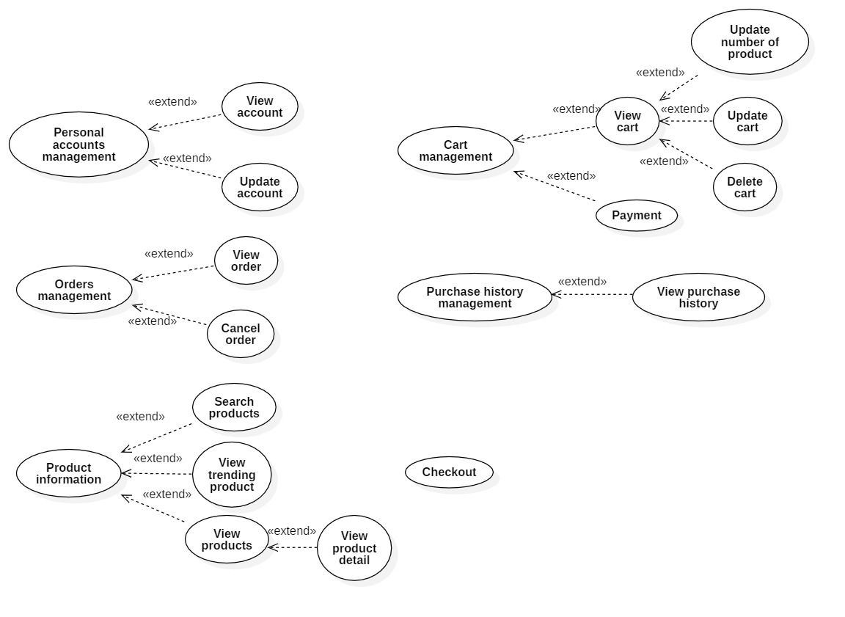

Diagram 3: Client user-case diagram in details

### **3.1.1 List of actors**

|  |  |  |
| --- | --- | --- |
| Index | Actors | Meaning |
| 1 | Admin Home | People manage the system |
| 2 | Customer Home | People use partial system’s services |

## **3.1.2 List of use-case**

|  |  |  |
| --- | --- | --- |
| Roles | Use case | Meaning |
| Admin’s role | Log in | Sign into the admin account |
| Log out | Sign out of the admin account |
| Coupons management | Manage product discount coupons |
| Category management | Product category management includes category code, category name  Add product categories |
| Supplier management | Product supplier management includes Supplier code, supplier name, product being supplied, phone number, address.  Add/delete/edit a product supplier |
| Customer management | Manage customer information including full name, date of birth, phone number, address.  Add/ delete/edit customers |
| Order management | Manage order information including Order code, product name, quantity, price, total amount, order status  Update order status |
| Product management | Manage product information including product code, product name, price, product details description  Add/edit a product |
| Employee management | Manage employee information including full name, date of birth, phone number, address.  Add/ delete/edit employee |
| Statistical and report | Statistical reports on products, orders, customers. |
| Customer’s role | Log in | Sign into user's account |
| Log out | Sign out of user's account |
| Register | Sign up for users |
| Personal account management | Manage personal information systems including full name, date of birth, phone number, address.  Edit information, update passwords |
| Cart management | Add, delete products  Change the quantity of the product. |
| Orders management | Order information from the time of order to the time of receipt |
| Purchase history management | View the purchase history. |
| Product information | View products, product insights |
| Checkout | Place an order |

## **3.2 Use-case specification and activity diagram**

### **3.2.1 Log in (for admin)**

|  |  |
| --- | --- |
| User-case name | Log in (for admin) |
| Description | The admin account has the admin permissions and have full right to edit the System |
| Trigger | The admin presses the "Log in" button to sign into the system |
| Pre-condition | The admin must be able to connect to the internet.  The account must be available on the database |
| Post-condition | There is a successful login message  Redirect to admin page |
| Basic flow | 1. Admin log in page 2. Admin enters email and password then presses confirm to sign in 3. The system checks if the email and password are in their right form (if the information is not in the correct format, display error notification and re-do step 2) 4. The system checks if the email and password had already existed on the database (if the information has already existed, display error notification and re-do step 2) 5. Redirect admin to admin home page 6. The system shows successful login notification 7. The system saves the login status |
| Alternative flow | 3a. Showing invalid information due to incorrect email formatting  The use-case continues from step 2.  4a. Display incorrect account or password information  The use-case continues from step 2. |
| Exception flow |  |

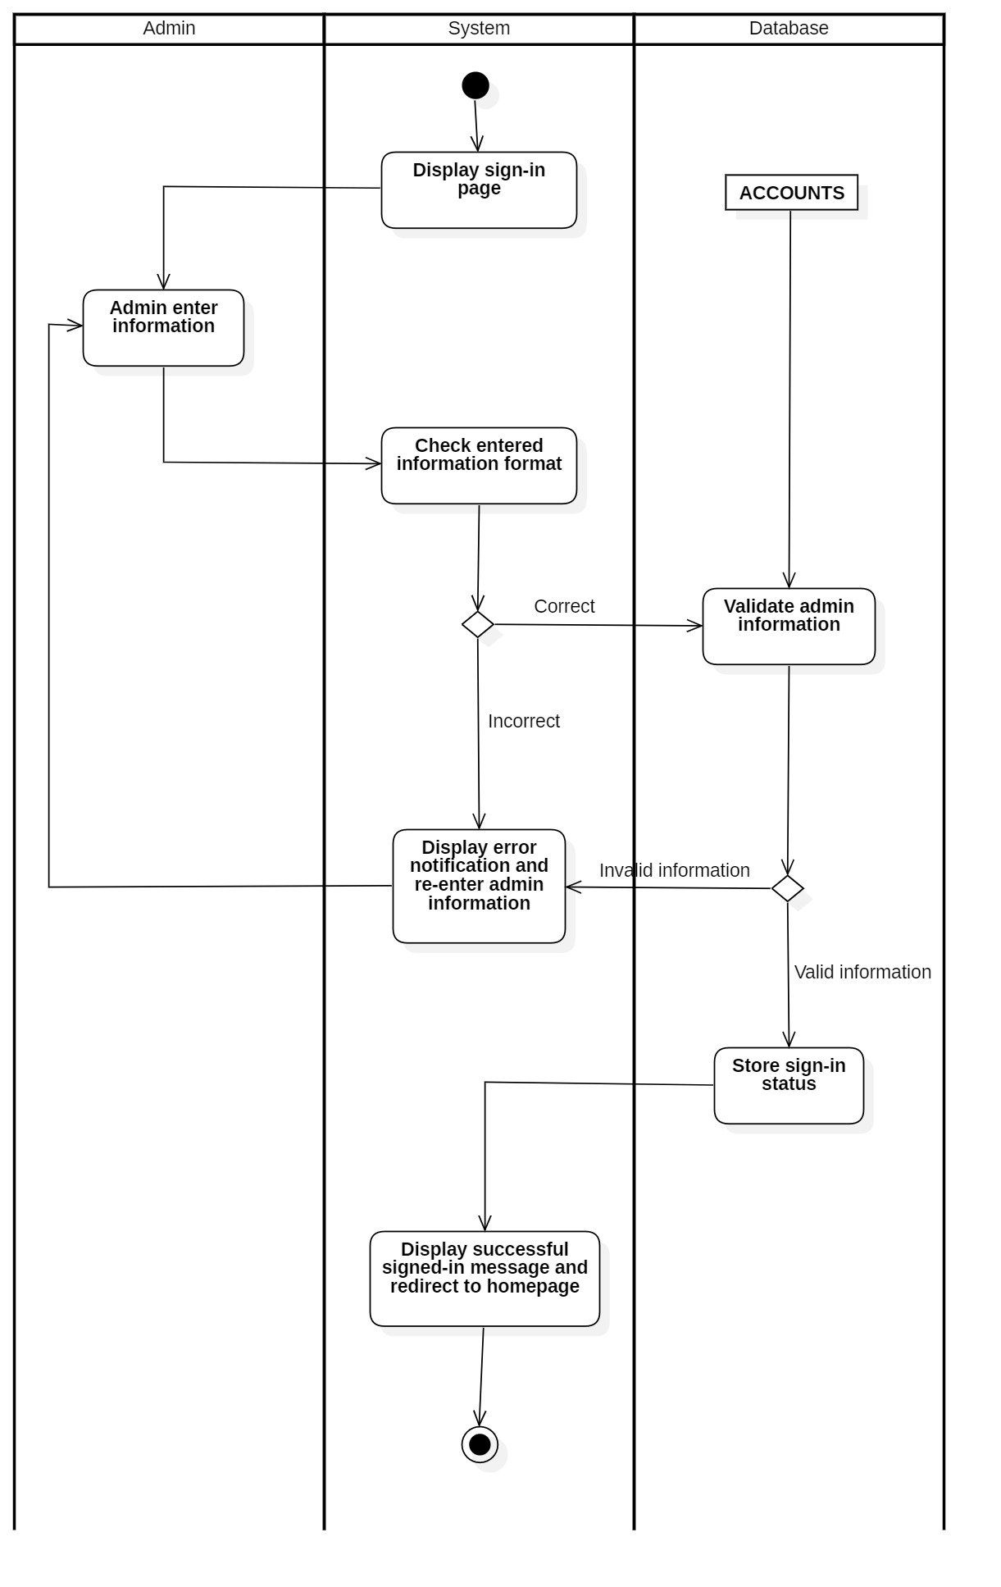

### **3.2.2 Log out(for admin)**

|  |  |
| --- | --- |
| User-case name | Log out(for admin) |
| Description | Admin [logs](https://www.babla.vn/tu-dien/tieng-anh-tieng-viet/log) [out](https://www.babla.vn/tu-dien/tieng-anh-tieng-viet/out) from the [account](https://www.babla.vn/tu-dien/tieng-anh-tieng-viet/account) |
| Trigger | Admin presses the "Log out" button to sign out of the system |
| Pre-condition | The admin must be able to connect to the internet.  The account must be logged in earlier |
| Post-condition | There is a successful sign-out message  Redirect to log in page |
| Basic flow | 1. Admin presses the "Log out" button to sign out 2. The system deletes the admin's login information on the session 3. Redirect admin to log in page 4. The system shows successful log-out notification and redirect to homepage |
| Alternative flow |  |
| Exception flow |  |

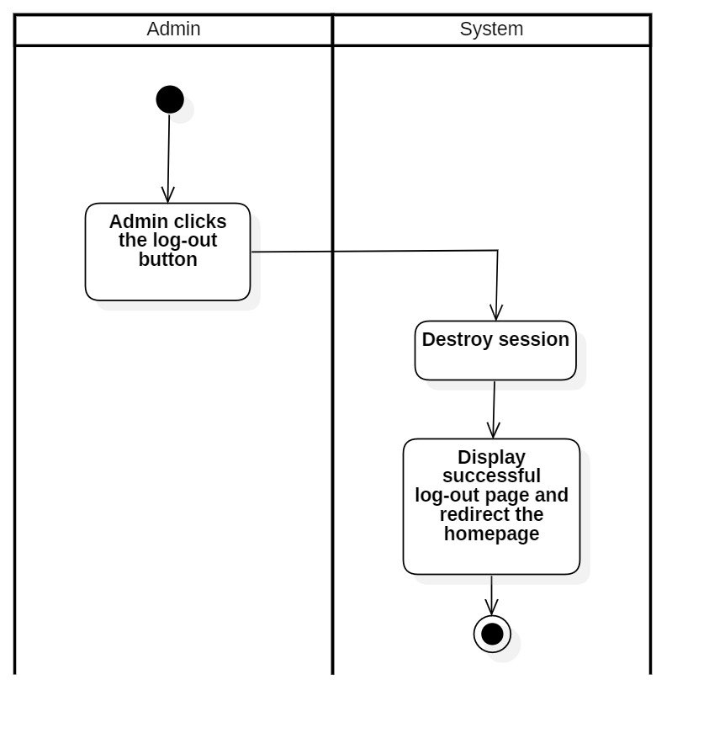

### **3.2.3 Coupons management**

#### **3.2.3.1 View coupons**

|  |  |
| --- | --- |
| User-case name | View coupons |
| Description | Admin view coupons |
| Trigger | Admin clicks the “Detail” button to view the coupons’s information |
| Pre-condition | The admin must be able to connect to the internet  The account must log in beforehand |
| Post-condition | Redirect detail coupons |
| Basic flow | 1. The system displays an coupons management page 2. Admin clicks "Detail" to view the details of the coupons 3. Takes out the information from the database 4. The system displays the details of the coupons |
| Alternative flow |  |
| Exception flow |  |

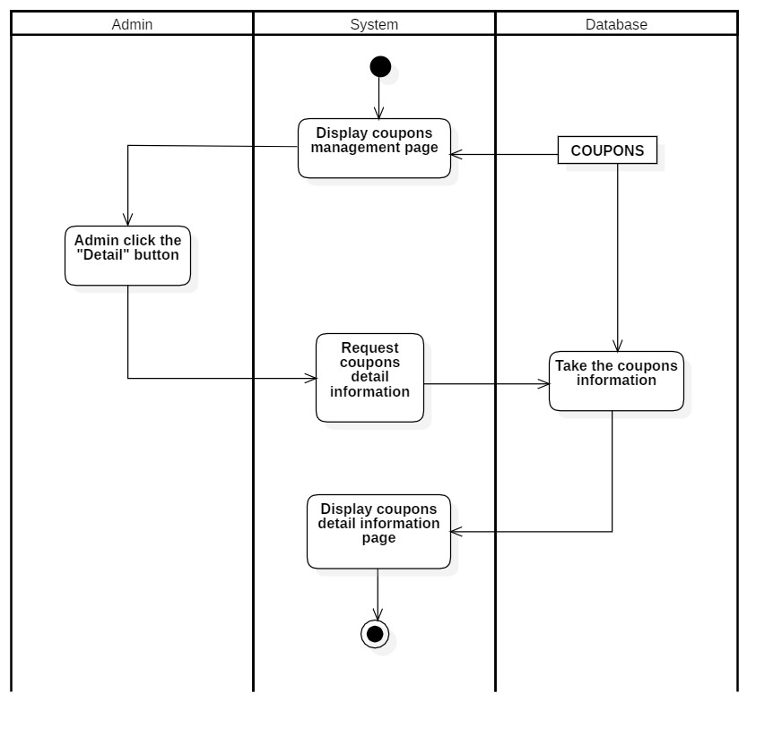

#### **3.2.3.2 Insert coupons**

|  |  |
| --- | --- |
| User-case name | Insert coupons |
| Description | Admin adds coupon codes |
| Trigger | Admin presses the "Add coupons" function to add coupons |
| Pre-condition | The admin must be able to connect to the internet.  The account must be logged in beforehand. |
| Post-condition | There are “Inserted successfully” announcements of success  Redirect to information coupons page |
| Basic flow | 1. Admin access the coupons management page 2. Admin clicks the "Add coupons" function to add new coupons 3. System shows the “Insert detail” coupons page 4. Admin enters full information of coupons 5. The system checks the coupons are in the correct format (if the information is not in the correct format re-do step 4) 6. The system checks if the coupons exist on the database or not (if the information has already existed re-do step 4) 7. The system conducts new coupons 8. The system shows successful new coupons inserted and redirect to coupons page |
| Alternative flow | 5a. Show invalid information due to improper coupons  Use-case continues from step 3  6a. Coupon information already exists  Use-case continues from step 3 |
| Exception flow |  |

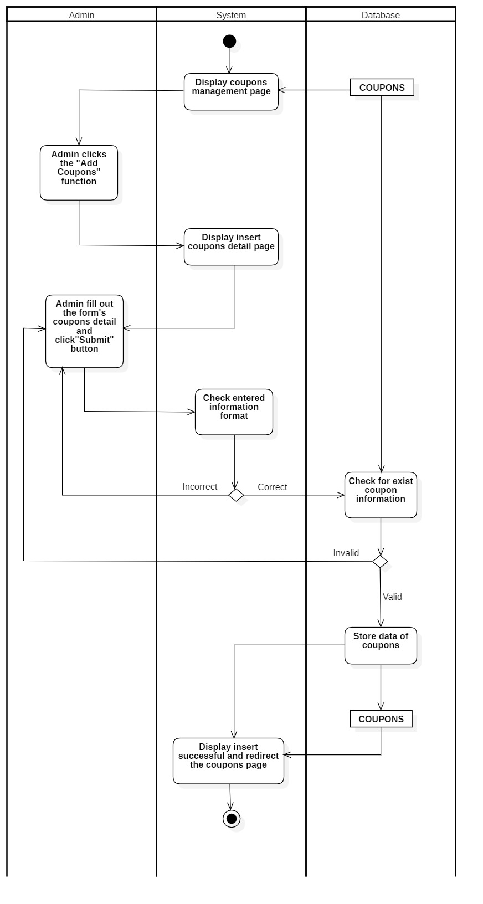

### **3.2.4 Category management**

#### **3.2.4.1 Insert category**

|  |  |
| --- | --- |
| User-case name | Insert category |
| Description | Admin add a new category |
| Trigger | Admin clicks "Add category" function to add category |
| Pre-condition | The admin must be able to connect to the internet.  The account must be logged in beforehand. |
| Post-condition | There are added successful announcements  Redirect to category page |
| Basic flow | 1. Admin access category page 2. Admin clicks the "Add category" function to add a new category 3. System shows detailed category entry page 4. Admin enters full information of category 5. The system inspects whether the category is in the correct format (if the information is not in the correct format, re-do step 4) 6. The system checks if the category exists on the database (if the information has already existed re-do step 4) 7. The system saves the new category data 8. The system successfully added a new category notification |
| Alternative flow | 5a. Display invalid information due to incorrect category formatting  Usecase continues from step 3  6a. Category information now exists  Usecase continues from step 3 |
| Exception flow |  |

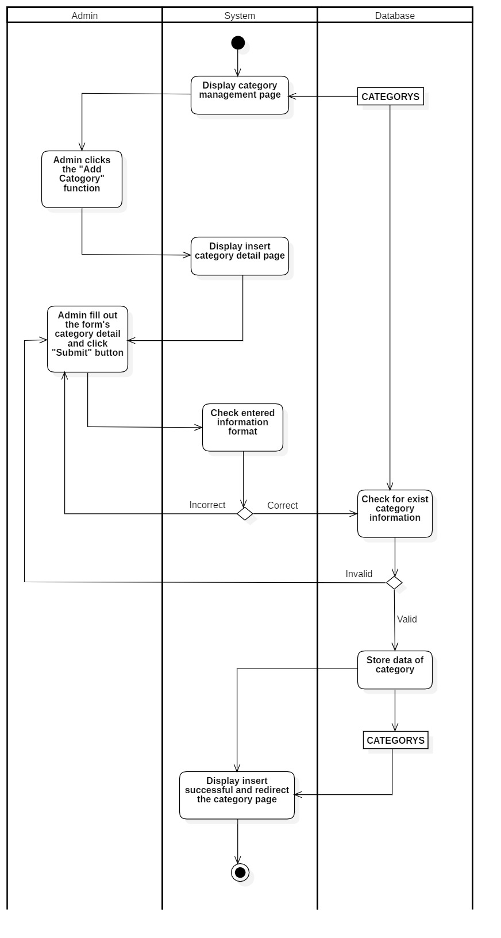

#### **3.2.4.2 Update category**

|  |  |
| --- | --- |
| User-case name | Update category |
| Description | Admin update category |
| Trigger | Admin searches and clicks the "Update" button to update category |
| Pre-condition | The admin must be able to connect to the internet.  The account must be logged in beforehand. |
| Post-condition | There is a successful update message  Redirect to category page |
| Basic flow | 1. Admin access category page 2. Admin clicks the "Detail" button to view the category detail 3. The system displays Category update detail page display 4. Admin enters full information of category to be edited 5. The system checks whether the category information is in the correct format (if the information is not in the correct format, display error notification and re-do step 4) 6. The system conducts category update 7. The system shows successful update category notification and redirect to category information page |
| Alternative flow | 5a. Display invalid information due to incorrect category formatting  Usecase continues from step 3 |
| Exception flow |  |

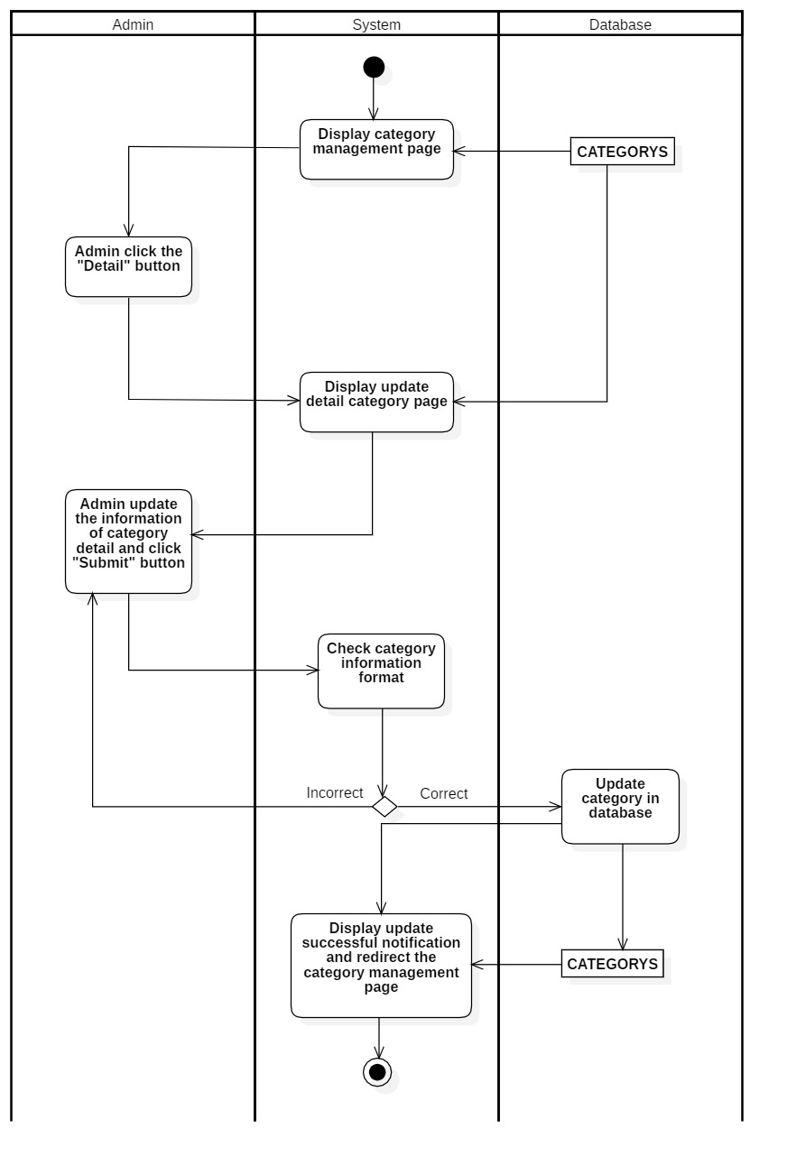

#### **3.2.4.3 View category**

|  |  |
| --- | --- |
| User-case name | View category |
| Description | Admin view catogory |
| Trigger | Admin clicks the “Detail” button to view the category’s information |
| Pre-condition | The admin must be able to connect to the internet  The account must log in beforehand |
| Post-condition | Redirect detail order |
| Basic flow | 1. The system displays an Category management page 2. Admin clicks "Detail" to view the details of the category 3. The system checks the order information and takes out the information from the database 4. The system displays the details of the order |
| Alternative flow |  |
| Exception flow |  |

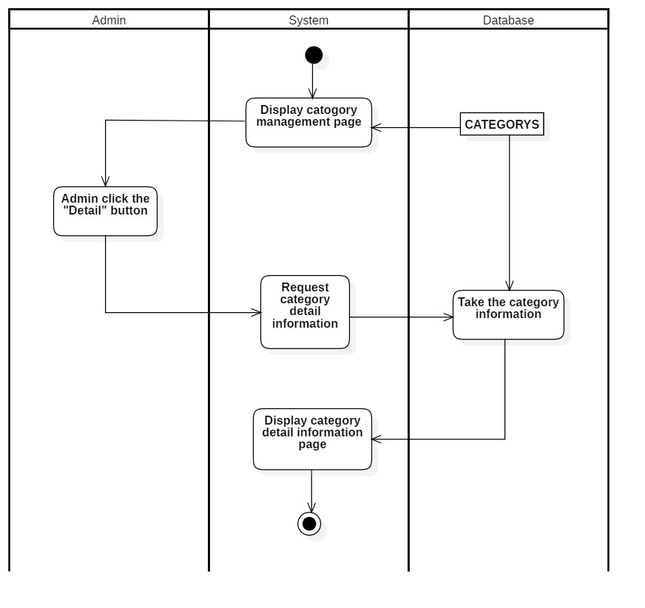

### **3.2.5 Supplier management**

#### **3.2.5.1 Insert supplier**

|  |  |
| --- | --- |
| User-case name | Insert supplier |
| Description | Admin add supplier |
| Trigger | Admin clicks on the “Add supplier ” function to insert supplier |
| Pre-condition | The admin must be able to connect to the internet.  The account must be logged in beforehand. |
| Post-condition | There is a successful added message  Redirect to supplier page |
| Basic flow | 1. Admin access supplier information page 2. Admin presses the "Add supplier" function to add a new supplier 3. System shows supplier input page details 4. Admin enters full supplier's information 5. The system checks whether the supplier is in the correct format (if the information is not in the correct format, re-do step 4) 6. The system checks if the supplier exists on the database (if the information has already existed, re-do step 4) 7. The system stores the data of supplier 8. The system shows Successful new supplier added and redirect to the supplier page |
| Alternative flow | 5a. Displays invalid information due to incorrect supplier format  Usecase continues from step 3  6a. Supplier information already exists.  Usecase continues from step 3 |
| Exception flow |  |

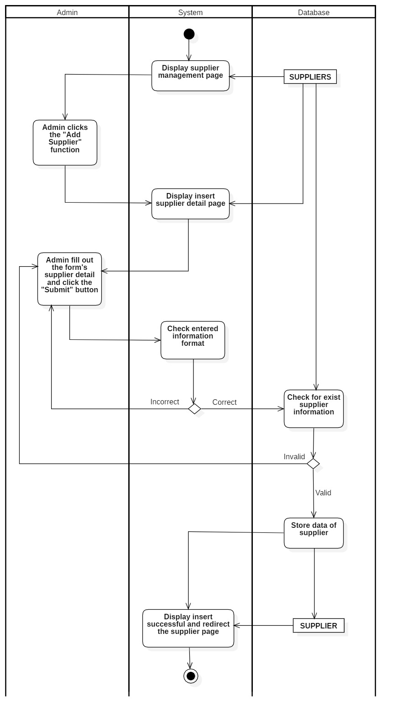

#### **3.2.5.2 Update supplier**

|  |  |
| --- | --- |
| User-case name | Update supplier |
| Description | Admin update supplier |
| Trigger | Admin searches and clicks the "Update" button to supplier |
| Pre-condition | The admin must be able to connect to the internet.  The account must be logged in beforehand |
| Post-condition | There is a successful update message  Redirect to supplier page |
| Basic flow | 1. Admin access supplier page 2. Admin clicks the "Detail" button to update supplier 3. The system displays the Supplier update page 4. Admin enters full supplier's information to be edited 5. The system checks whether supplier information is in the correct format (if the information is not in the correct format, display error notification and re-do step 4) 6. The system update Supplier 7. The system shows Successful supplier updated notification and redirect to the supplier information page |
| Alternative flow | 5a. Displays invalid information due to incorrect supplier format  Usecase continues from step 3 |
| Exception flow |  |

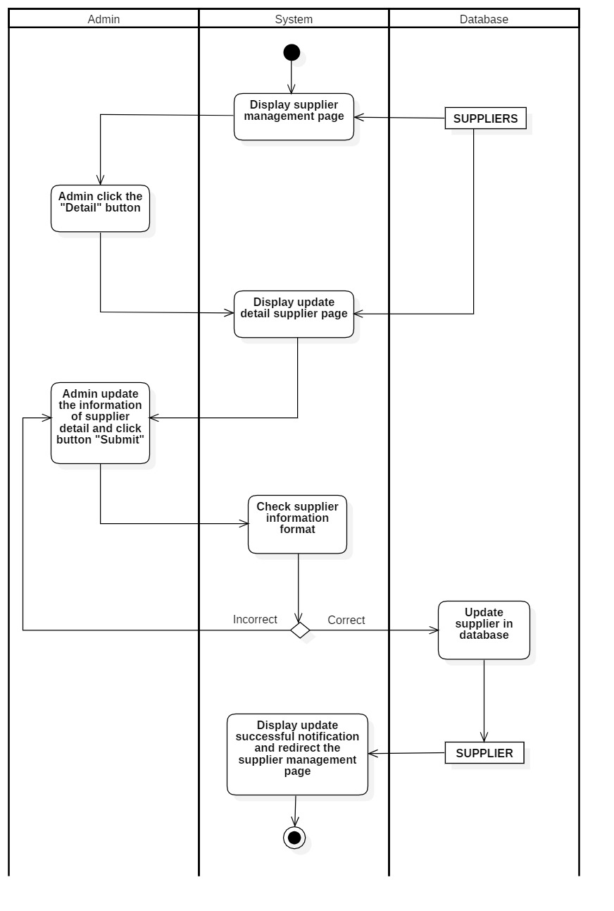

#### **3.2.5.3 Delete supplier**

|  |  |
| --- | --- |
| User-case name | Delete supplier |
| Description | Admin delete supplier |
| Trigger | Admin clicks on “Delete” to delete supplier |
| Pre-condition | The admin must be able to connect to the internet.  The account must be logged in beforehand. |
| Post-condition | There is a successfully deleted message  Redirect to supplier page |
| Basic flow | 1. Admin access to supplier page 2. Admin searches and clicks the "Delete" button to delete supplier 3. The system delete supplier (if the supplier can’t be deleted, display error notification and re-do step 2) 4. The system deletes the Supplier data 5. The system shows Successful deleted supplier notification and redirect to the supplier management page |
| Alternative flow | 3a. Supplier information does not exist, or errors occur when deleting  The usecase continues from step 2. |
| Exception flow |  |

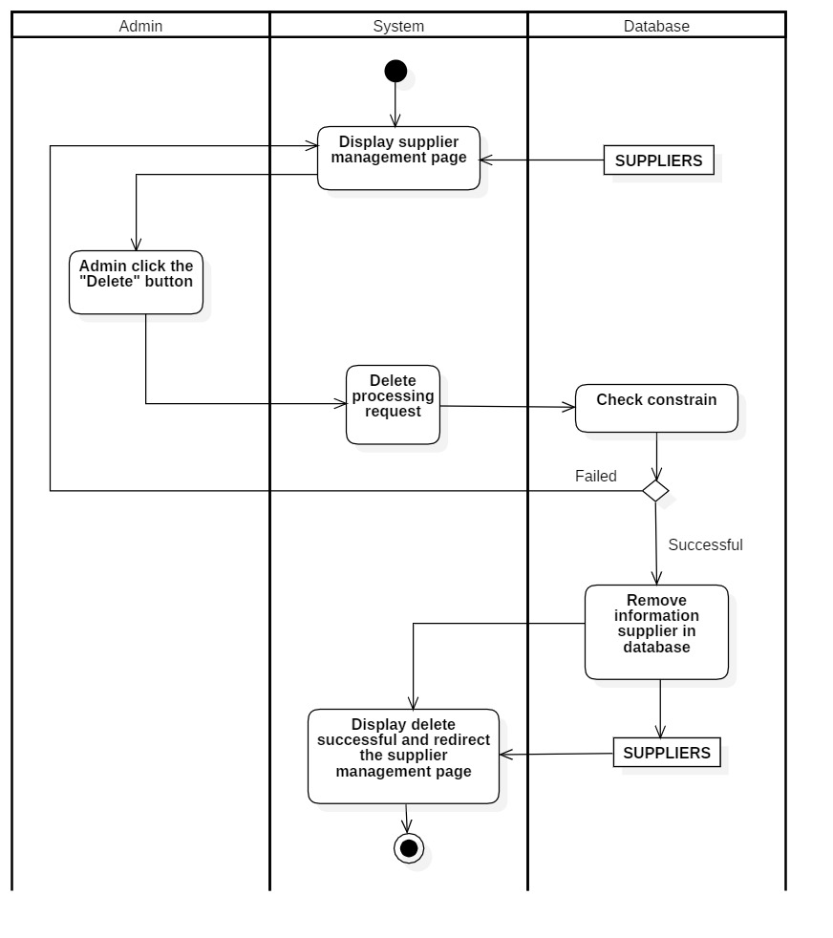

#### **3.2.5.4 View supplier**

|  |  |
| --- | --- |
| User-case name | View supplier |
| Description | Admin view supplier |
| Trigger | Admin clicks the “Detail” button to view the supplier’s information |
| Pre-condition | The admin must be able to connect to the internet  The account must log in beforehand |
| Post-condition | Redirect detail order |
| Basic flow | 1. The system displays an supplier management page 2. Admin clicks "Detail" to view the details of the supplier 3. The system checks the order information and takes out the information from the database 4. The system displays the details of the supplier |
| Alternative flow |  |
| Exception flow |  |

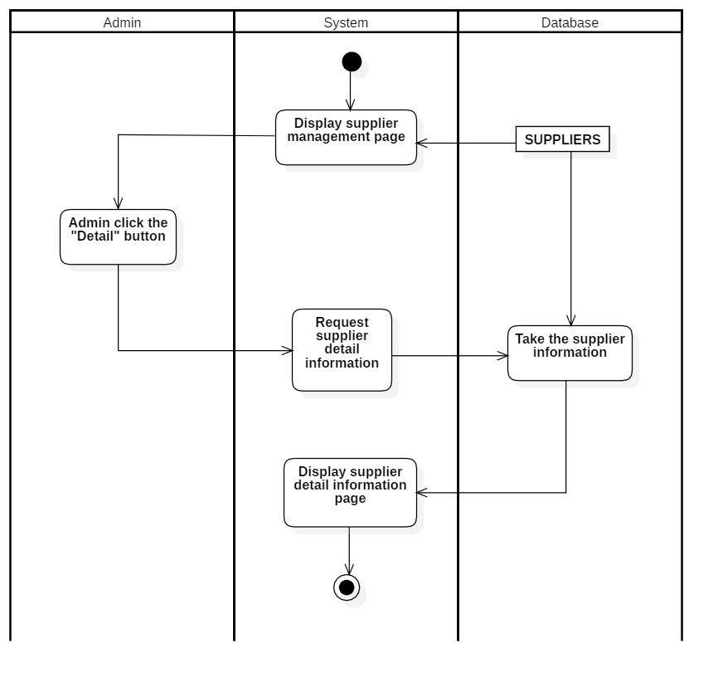

#### **3.2.5.5 Filter supplier**

|  |  |
| --- | --- |
| User-case name | Filter supplier |
| Description | Admin filters supplier data to view |
| Trigger | The admin clicks the “Filter” button |
| Pre-condition | The admin must be able to connect to the internet  The account must log in beforehand |
| Post-condition | Redirect to customer page |
| Basic flow | 1. The system displays the Customer page 2. Admin clicks the "Filter” button 3. The system displays filtered customer information |
| Alternative flow |  |
| Exception flow |  |

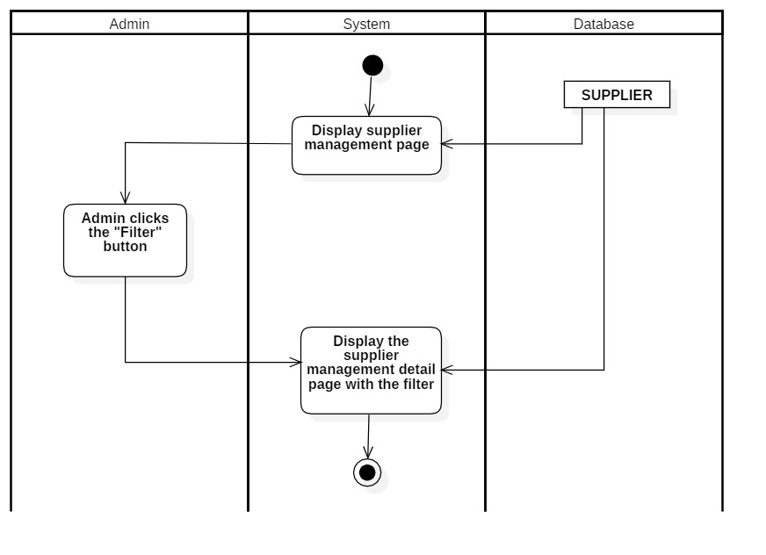

#### **3.2.5.6 Search supplier**

|  |  |
| --- | --- |
| User-case name | Search supplier |
| Description | Admin types in the supplier’s name to search |
| Trigger | The admin clicks the “Search” button to search |
| Pre-condition | The admin must be able to connect to the internet  The account must log in beforehand |
| Post-condition | Redirect to customer page |
| Basic flow | 1. The system displays the supplier management page 2. Admin enter keywords (supplier’s name) 3. The system searches for supplier data (if there are no product have the same name displays no matching notifications) 4. Display searched results |
| Alternative flow |  |
| Exception flow |  |

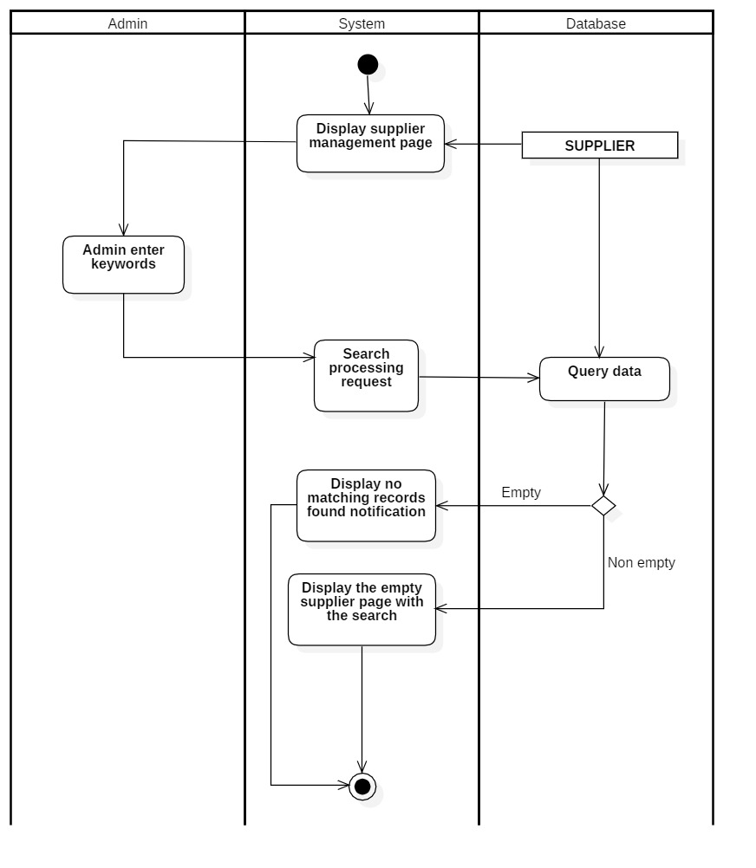

### **3.2.6 Customer management**

#### **3.2.6.1 Insert customer account**

|  |  |
| --- | --- |
| User-case name | Insert customer account |
| Description | Admin creates a customer account |
| Trigger | Admin clicks the “Add customer” function to create customer information |
| Pre-condition | The admin must be able to connect to the internet  The account must not exist on the database. |
| Post-condition | There is a successfully created notification  Redirect to customer’s information page |
| Basic flow | 1. Admin to customer information page 2. Admin presses "Add customer" function and fill in customer's necessary information 3. The system checks the entered information form (if the information is not in the correct format, re-do step 2) 4. The system checks if Customer has already existed or not (if the customer has already existed, re-do step 2) 5. The system adds customers to the database 6. The system stores new customers' data 7. The system announces successful added new customers 8. The system redirects to the customer page |
| Alternative flow | 3a. Customer notifications already exist  The usecase continues from step 2. |
| Exception flow |  |

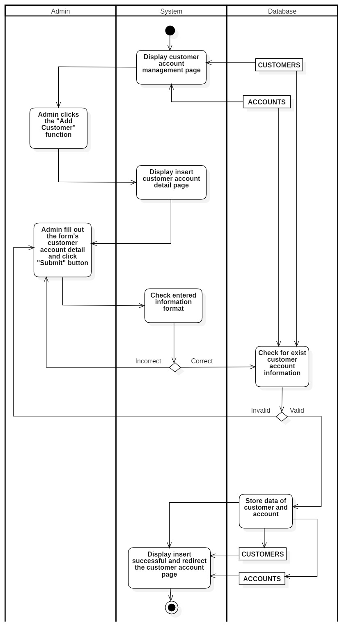

#### **3.2.6.2 View customer information**

|  |  |
| --- | --- |
| User-case name | View customer information |
| Description | Admin view customer insights |
| Trigger | Admin clicks the "View" button in the customer page to see details |
| Pre-condition | The admin must be able to connect to the internet  The account must logged in beforehand. |
| Post-condition | Redirect to detail customer page |
| Basic flow | 1. The system displays the Customer account management page 2. Admin clicks "View" to view customer details 3. The system checks customer information on the database and draws it out 4. The system displays customer details |
| Alternative flow |  |
| Exception flow |  |

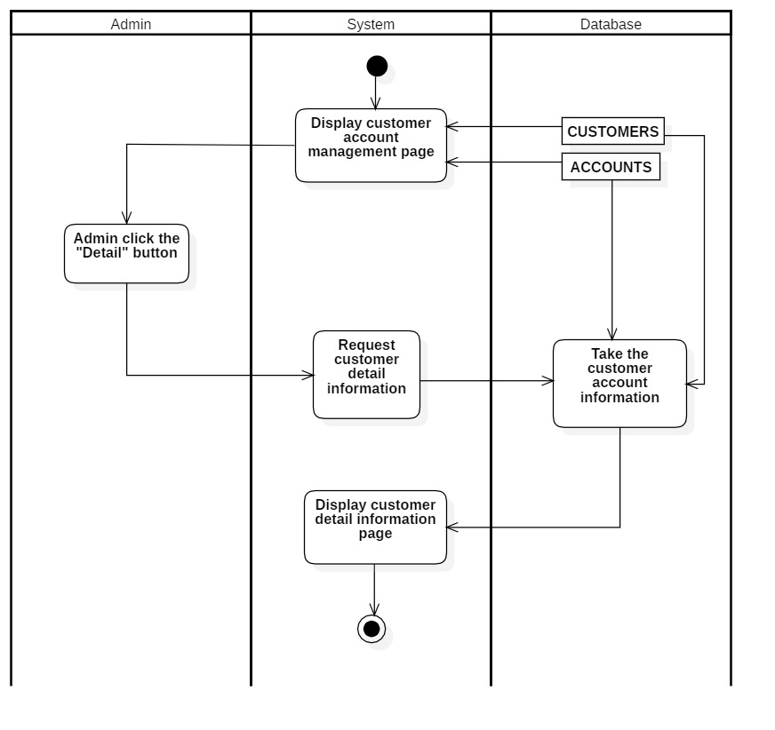

#### **3.2.6.3 Change customer account status**

|  |  |
| --- | --- |
| User-case name | Change customer account status |
| Description | Admin changed the customer account status |
| Trigger | Admin clicks the “Lock” or “Unlock” button in customer account management page |
| Pre-condition | The admin must be able to connect to the internet  The account must logged in beforehand |
| Post-condition | Redirect to customer page |
| Basic flow | 1. The System displays Customer management page 2. Admin clicks "Change status" to lock customer's account 3. The system changes the customer status on the database to lock or unlock 4. The system shows the successful change status notification and redirect to customer management |
| Alternative flow |  |
| Exception flow |  |

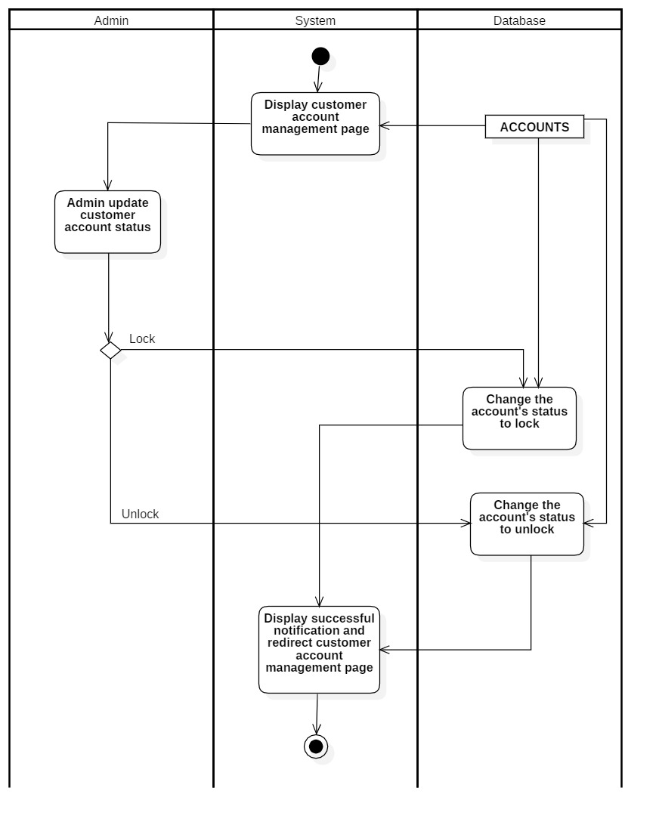

#### **3.2.6.4 Filter customer**

|  |  |
| --- | --- |
| User-case name | Filter customer |
| Description | Admin filters customer data to view |
| Trigger | The admin clicks the “Filter” button |
| Pre-condition | The admin must be able to connect to the internet  The account must log in beforehand |
| Post-condition | Redirect to customer page |
| Basic flow | 1. The system displays the Customer page 2. Admin selects the information and presses "Filter" to filter out the value to view 3. The system displays filtered customer information |
| Alternative flow |  |
| Exception flow |  |

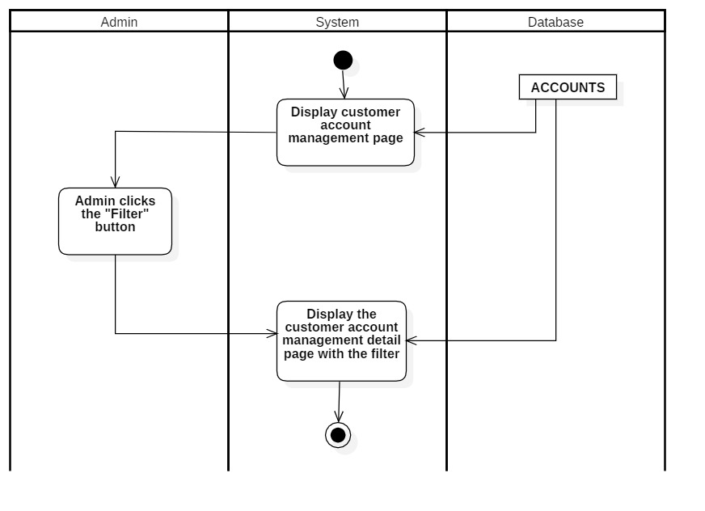

#### **3.2.6.5 Search customer**

|  |  |
| --- | --- |
| User-case name | Search customer |
| Description | Admin types in the customer’s name to search |
| Trigger | The admin clicks the “Search” button to search |
| Pre-condition | The admin must be able to connect to the internet  The account must log in beforehand |
| Post-condition | Redirect to customer page |
| Basic flow | 1. The system displays the Customer account management page 2. Admin enter keywords (customer’s name) 3. The system searches for customer data (if there are no customers have the same name displays no matching notifications) 4. Display search results |
| Alternative flow |  |
| Exception flow |  |

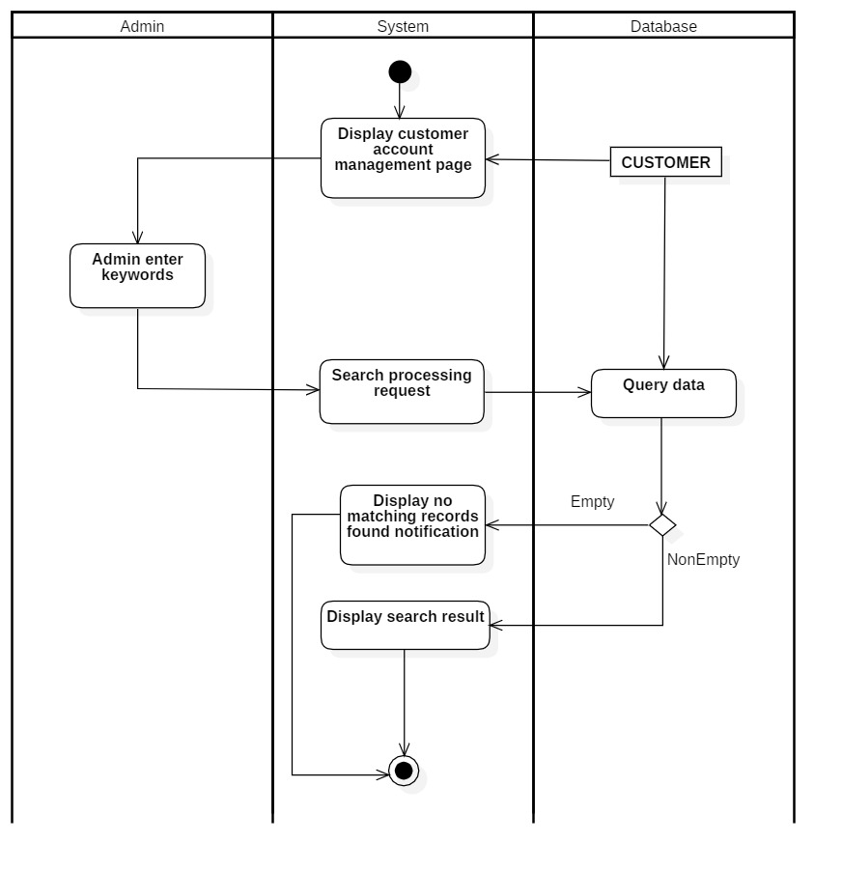

#### **3.2.6.6 Update customer information**

|  |  |
| --- | --- |
| User-case name | Update supplier |
| Description | Admin update supplier |
| Trigger | Admin searches and clicks the "Update" button to supplier |
| Pre-condition | The admin must be able to connect to the internet.  The account must be logged in beforehand |
| Post-condition | There is a successful update message  Redirect to supplier page |
| Basic flow | 1. Admin access supplier page 2. Admin clicks the "Detail" button to update supplier 3. The system displays the Supplier update page 4. Admin enters full supplier's information to be edited 5. The system checks whether supplier information is in the correct format (if the information is not in the correct format, display error notification and re-do step 4) 6. The system update Supplier 7. The system shows Successful supplier updated notification and redirect to the supplier information page |
| Alternative flow | 5a. Displays invalid information due to incorrect supplier format  Usecase continues from step 3 |
| Exception flow |  |

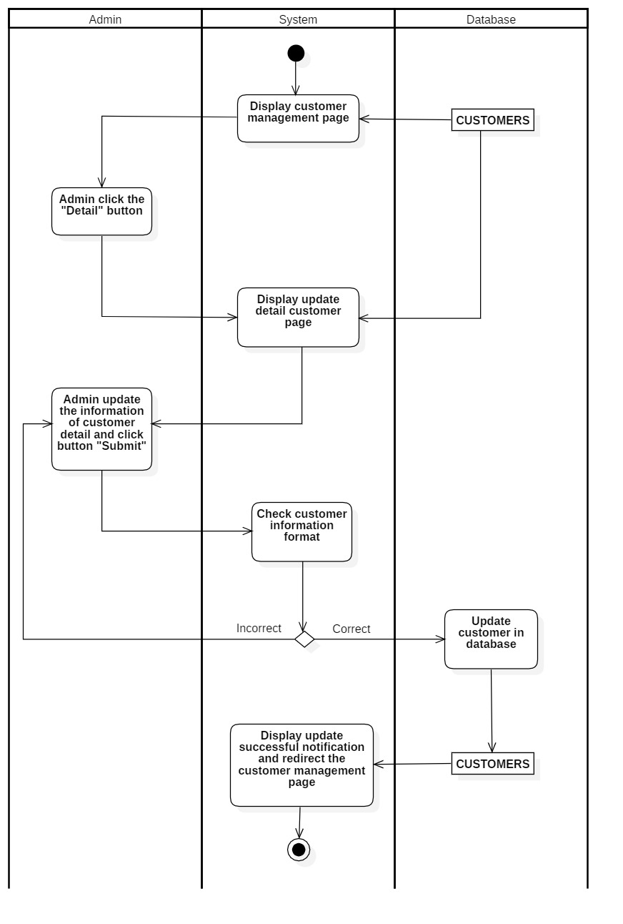

### **3.2.7 Order management**

#### **3.2.7.1 View order**

|  |  |
| --- | --- |
| User-case name | View order |
| Description | Admin view order of customers |
| Trigger | Admin clicks the “Detail” button to view the customer’s information |
| Pre-condition | The admin must be able to connect to the internet  The account must log in beforehand |
| Post-condition | Redirect detail order |
| Basic flow | 1. The system displays an Order page 2. Admin clicks "Detail" to view the details of the order 3. The system checks the order information and takes out the information from the database 4. The system displays the details of the order |
| Alternative flow |  |
| Exception flow |  |

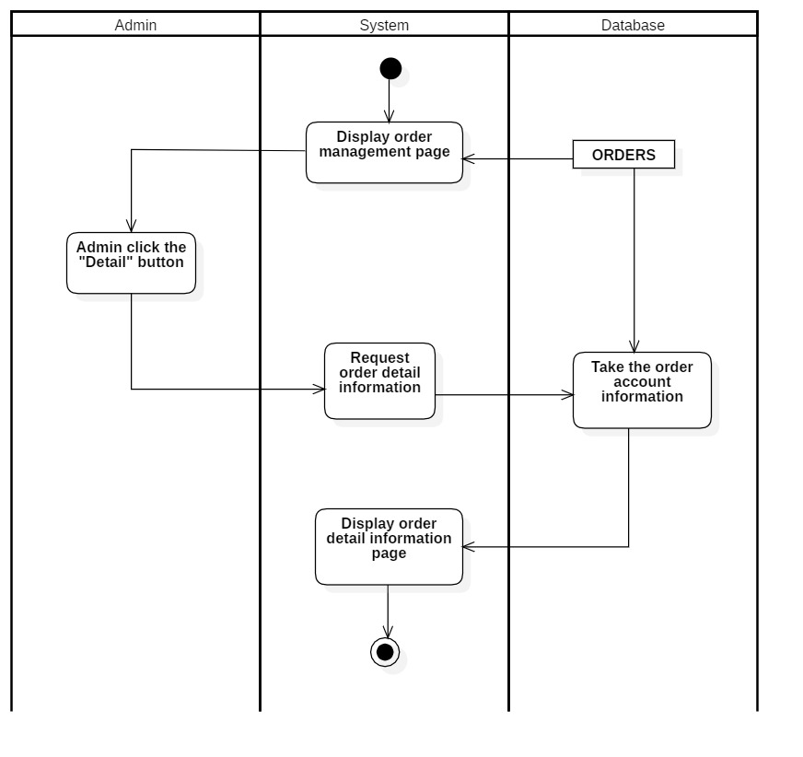

#### **3.2.7.2 Update order status**

|  |  |
| --- | --- |
| User-case name | Update orders status |
| Description | Admin update orders |
| Trigger | Admin select the order status |
| Pre-condition | The admin must be able to connect to the internet  The account must log in beforehand |
| Post-condition | There is a successful update message  Redirect to order page |
| Basic flow | 1. Admin access to order page 2. Admin searches and clicks the "Detail" button to change orders status 3. The system takes order detail information on the database 4. The system displays the Order details page 5. Admin selects the new status and submit 6. Order status being updated in the database 7. Display successful updated notification and display the order details |
| Alternative flow | 3a. Show that order information does not exist, or an error occurred when deleting  The usecase continues from step 2. |
| Exception flow |  |

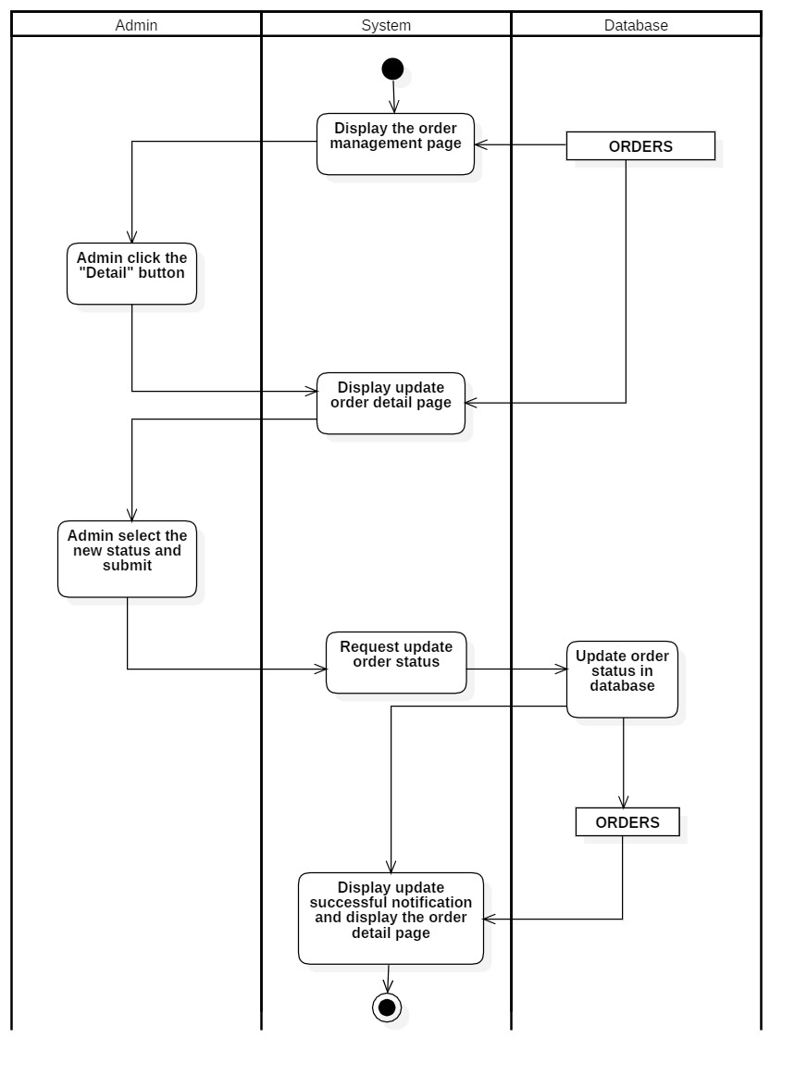

#### **3.2.7.3 Search order**

|  |  |
| --- | --- |
| User-case name | Search order |
| Description | Admin types in the order’s name to search |
| Trigger | The admin clicks the “Search” button to search |
| Pre-condition | The admin must be able to connect to the internet  The account must log in beforehand |
| Post-condition | Redirect to customer page |
| Basic flow | 1. The system displays the order management page 2. Admin enter keywords 3. The system searches for order data (if there are no order have the same name displays no matching notifications) 4. Display searched results |
| Alternative flow |  |
| Exception flow |  |

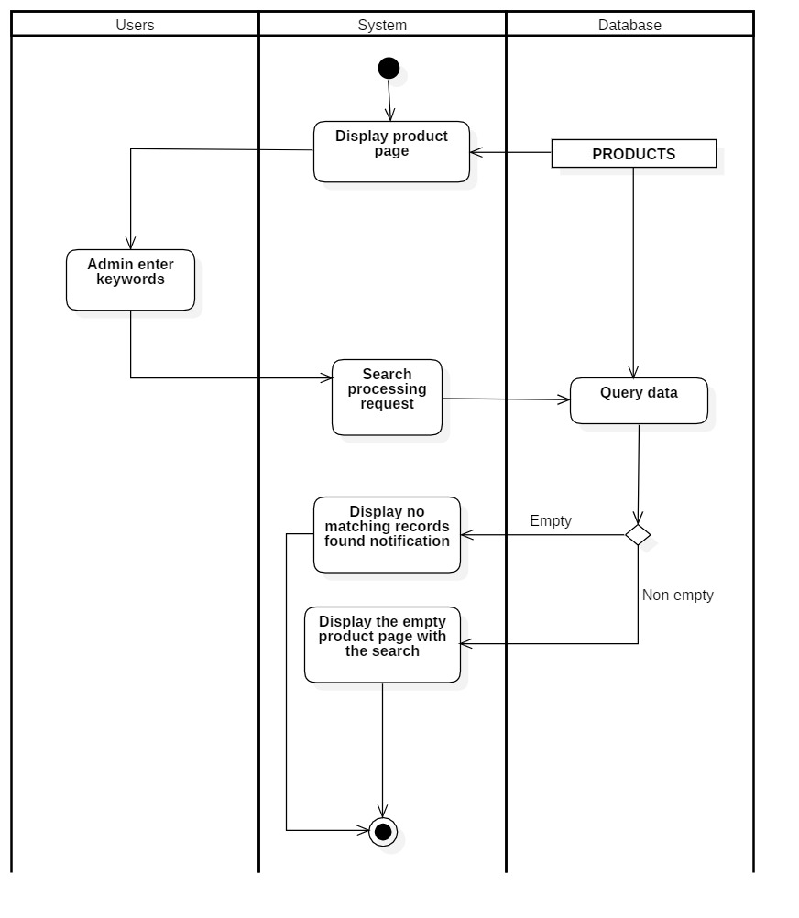

#### **3.2.7.4 Filter order**

|  |  |
| --- | --- |
| User-case name | Filter order |
| Description | Admin filters order data to view |
| Trigger | The admin clicks the "Filter" button to filter the data |
| Pre-condition | The admin must be able to connect to the internet  The account must log in beforehand |
| Post-condition | Redirect to order page |
| Basic flow | 1. The system displays the Order page 2. Admin clicks "Filter" to filter out the value to view 3. The system displays the order page with the filter |
| Alternative flow |  |
| Exception flow |  |

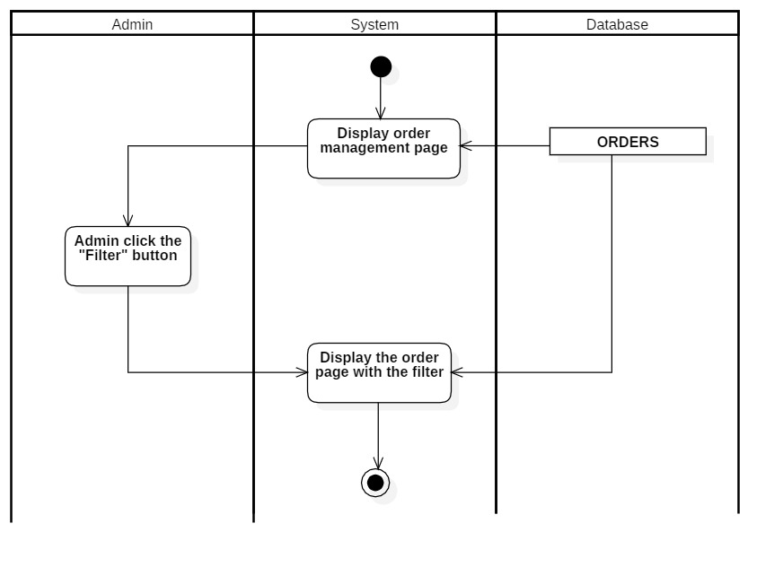

### **3.2.8 Product management**

#### **3.2.8.1 Insert product**

|  |  |
| --- | --- |
| User-case name | Insert product |
| Description | Admin add new product |
| Trigger | Admin clicks the “Add product” function to add new product |
| Pre-condition | The admin must be able to connect to the internet  The account must loggedin beforehand |
| Post-condition | There is a successful added message  Redirect to product page |
| Basic flow | 1. Admin access product page 2. Admin clicks the "Add product" function to add a new product 3. System shows detail insert product page 4. Admin enters product information 5. The system checks whether the product is in the correct format ( if not, re-do step 4) 6. The system checks whether the product exists on the database ( if not, re-do step 4) 7. The system stores new product data 8. The system displays Successful inserted new product notification and redirect to product page |
| Alternative flow | 5a. Display invalid information due to incorrect product format  Usecase continues from step 3  6a. The product information now exists.  Usecase continues from step 3 |
| Exception flow |  |

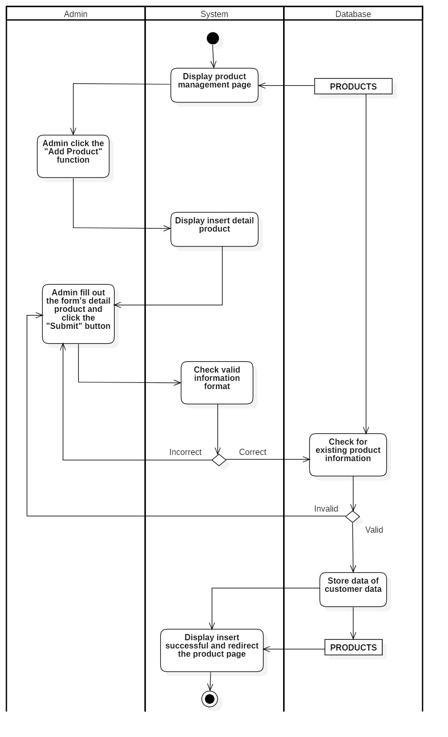

#### **3.2.8.2 Filter product**

|  |  |
| --- | --- |
| User-case name | Filter product |
| Description | Admin filters product data to view |
| Trigger | The admin clicks the "Filter" button to filter the data |
| Pre-condition | The admin must be able to connect to the internet  The account must log in beforehand |
| Post-condition | Redirect to product page |
| Basic flow | 1. The system display Product page 2. Admin clicks "Filter" to filter out the value to view 3. The system checks product information on the database and takes it out. 4. The system displays the information of the filtered product (if there is the imformation needed, if not display an empty page) |
| Alternative flow |  |
| Exception flow |  |

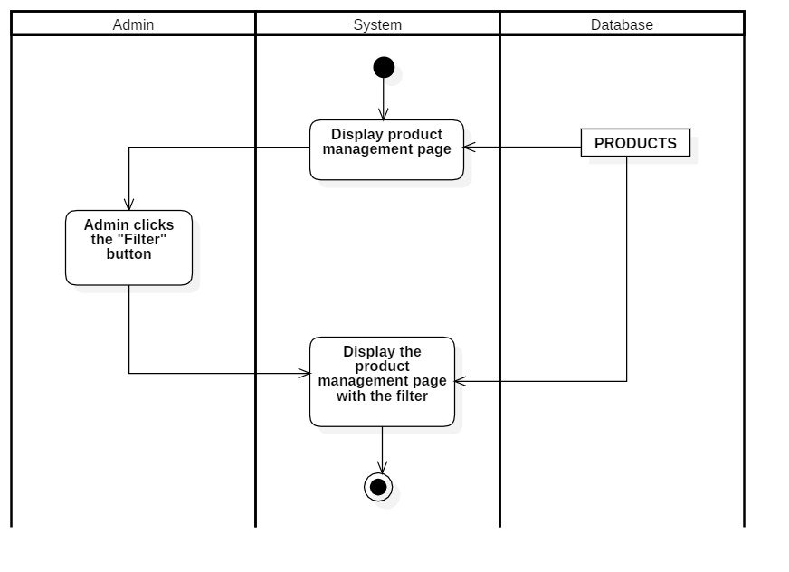

#### **3.2.8.3 Search product**

|  |  |
| --- | --- |
| User-case name | Search product |
| Description | Admin types in the customer’s name to search |
| Trigger | The admin clicks the “Search” button to search |
| Pre-condition | The admin must be able to connect to the internet  The account must log in beforehand |
| Post-condition | Redirect to customer page |
| Basic flow | 1. The system displays the product management page 2. Admin enter keywords (product’s name) 3. The system searches for product data (if there are no product have the same name displays no matching notifications) 4. Display searched results |
| Alternative flow |  |
| Exception flow |  |

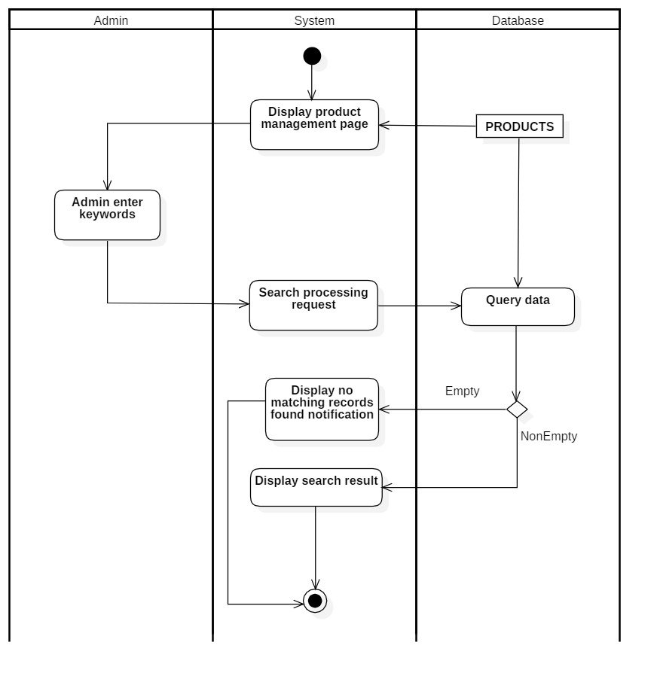

#### **3.2.8.4 View product**

|  |  |
| --- | --- |
| User-case name | View product |
| Description | Admin view information of product |
| Trigger | Admin clicks the “Detail” button to view the product’s information |
| Pre-condition | The admin must be able to connect to the internet  The account must log in beforehand |
| Post-condition | Redirect detail order |
| Basic flow | 1. The system displays an product management page 2. Admin clicks "Detail" to view the details of the product 3. The system checks the product information and takes out the information from the database 4. The system displays the details of the product |
| Alternative flow |  |
| Exception flow |  |

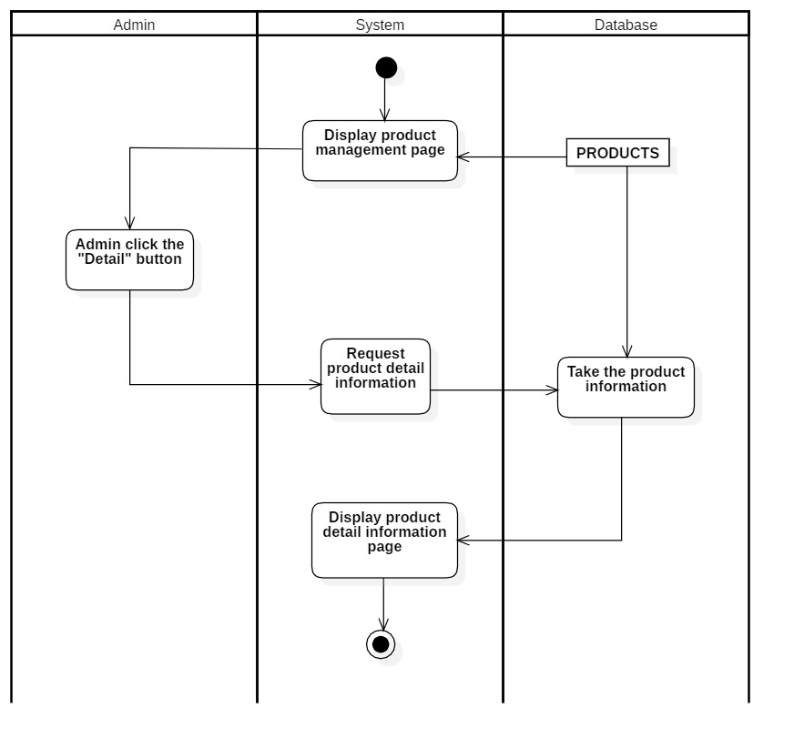

#### **3.2.8.5 Update product**

|  |  |
| --- | --- |
| User-case name | Update product |
| Description | Admin update product |
| Trigger | Admin searches and clicks the "Detail" button and update the product information |
| Pre-condition | The admin must be able to connect to the internet  The account must log in beforehand |
| Post-condition | There is a successful update message  Redirect to product page |
| Basic flow | 1. Admin access to product page 2. Admin clicks the "Detail" button to update the product 3. The system display update product detail page 4. Admin update the information 5. The system checks Whether the product information is in the correct format ( if not, re-do step 4) 6. The product being updated in the database 7. The system displays successful updated product notification and redirect to product page |
| Alternative flow | 5a. Display invalid information due to incorrect product format  Usecase continues from step 3 |
| Exception flow |  |

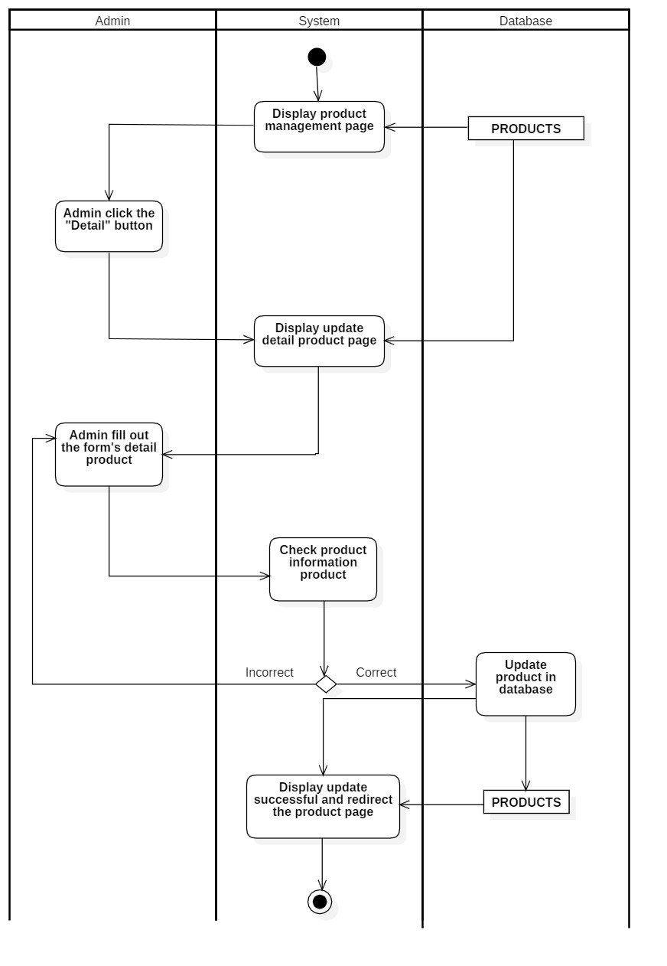

### **3.2.9 Employee management**

#### **3.2.9.1 Insert employee**

|  |  |
| --- | --- |
| User-case name | Insert employee |
| Description | Admin creates a employee account |
| Trigger | Admin clicks the “Add employee” function to create employee information |
| Pre-condition | The admin must be able to connect to the internet  The account must not exist on the database. |
| Post-condition | There is a successfully created notification  Redirect to empplyee’s information page |
| Basic flow | 1. Admin to employee management page 2. Admin clicks "Add employee" function 3. The system displays insert employees details page 4. Admin fills out the employee detail forms 5. The system checks if the entered information is in the correct format ( if not, re-do step4) 6. The system checks if the employee has already existed on the database (if it does, re-do step 4) 7. The new employee is stored in the database 8. The system displays successful inserted emoployee notification redirects to the employee page |
| Alternative flow | 3a. Employee notifications already exist  The usecase continues from step 2. |
| Exception flow |  |

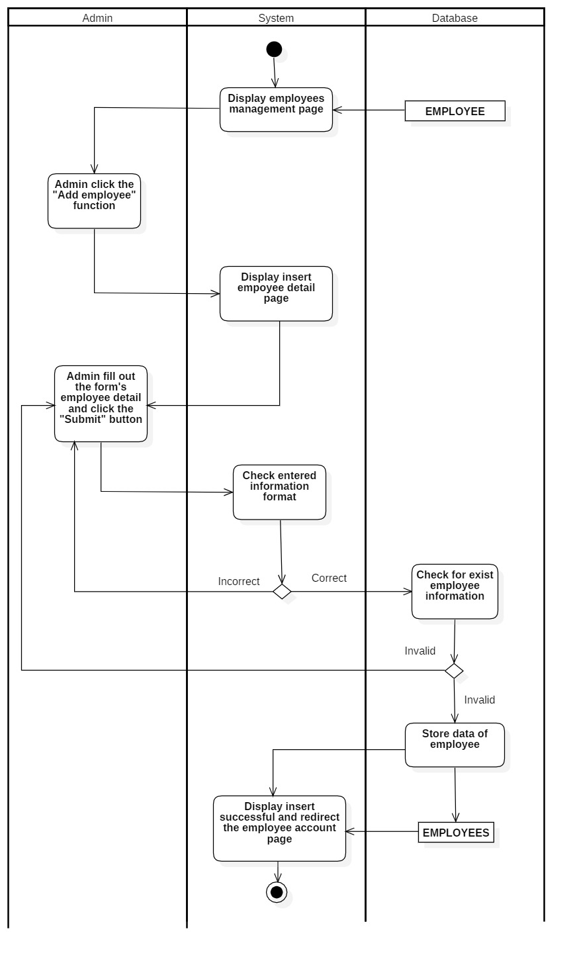

#### **3.2.9.2 Delete employee**

|  |  |
| --- | --- |
| User-case name | Delete emloyee |
| Description | Admin deletes a empplyee’s account |
| Trigger | Admin clicks on the “Delete "button to delete a employee |
| Pre-condition | The admin must be able to connect to the internet  The account must not exist on the database. |
| Post-condition | There is a successful Delete message  Redirect to employee’s information page |
| Basic flow | 1. Admin access to employee management page 2. Admin searches and clicks the "Delete" button to delete employees 3. The employee data is being removed in the database(if it can’t be delete, displays error notification) 4. The system shows successfully deleted employee notification and redirect to employee management page |
| Alternative flow | 3a. Show coupons that do not exist or there is an error when deleting  The usecase continues from step 2. |
| Exception flow |  |

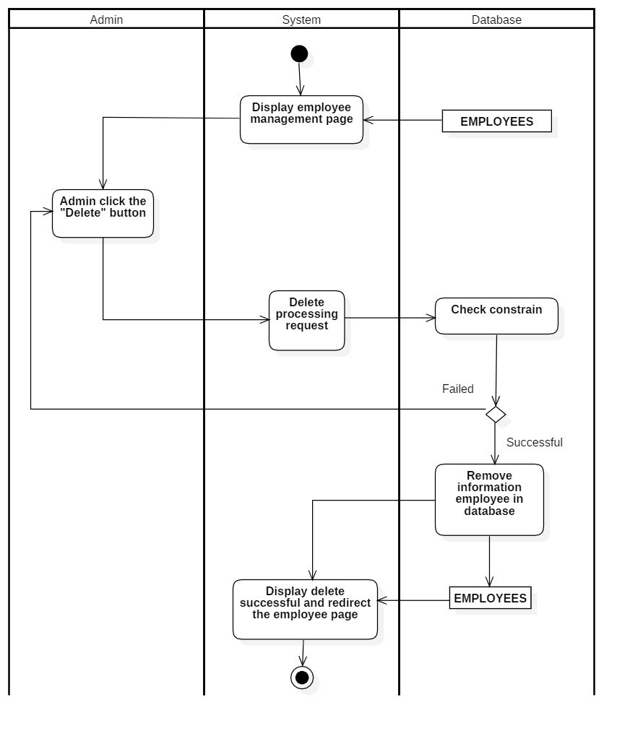

#### **3.2.9.3 Search employee**

|  |  |
| --- | --- |
| User-case name | Search customer |
| Description | Admin types in the employee’s name to search |
| Trigger | The admin clicks the “Search” button to search |
| Pre-condition | The admin must be able to connect to the internet  The account must log in beforehand |
| Post-condition | Redirect to customer page |
| Basic flow | 1. The system displays the employee account management page 2. Admin enter keywords (employee’s name) 3. The system searches for customer data (if there are no customers have the same name displays no matching notifications) 4. Display search results |
| Alternative flow |  |
| Exception flow |  |

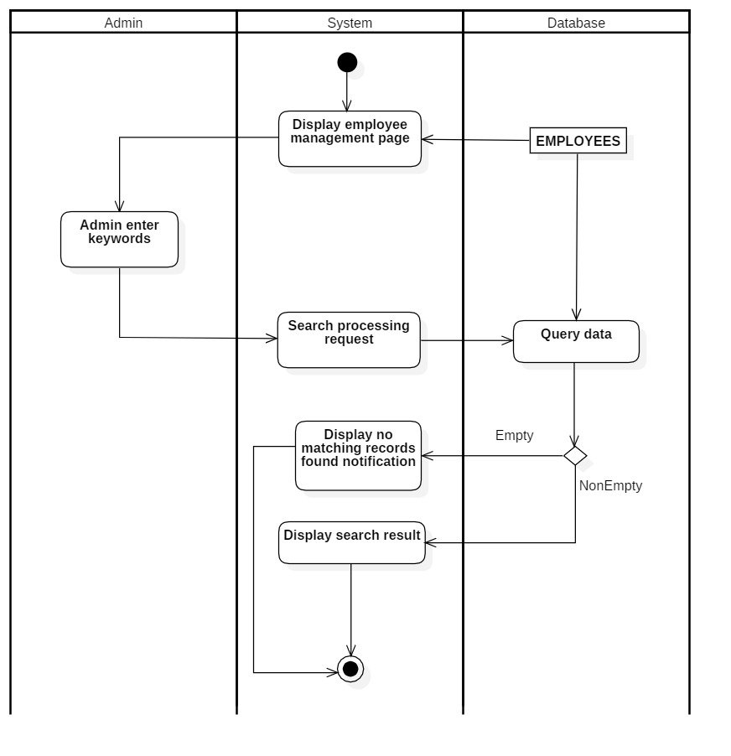

#### **3.2.9.4 Filter employee**

|  |  |
| --- | --- |
| User-case name | Filter employee |
| Description | Admin filters employee data to view |
| Trigger | The admin clicks the "Filter" button to filter the data |
| Pre-condition | The admin must be able to connect to the internet  The account must log in beforehand |
| Post-condition | Redirect to product page |
| Basic flow | 1. The system displays employee management page 2. Admin clicks "Filter" button 3. The system displays the information of the filtered employee (if there is the imformation needed, if not display an empty page) |
| Alternative flow |  |
| Exception flow |  |

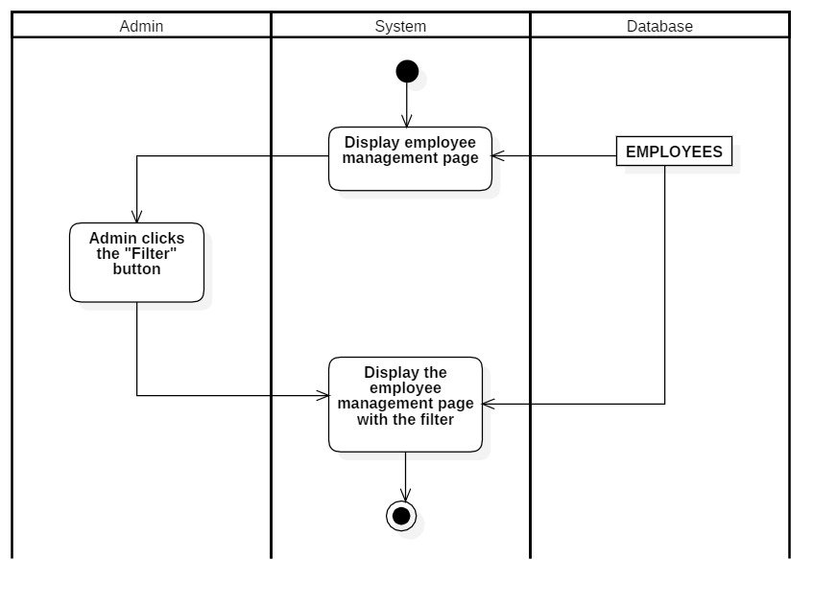

#### **3.2.9.5 View employee**

|  |  |
| --- | --- |
| User-case name | View employee |
| Description | Admin view employee information detail |
| Trigger | Admin clicks the "View" button in the employee page to see details |
| Pre-condition | The admin must be able to connect to the internet  The account must loggedin beforehand. |
| Post-condition | Redirect to detail employee page |
| Basic flow | 1. The system displays the employee page 2. Admin clicks "View" to view employee details 3. The system checks employee information on the database and draws it out 4. The system displays employee details |
| Alternative flow |  |
| Exception flow |  |

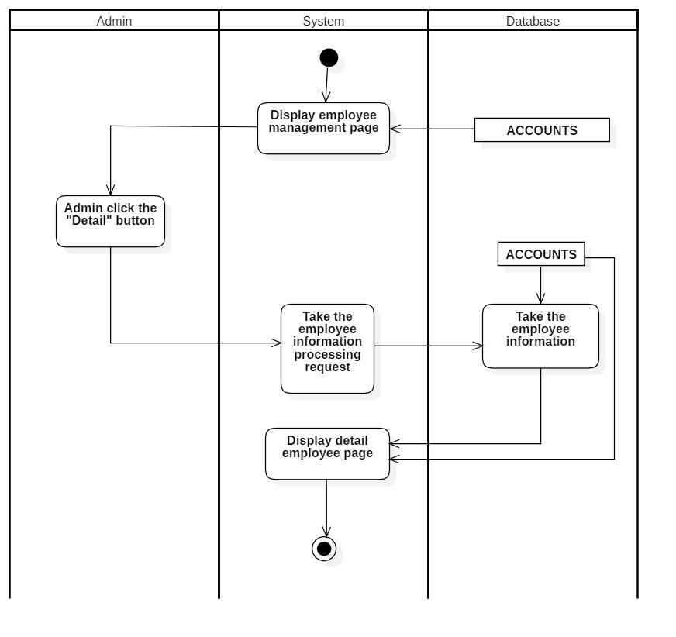

#### **3.2.9.6 Update employee**

|  |  |
| --- | --- |
| User-case name | Update employee |
| Description | Admin update employee |
| Trigger | Admin searches and clicks the "Update" button to employee |
| Pre-condition | The admin must be able to connect to the internet.  The account must be logged in beforehand |
| Post-condition | There is a successful update message  Redirect to employee page |
| Basic flow | 1. Admin accesses employee management page 2. Admin clicks the "Detail" button to update employee 3. The system display the detail employee update page 4. Admin updates the employee's information 5. The system checks whether employee information is in the correct format (if not, re-do step 4) 6. The employee information is being updated in the database 7. The system shows successful employee updated notification and redirect to employee management page |
| Alternative flow | 5a. Displays invalid information due to incorrect employee format  Usecase continues from step 3 |
| Exception flow |  |

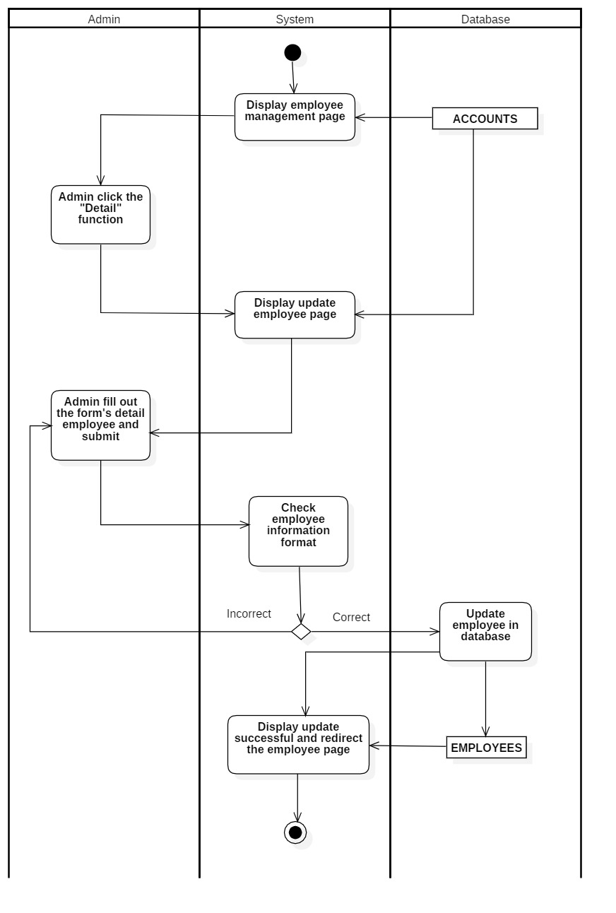

### **3.2.****10 Statistical and report**

#### **3.2.10.1 Export revenue report**

|  |  |
| --- | --- |
| User-case name | Export revenue report |
| Description | Admin viewed and exported the revenue report order |
| Trigger | Admin clicked “Export order report” function to a report |
| Pre-condition | The admin must be able to connect to the internet  The account must log in beforehand |
| Post-condition | Redirect to report page |
| Basic flow | 1. The system displays order report page 2. The admin picks startdate and enddate 3. The system takes the purchase_history information 4. Admin clicks "Export revenue" to export the report |
| Alternative flow |  |
| Exception flow |  |

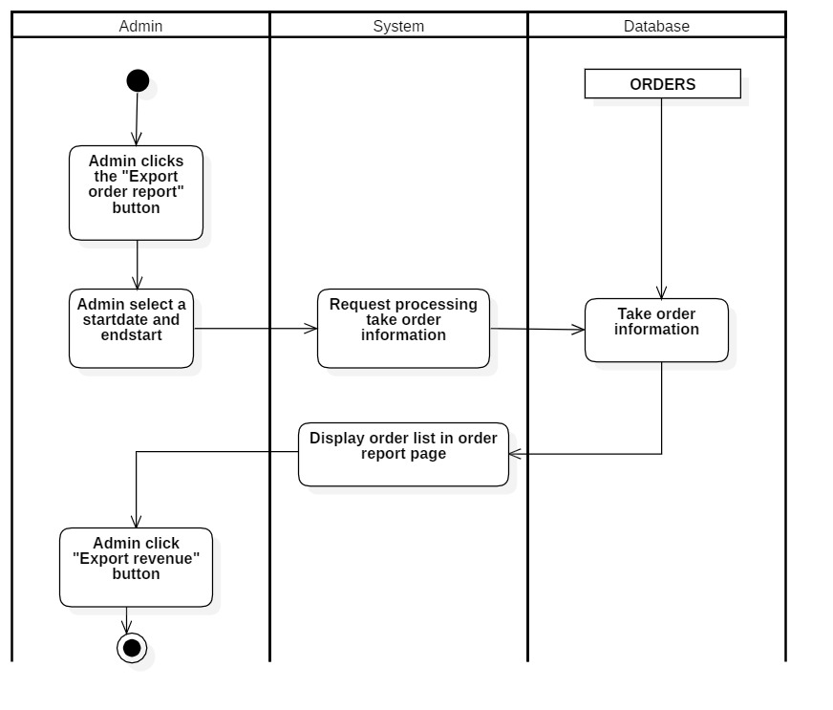

#### **3.2.10.2 Export products report**

|  |  |
| --- | --- |
| User-case name | Export products report |
| Description | Admin view and export reports about purchased products |
| Trigger | Admin clicks the “Export products report”function to export the reports |
| Pre-condition | The admin must be able to connect to the internet  The account must log in beforehand |
| Post-condition | Redirect to report page |
| Basic flow | 1. The system takes the product information on the database 2. The system displays product list in product report page 3. Admin clicks "Export report" button |
| Alternative flow |  |
| Exception flow |  |

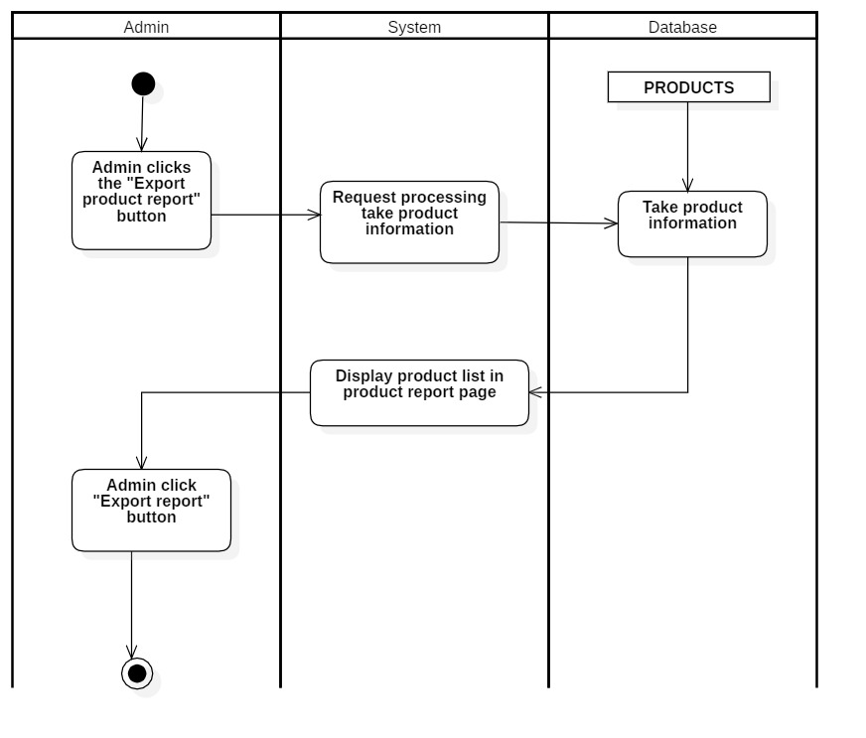

#### **3.2.10.3 Export customer report**

|  |  |
| --- | --- |
| User-case name | Export customer report |
| Description | Admin view and export reports of the purchased products |
| Trigger | Admin clicks the “Export Customer Report” function to export reports |
| Pre-condition | The admin must be able to connect to the internet  The account must log in beforehand |
| Post-condition | Redirect to report page |
| Basic flow | 1. The system takes the customer information on the database 2. Display customer list in customer report page 3. Admin clicks the "Export Customer " button |
| Alternative flow |  |
| Exception flow |  |

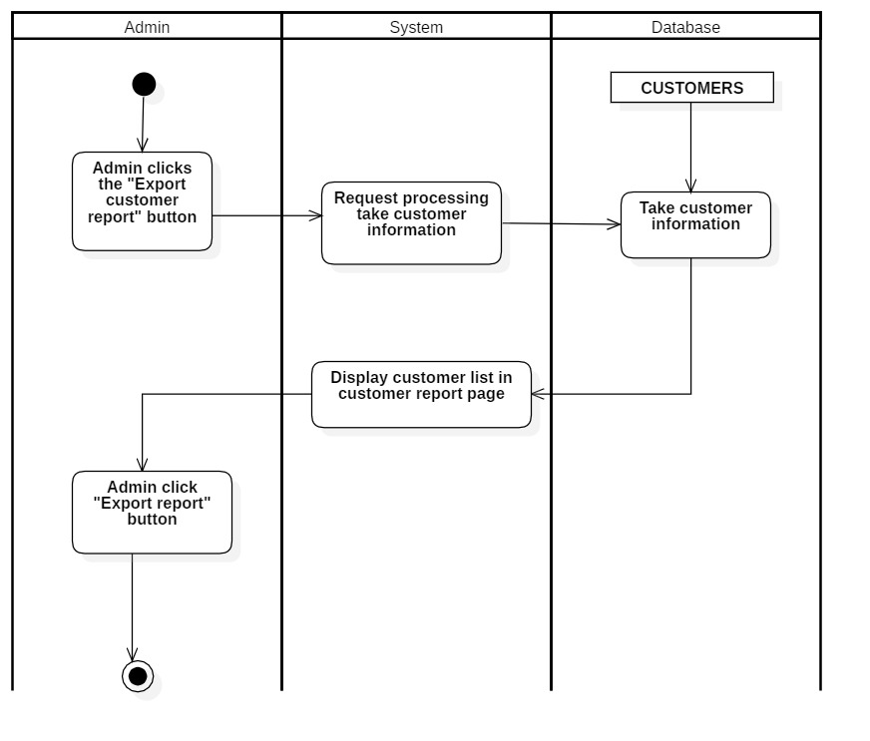

### **3.2.11 Log in(for users)**

|  |  |
| --- | --- |
| User-case name | Log in(for users) |
| Description | Users use their accounts to log in with user permissions and can edit their personal information |
| Trigger | The user presses the "Log in" button to log into the system |
| Pre-condition | The user must be able to connect to the internet.  The account must be available on the database |
| Post-condition | There is a successful login message  Redirect to the user page |
| Basic flow | 1. The system display sign-in page 2. User enters email and password and presses confirmation to log in 3. The system checks whether the Email and password check are in the correct format (if not, display error notification and re-do step 2) 4. The system checks Whether the email and password have already existed on the database (if do, display error notification and re-do step 2) 5. Store sign-in status 6. The system shows successful login notifications and redirect to homepage |
| Alternative flow | 3a. Showing invalid information due to incorrect email formatting  The usecase continues from step 2.  4a. Display incorrect account or password information  The usecase continues from step 2. |
| Exception flow |  |

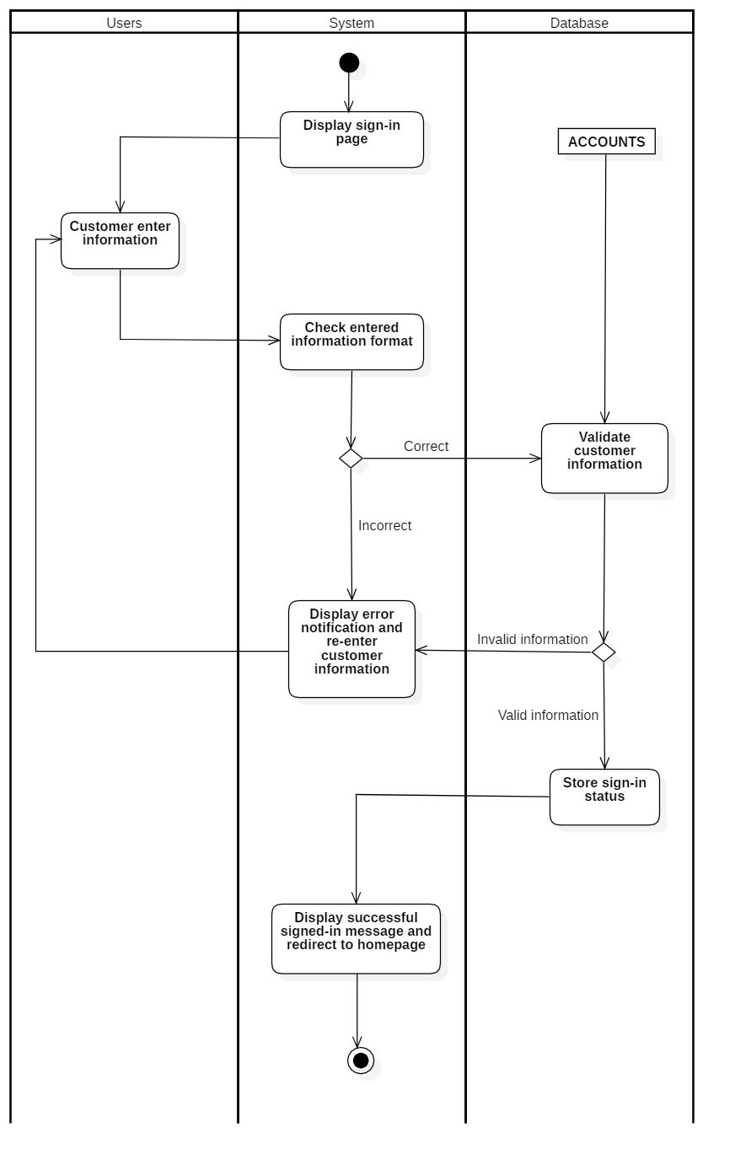

### **3.2.12 Log out(for users)**

|  |  |
| --- | --- |
| User-case name | Log out (for admin) |
| Description | User logout from the account |
| Trigger | User clicks the “Log out” button to logout from the system |
| Pre-condition | The user must be able to connect to the internet  The user account must log in beforehand |
| Post-condition | There is a successful sign-out message  Redirect to log in page |
| Basic flow | 1. User clicks the "Log out" button to sign out of the system 2. The system destroys session 3. The system announces the successful logout and redirect to homepage |
| Alternative flow |  |
| Exception flow |  |

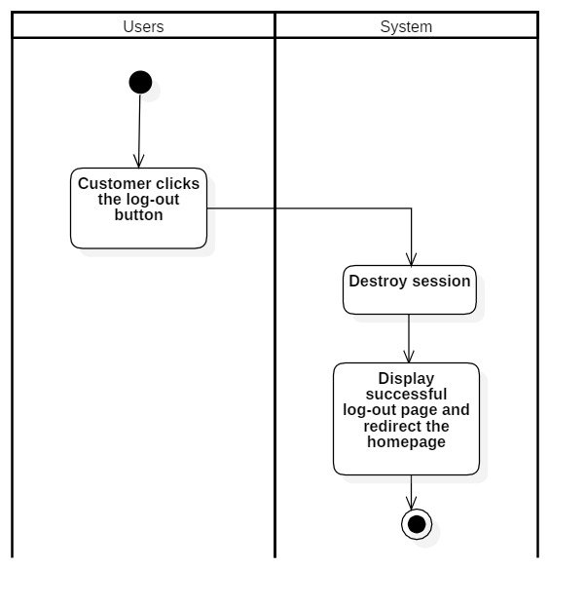

### **3.2.13 Register(for users)**

|  |  |
| --- | --- |
| User-case name | Register (for users) |
| Description | Users sign up for a new account |
| Trigger | The user clicks on the "Create a new account" button to create an account |
| Pre-condition | The user must be able to connect to the internet  The user account must log in beforehand |
| Post-condition | There are further announcements of success  Redirect to the user's homepage page |
| Basic flow | 1. System displays log-in page 2. User clicks the "Create a new account" button to create a new account 3. The system displays the insert detail account page 4. User enters fill out the information form 5. The system checks whether the user inputed information is in the correct format (if not, re-do step 4) 6. The system checks whether the user account has already existed on the database (if does, re-do step 4) 7. The systemdisplays successful inserted notification and redirect to the user's homepage |
| Alternative flow | 5a. Display invalid information due to incorrect user or pass format  Usecase continues from step 3  6a. Show that account information already exists  Usecase continues from step 3 |
| Exception flow |  |

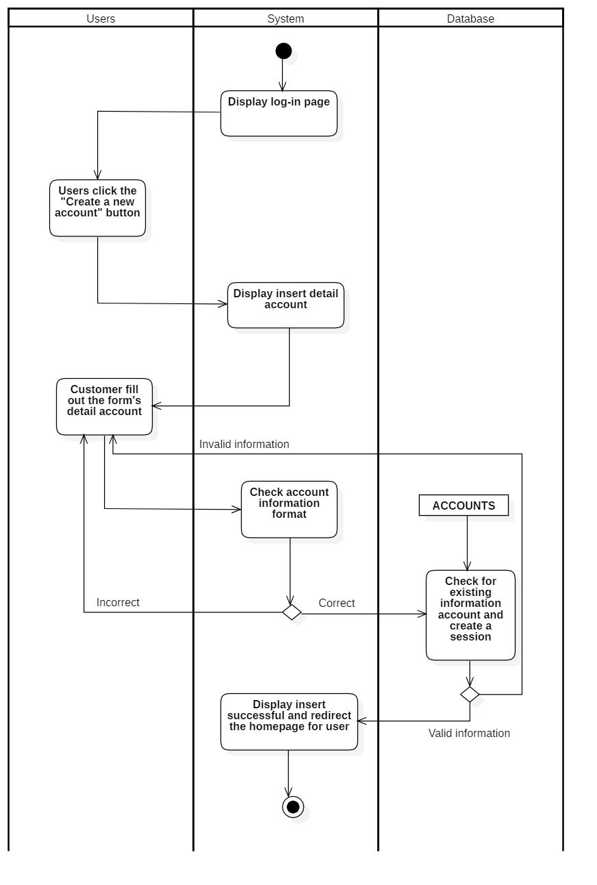

### **3.2.14 Personal account management**

#### **3.2.14.1 View account**

|  |  |
| --- | --- |
| User-case name | View account |
| Description | Users view their details information on the homepage |
| Trigger | The user clicks the "User" button in the homepage to see the details |
| Pre-condition | The user must be able to connect to the internet.  The account must be logged in beforehand. |
| Post-condition | Redirect to the detail account page |
| Basic flow | 1. The system displays the homepage 2. User clicks "User" to see his or her account details 3. The system takes the customers information from the database 4. The system displays account details |
| Alternative flow |  |
| Exception flow |  |

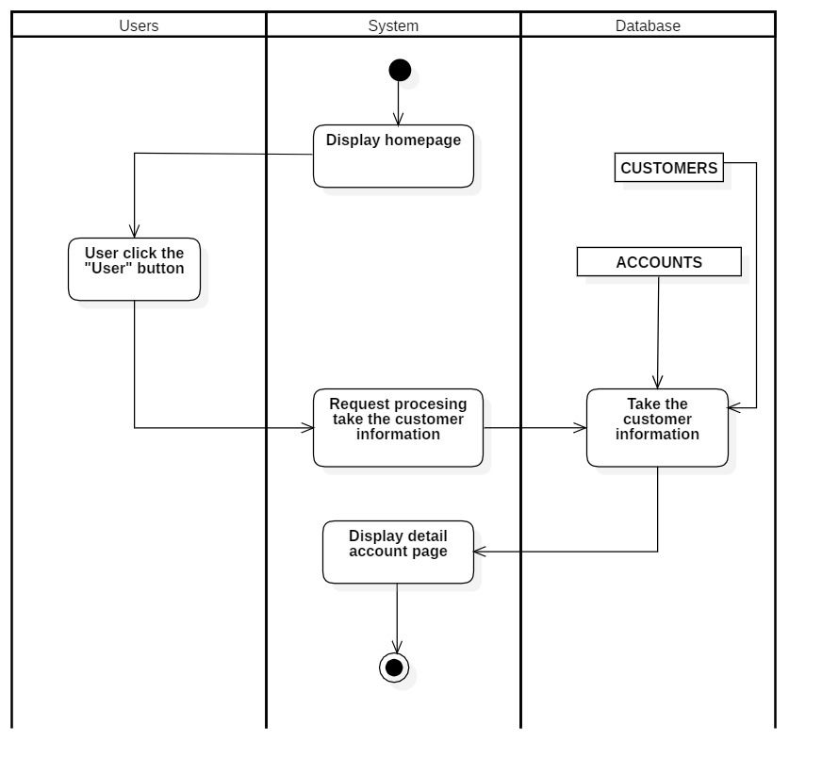

#### **3.2.14.2 Update account**

|  |  |
| --- | --- |
| User-case name | Update account |
| Description | User update account the account |
| Trigger | User searches and taps the "Update" button to update their account |
| Pre-condition | The user must be able to connect to the internet.  The account must be logged in beforehand. |
| Post-condition | The user must be able to connect to the internet.  The account must be logged in beforehand. |
| Basic flow | 1. System displays account page 2. User clicks the "Update" button to update the account 3. The system displays the Account update page 4. User fills out the information that needs to be edited 5. The system checks whether the account information is in the correct format (if not,re-do step 4) 6. The system shows Successful account update notification and redirect the log-in page |
| Alternative flow | 5a. Showing invalid information due to entering the wrong account in the wrong format  Usecase continues from step 3 |
| Exception flow |  |

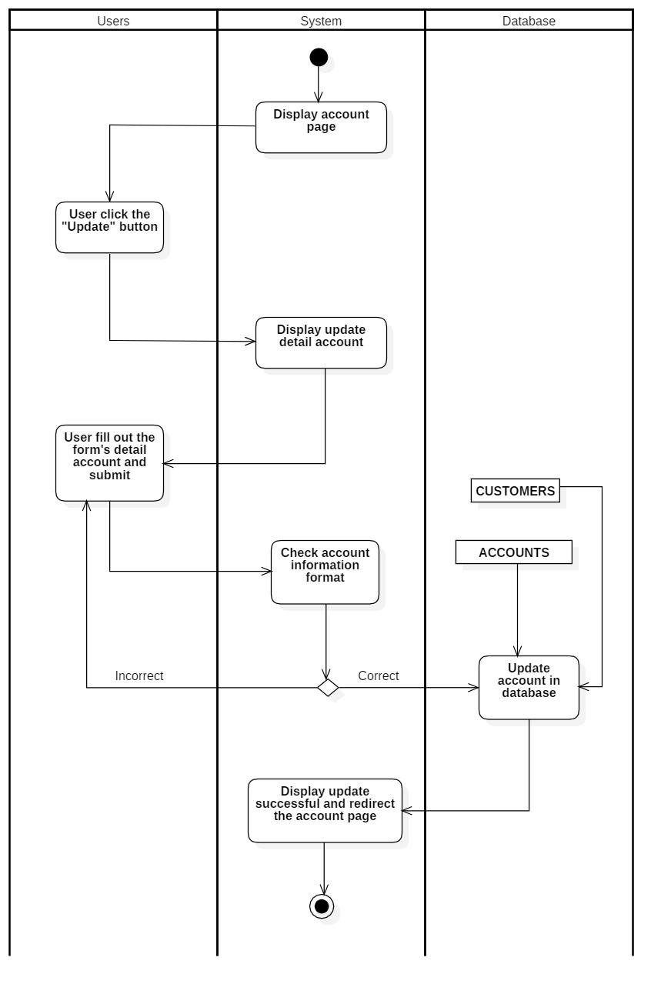

### **3.2.15 Cart management**

#### **3.2.15.1 View cart**

|  |  |
| --- | --- |
| User-case name | View cart |
| Description | The users view their cart. |
| Trigger | The user clicks the "Cart" button to view the cart's information |
| Pre-condition | The user must be able to connect to the internet.  The account must be logged in beforehand. |
| Post-condition | Redirect detail cart page |
| Basic flow | 1. The system displays the homepage 2. Admin clicks the "Cart" button to view cart details 3. The system takes cart information from the database 4. The system displays detailed information about the cart |
| Alternative flow |  |
| Exception flow |  |

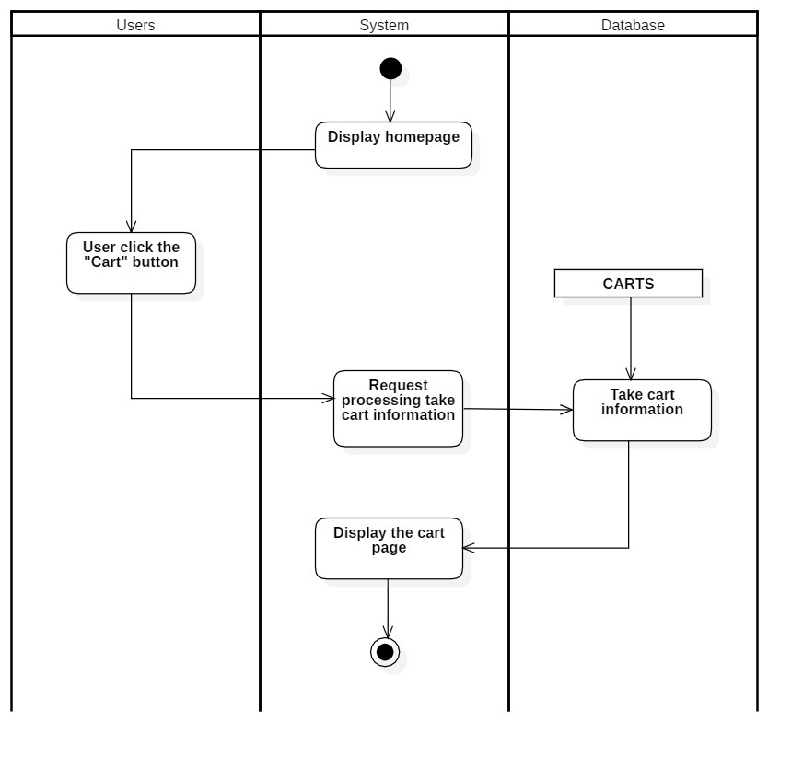

#### **3.2.15.2 Update number of product**

|  |  |
| --- | --- |
| User-case name | Update cart |
| Description | Users update their cart |
| Trigger | The users enter the number of products and click the "Update" button to update their cart |
| Pre-condition | The user must be able to connect to the internet.  The account must be logged in beforehand |
| Post-condition | There is a successful update message  Redirect to cart page |
| Basic flow | 1. Users access the cart page 2. User enters the number and clicks on the "Update" button to update the cart 3. The system checks whether Quantity is smaller than the number of products on the database à if true 4. The system updates the cart 5. The system shows the successful update cart notification |
| Alternative flow | 3a. Showing invalid information due to entering a quantity that exceeds the actual number or entering a negative number  Usecase continues from step 1 |
| Exception flow |  |

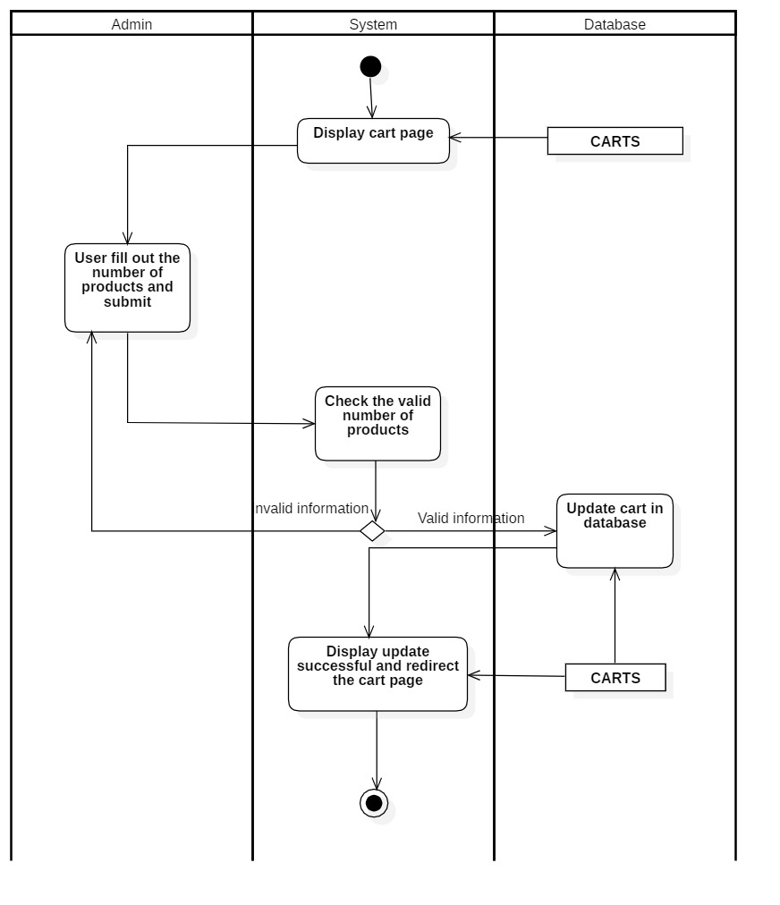

#### **3.2.15.3 Update cart**

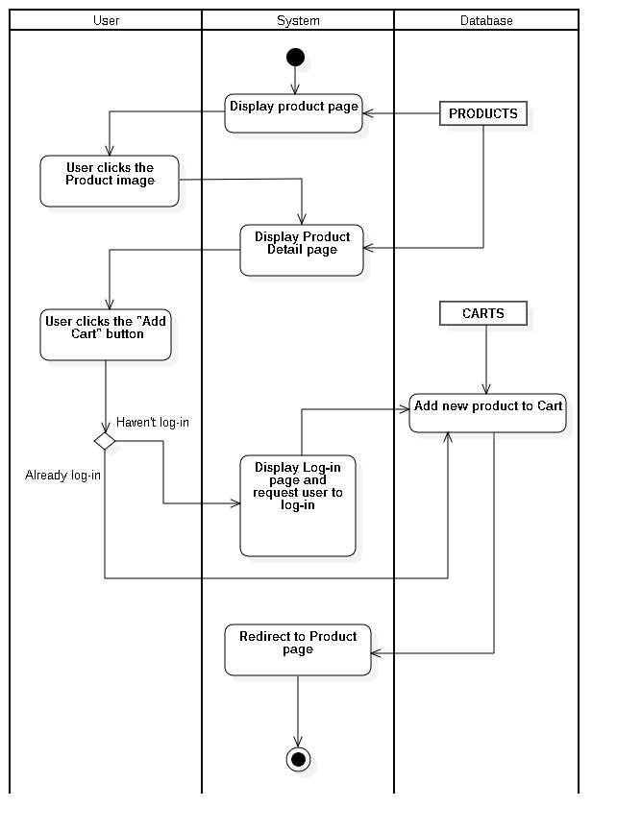

#### **3.2.15.4 Delete cart**

|  |  |
| --- | --- |
| User-case name | Delete cart |
| Description | Users delete their cart |
| Trigger | The user clicks the "Delete" button to perform cart deletion |
| Pre-condition | The user must be able to connect to the internet.  The account must exist on a database |
| Post-condition | There is a successful deletion message  Redirect to account page |
| Basic flow | 1. Users access cart page 2. Users click the "Delete" button to delete their cart 3. The system checks whether the cart has already exited on database if true 4. The system deletes the cart data 5. The system shows successful delete cart notification |
| Alternative flow | 3a. Show cart information that doesn't exist or there's an error when deleting it  Usecase continues from step 1 |
| Exception flow |  |

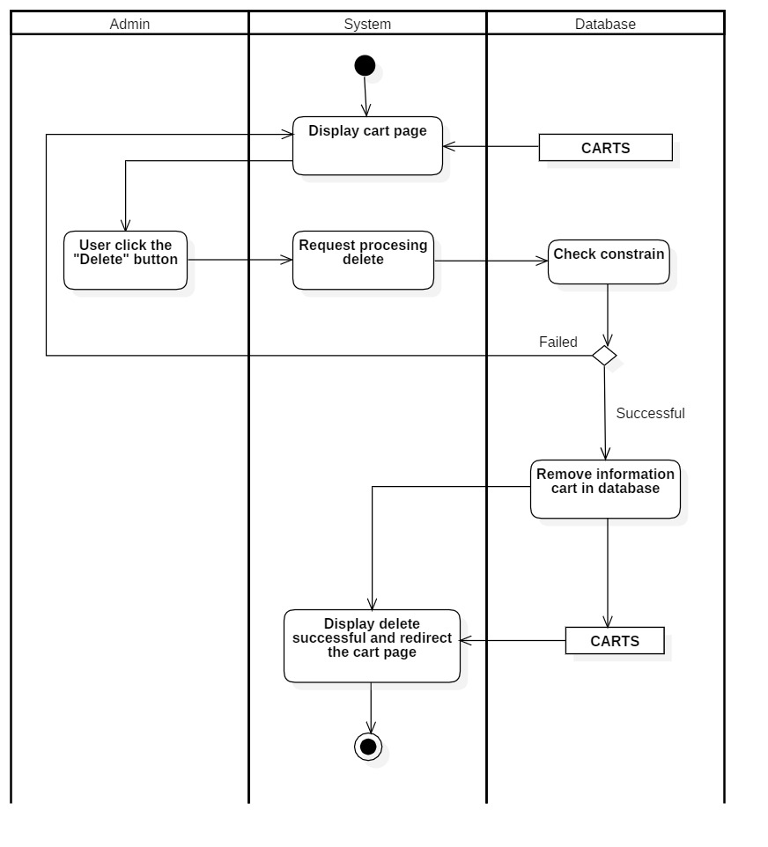

#### **3.2.15.5 Payment**

|  |  |
| --- | --- |
| User-case name | Payment |
| Description | User confirms payment |
| Trigger | The user presses the "Payment" button to make a payment |
| Pre-condition | The user must be able to connect to the internet.  The account must exist on a database |
| Post-condition | There is a payment message that has entered the queue successfully  Redirect to the homepage page |
| Basic flow | 1. User access cart page 2. User clicks the "Payment" button to enter the invoice page 3. User clicks the "Confirm payment" button to confirm payment 4. The system adds invoices to the table "PAYMENTS" 5. The system deletes cart data 6. The system shows Successful payment confirm notification |
| Alternative flow |  |
| Exception flow |  |

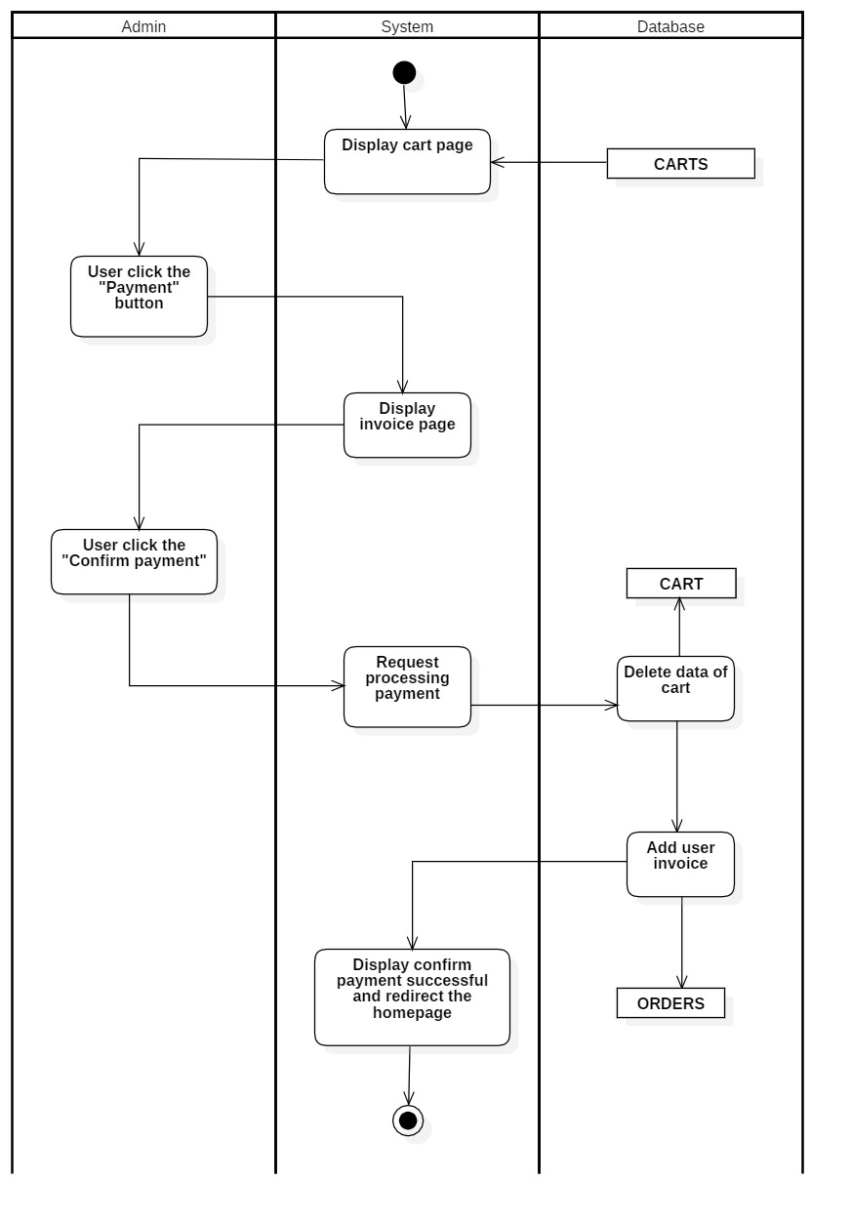

### **3.2.16 Orders management**

#### **3.2.16.1 View order**

|  |  |
| --- | --- |
| User-case name | View order |
| Description | The users view their order. |
| Trigger | The user clicks the "Orders" button to see the order's information |
| Pre-condition | The user must be able to connect to the internet.  The account must be logged in beforehand. |
| Post-condition | Redirect to order’s detail page |
| Basic flow | 1. The system displays the account page 2. User clicks "Your Order" to view the details of the order 3. The system takes the order information from the database 4. The system displays the order details page |
| Alternative flow |  |
| Exception flow |  |

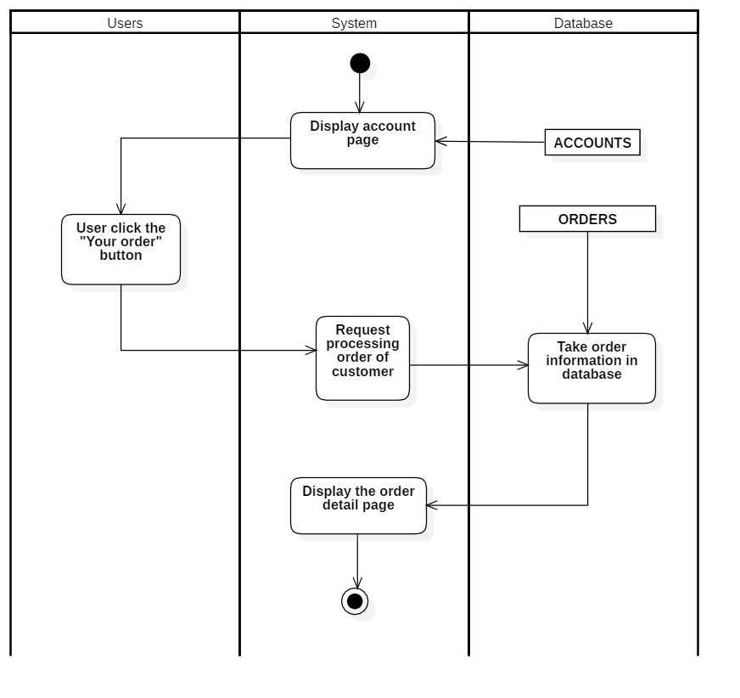

#### **3.2.16.2 Cancel order**

|  |  |
| --- | --- |
| User-case name | Cancel order |
| Description | Users cancel their order |
| Trigger | The user presses the "Cancel" button to perform the deletion of the order |
| Pre-condition | The user must be able to connect to the internet.  The account must exist on a database |
| Post-condition | There was a successful cancellation announcement.  Redirect to the order page |
| Basic flow | 1. System displays order page 2. User clicks the "Cancel" button 3. The system checks the order information in the database (if not waiting status, return to order page) 4. The system shows the Successful cancel order notification and redirect to order page |
| Alternative flow | 3a. Show order information being shipped  Usecase continues from step 1 |
| Exception flow |  |

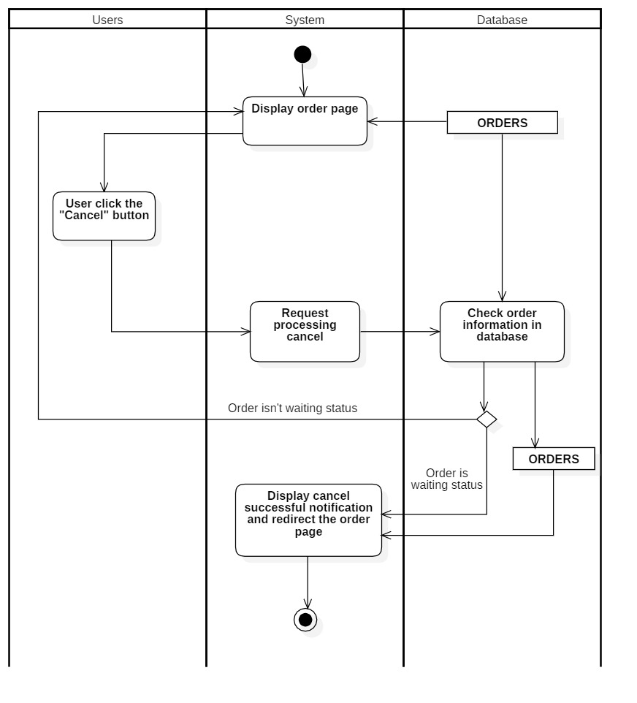

### **3.2.17 Purchase history management**

#### **3.2.17.1 View purchase history**

|  |  |
| --- | --- |
| User-case name | View purchase history |
| Description | Users view their purchase history |
| Trigger | User clicks the “Purchase History” button to view the purchased history |
| Pre-condition | The user must be able to connect to the internet.  The account must be logged in beforehand. |
| Post-condition | Redirect to the detail purchase history page |
| Basic flow | 1. The system displays the account page 2. User clicks "Purchase History" to see purchase history information 3. The system takes the purchase history from the database 4. The system shows purchase history information |
| Alternative flow |  |
| Exception flow |  |

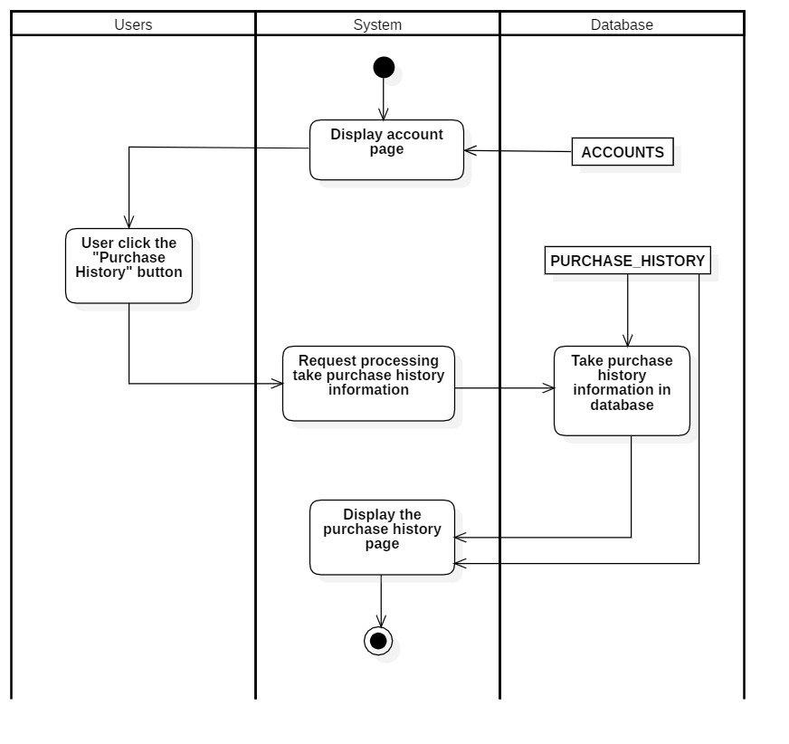

### **Product information**

#### **3.2.18.1 Search products**

|  |  |
| --- | --- |
| User-case name | Search products |
| Description | User search product to view |
| Trigger | The users enter the information they want to view and click the "Search" button to search |
| Pre-condition | The user must be able to connect to the internet.  The account must be logged in beforehand. |
| Post-condition | Redirect to product page |
| Basic flow | 1. The system displays product page 2. User enters Keywords 3. The system requests to search(if there are not product have the same keywords, display error notification and re-do step 2) 4. The system shows the information of the product searched |
| Alternative flow |  |
| Exception flow |  |



#### **3.2.18.2 View product**

|  |  |
| --- | --- |
| User-case name | View product |
| Description | User views the product |
| Trigger | User clicks the “Homepage” button to view |
| Pre-condition | The user must be able to connect to the internet.  The account must be logged in beforehand |
| Post-condition | Redirect to product page |
| Basic flow | 1. Admin clicks "Homepage" button 2. The system takes product information from the database 3. The system displays the product |
| Alternative flow |  |
| Exception flow |  |

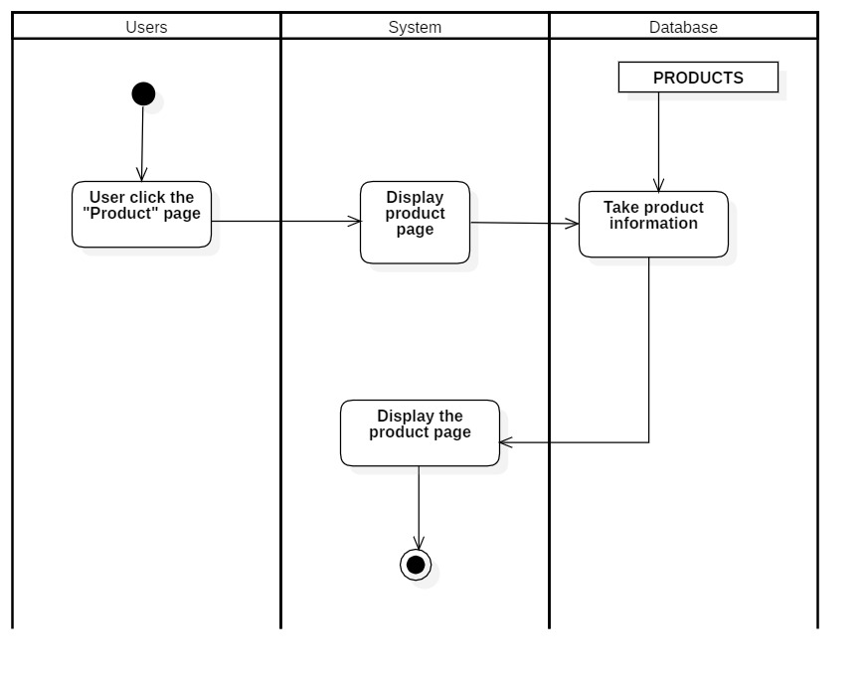

#### **3.2.18.3 View product detail**

|  |  |
| --- | --- |
| User-case name | View product detail |
| Description | Users review the product detail that they choose |
| Trigger | The user clicks on the "View" button to see the product details |
| Pre-condition | The user must be able to connect to the internet.  The account must be logged in beforehand |
| Post-condition | Redirect to product detail page |
| Basic flow | 1. The system displays the product page 2. User clicks the "Product picture" button 3. The system takes product detail information from the database 4. The system displays prodydetailed information |
| Alternative flow |  |
| Exception flow |  |

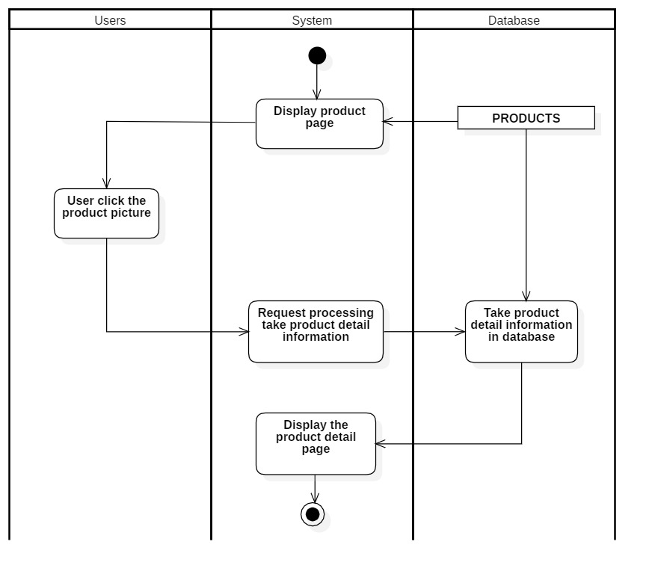

### **3.2.19 Checkout**

|  |  |
| --- | --- |
| User-case name | Checkout |
| Description | User confirms product payment |
| Trigger | The user presses the "Payment" button to make a payment |
| Pre-condition | The user must be able to connect to the internet.  The account must exist on a database |
| Post-condition | There is a payment message that has entered the queue successfully  Redirect to the homepage page |
| Basic flow | 1. User access Homepage page 2. User clicks the "Payment" button to enter the invoice page 3. User clicks the "Confirm payment" button to confirm payment 4. The system adds invoices to the table "PAYMENTS" 5. The system deletes cart data 6. The system shows successful payment confirmation notification |
| Alternative flow |  |
| Exception flow |  |

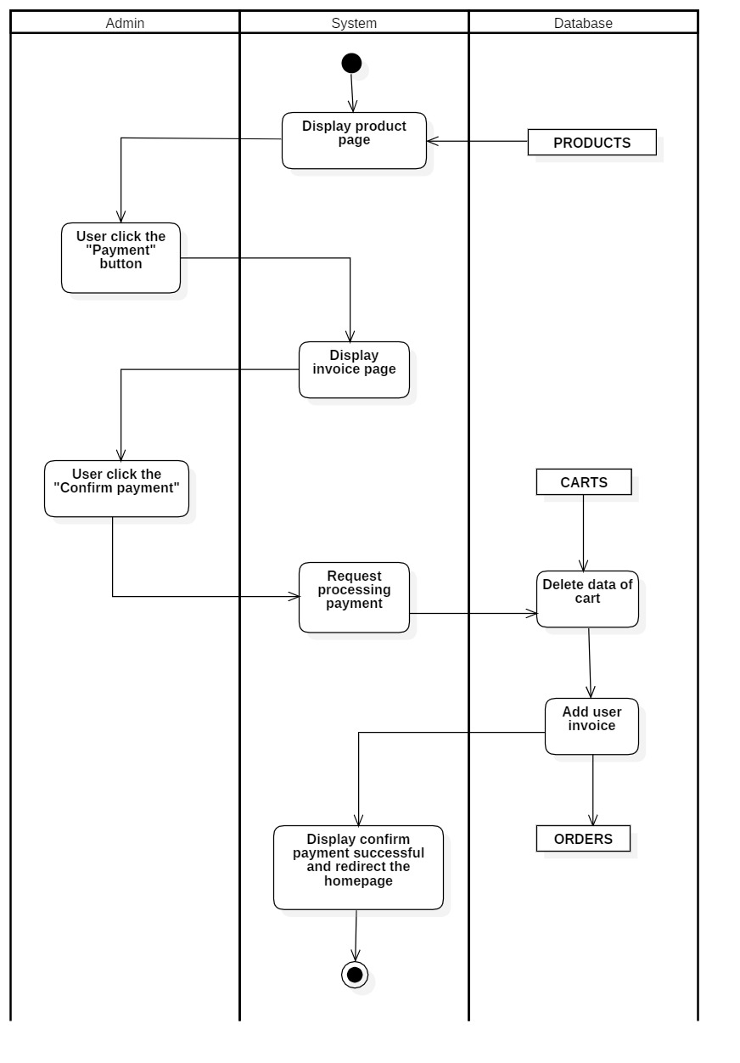

## **3.3 Sequence diagram and class diagram**

### **3.3.1 Log in (for admin)**

#### **3.3.1.1 Sequence diagram**

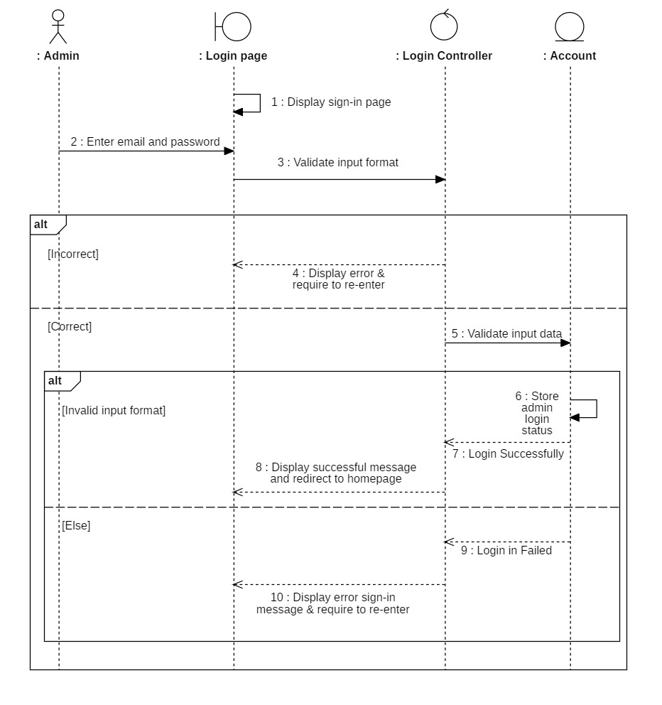

#### **3.3.1.2 Class diagram**

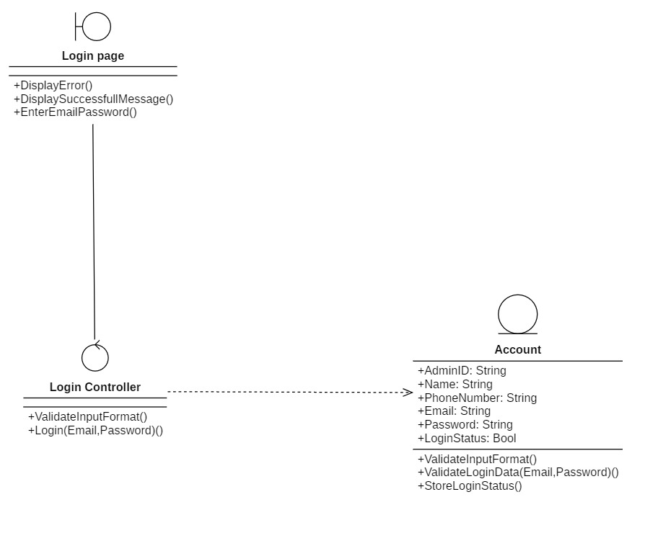

### **3.3.2 Log out (for admin)**

#### **3.3.2.1 Sequence diagram**

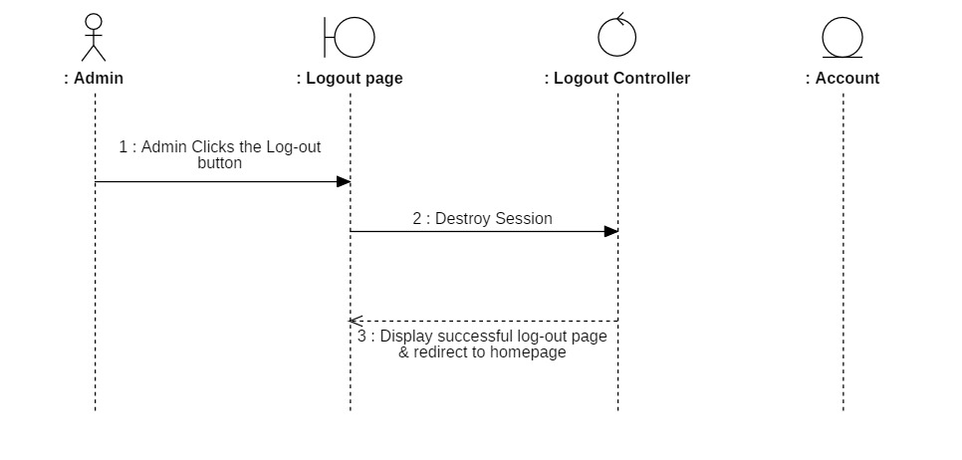

#### **3.3.2.2 Class diagram**

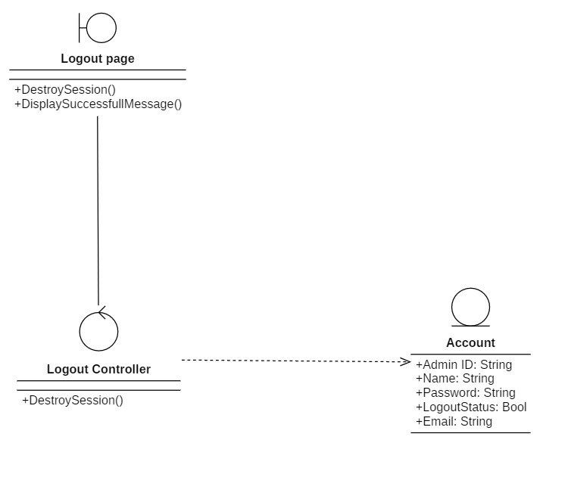

### **3.3.3 Coupons management**

#### **3.3.3.1 Sequence diagram**

##### **3.3.3.1.1 View coupons**

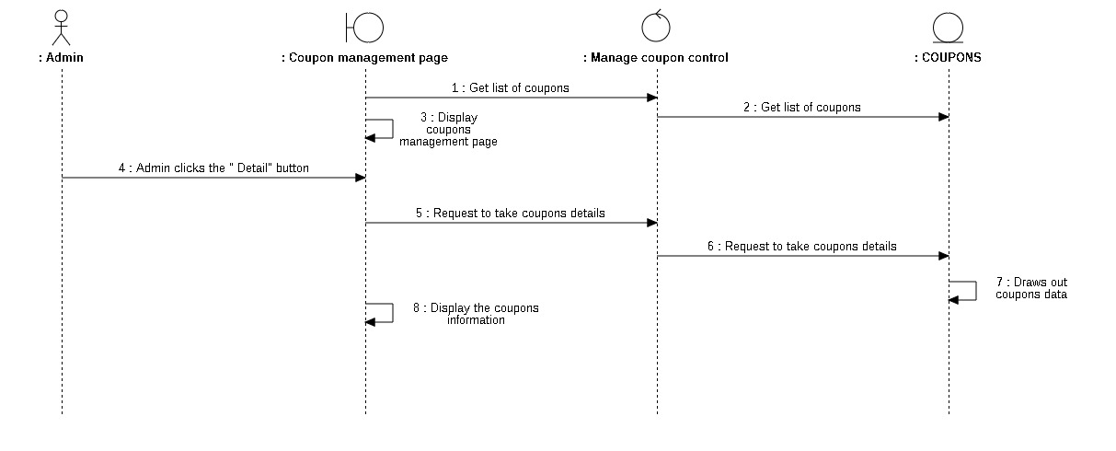

##### **3.3.3.1.2 Insert coupons**

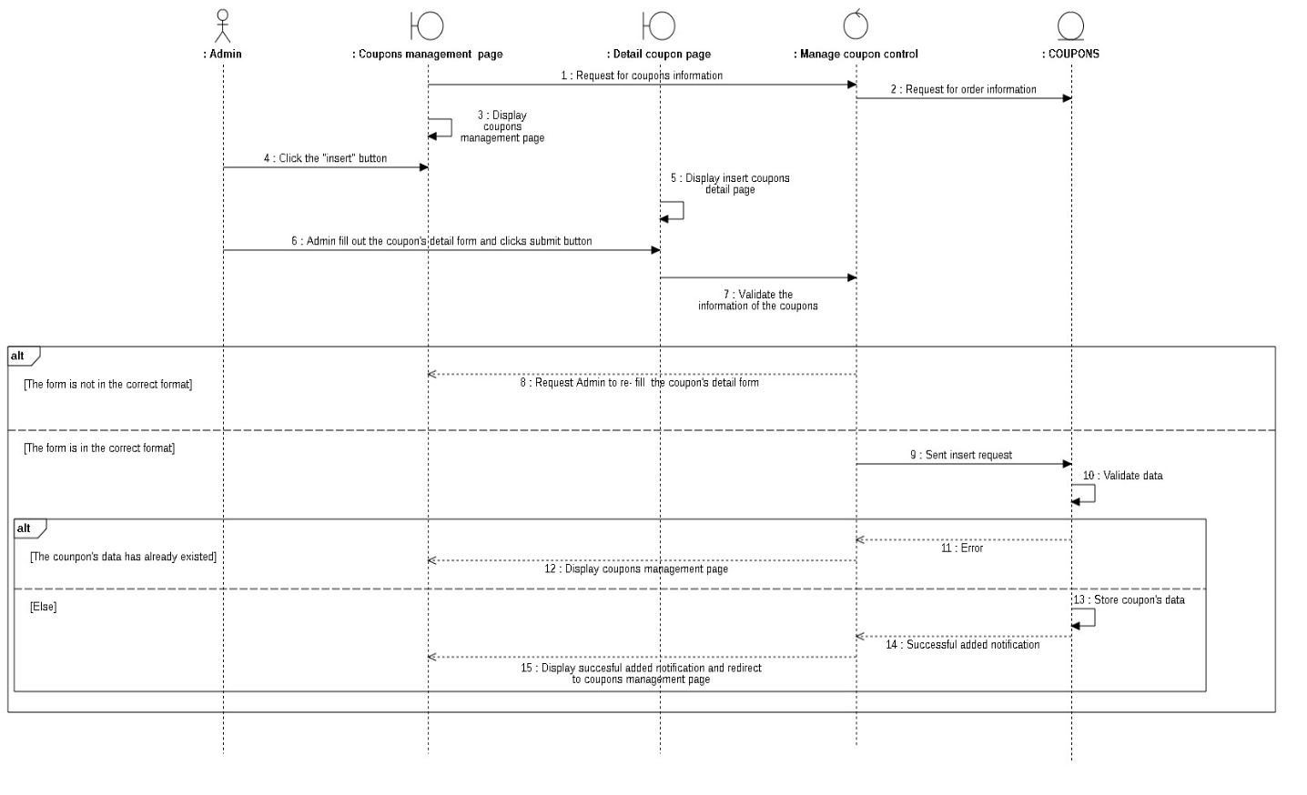

#### **3.3.3.2 Class Diagram**

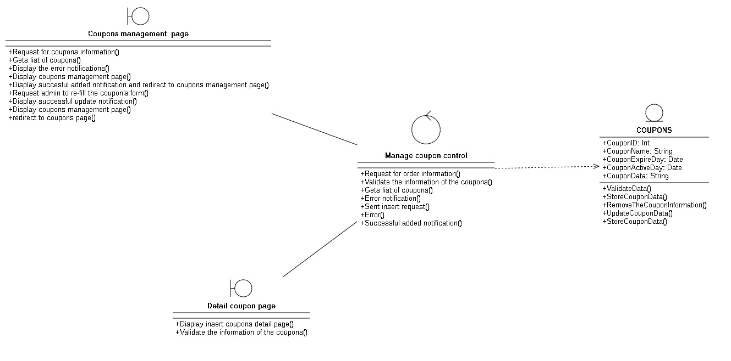

### **3.3.4 Category management**

#### **3.3.4.1 Sequence diagram**

##### **3.3.4.1.1 Insert category**

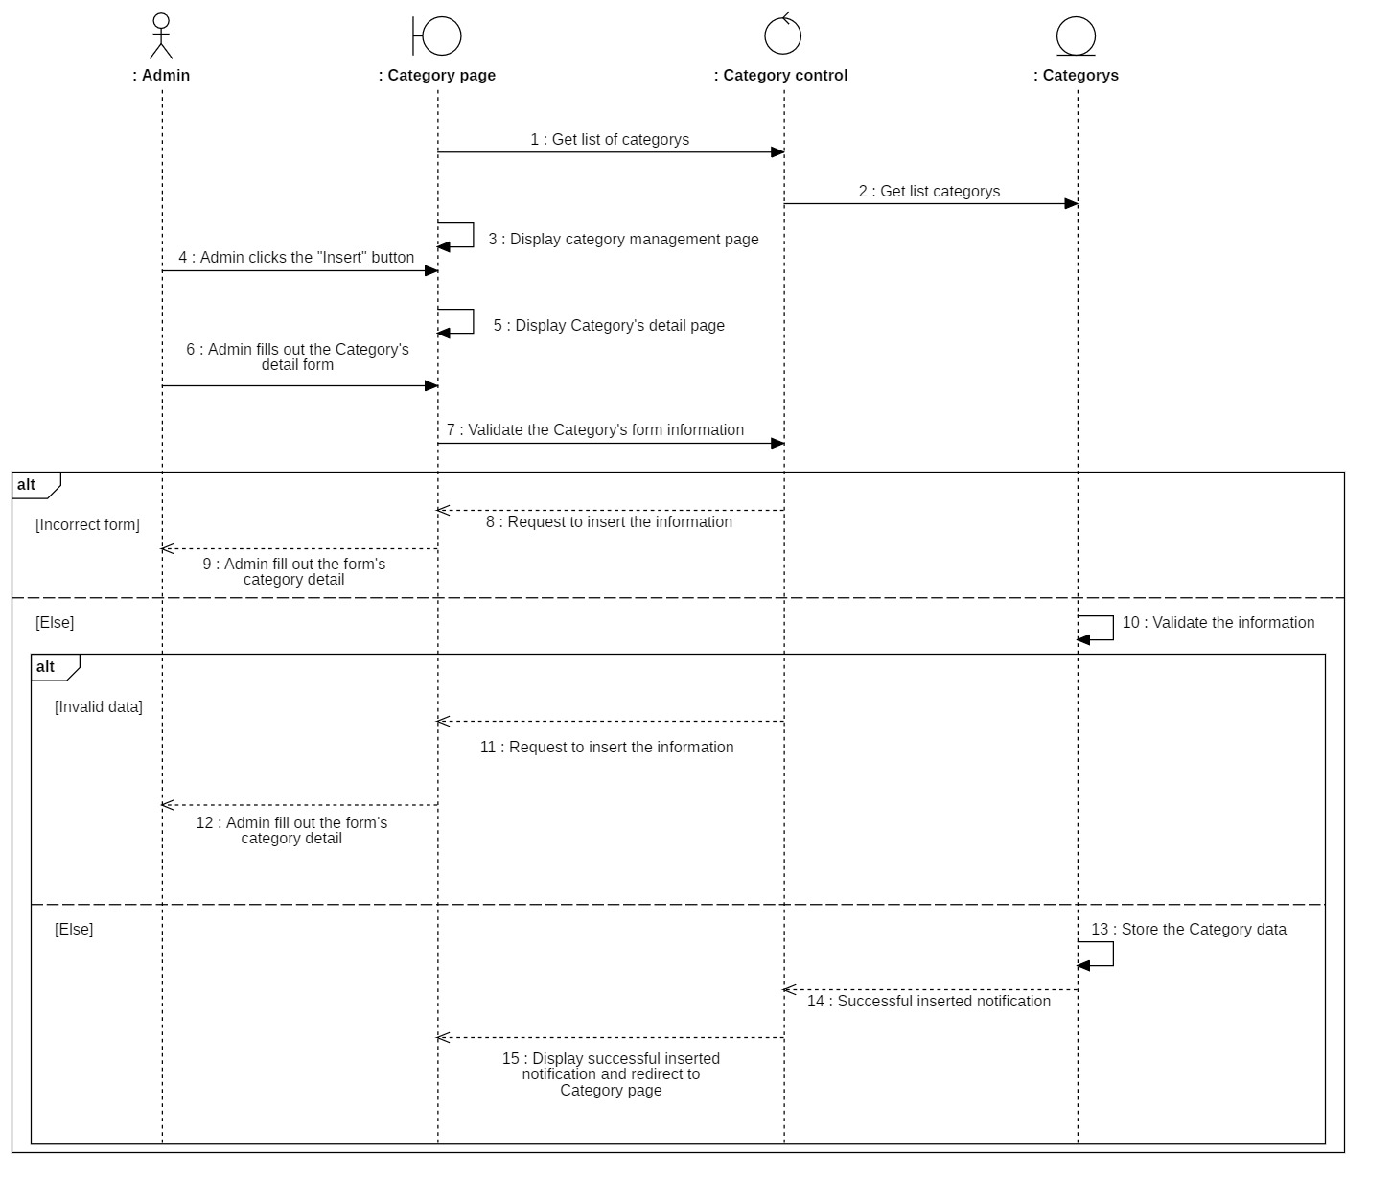

##### **3.3.4.1.2 Update category**

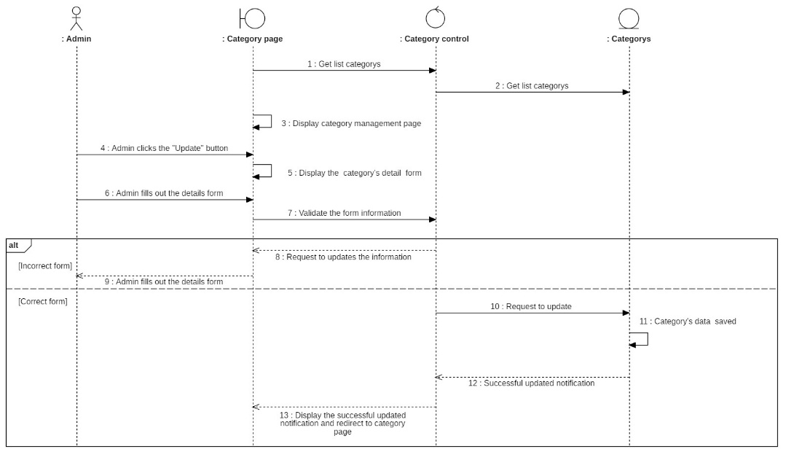

##### **3.3.4.1.3 View category**

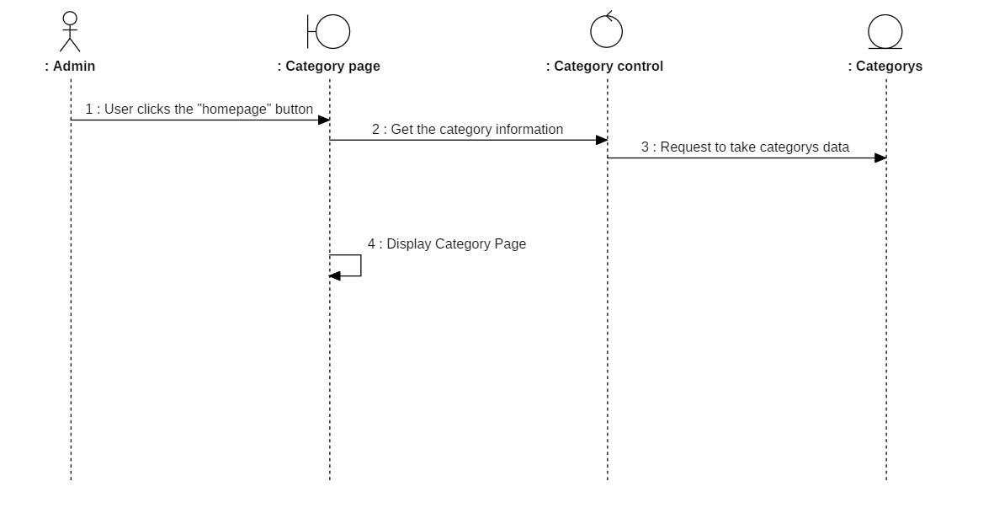

#### **3.3.4.2 Class diagram**

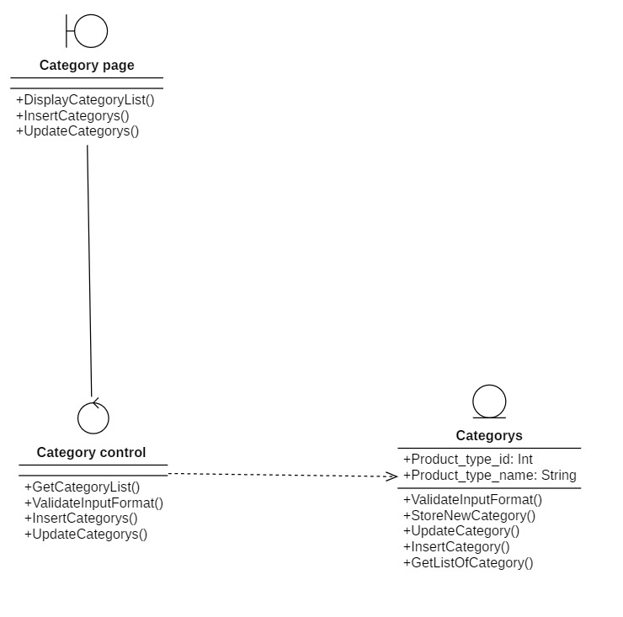

### **3.3.5 Supplier management**

#### **3.3.5.1 Sequence diagram**

##### **3.3.5.1.1 Update supplier**

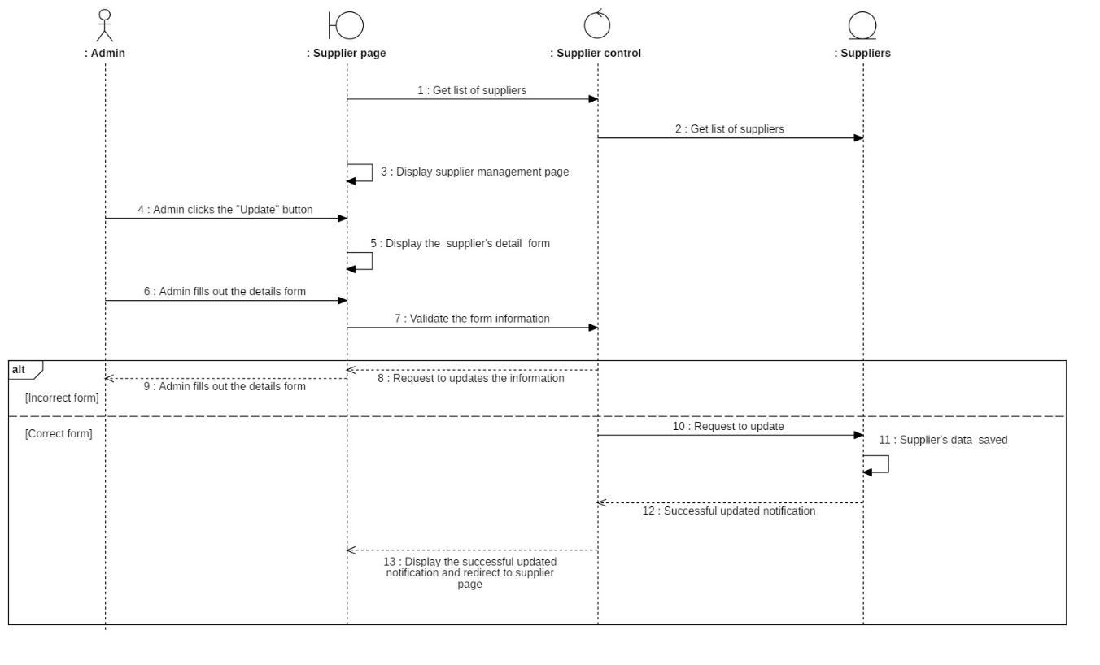

##### **3.3.5.1.2 Insert supplier**

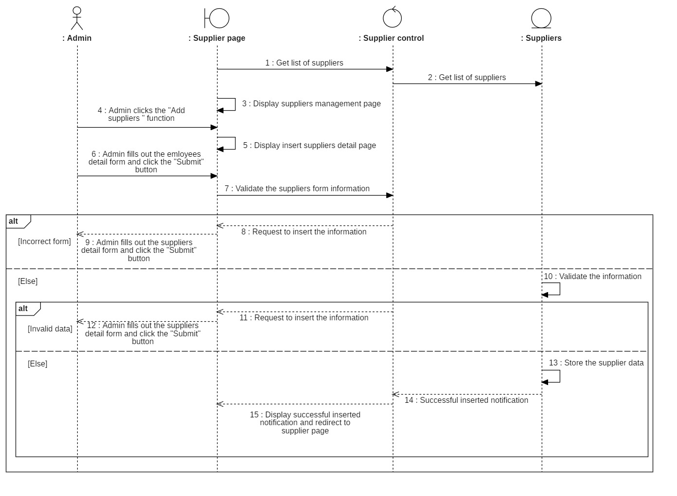

##### **3.3.5.1.3 Delete supplier**

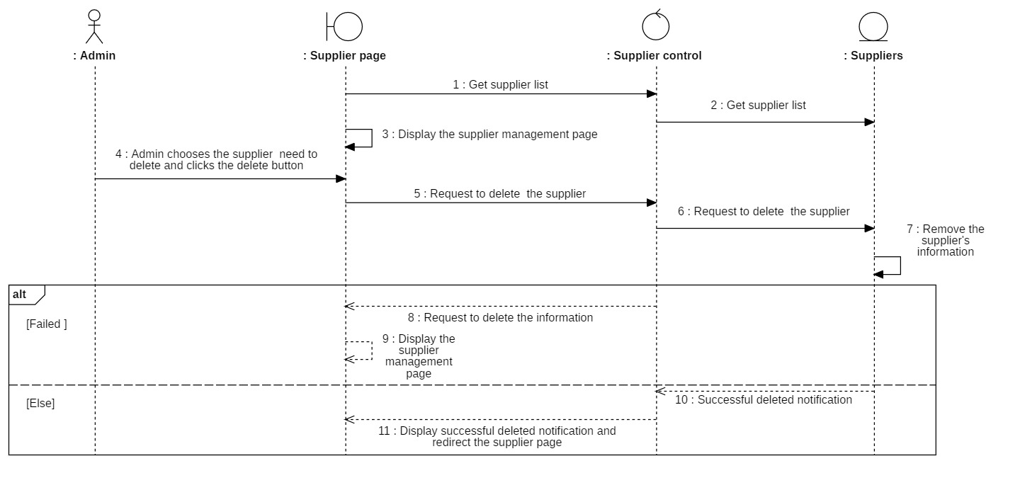

##### **3.3.5.1.4 View supplier**

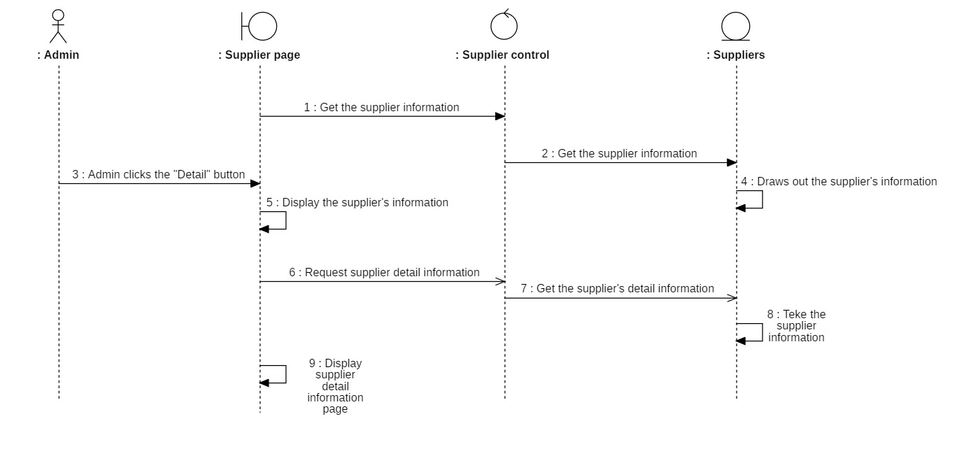

##### **3.3.5.1.5 Filter supplier**

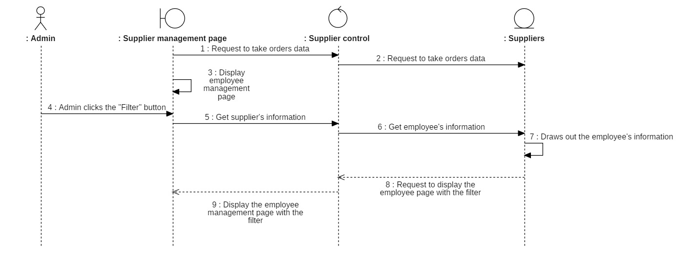

##### **3.3.6.1.6 Search supplier**

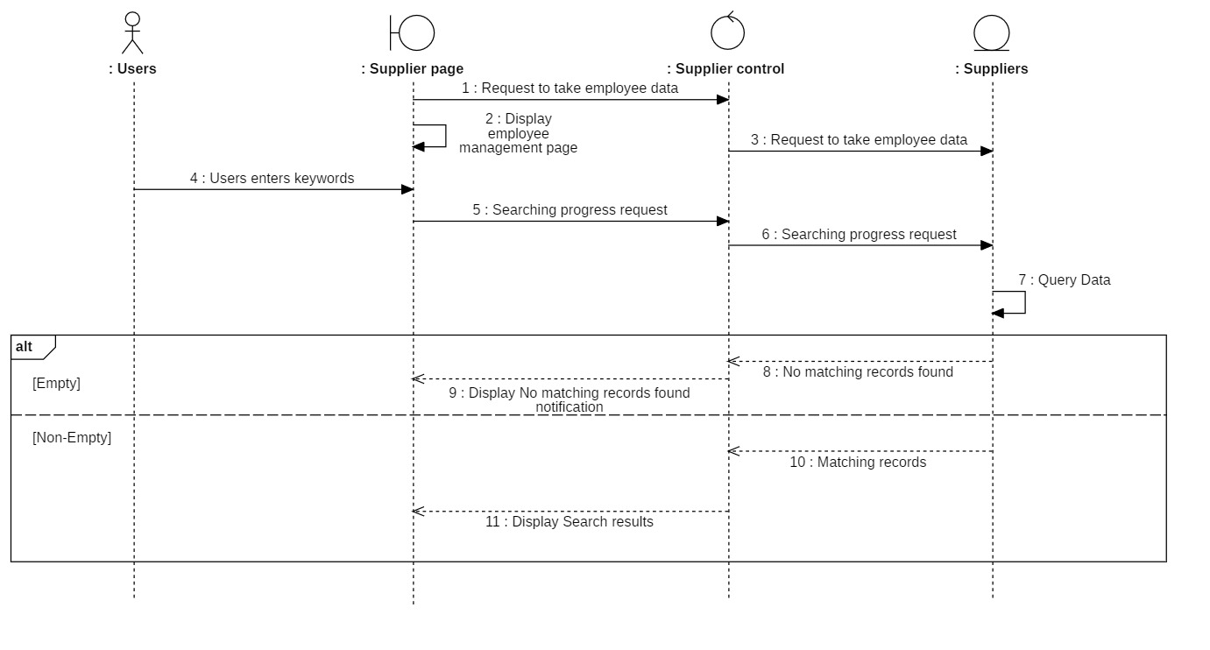

#### **3.3.6.2 Class diagram**

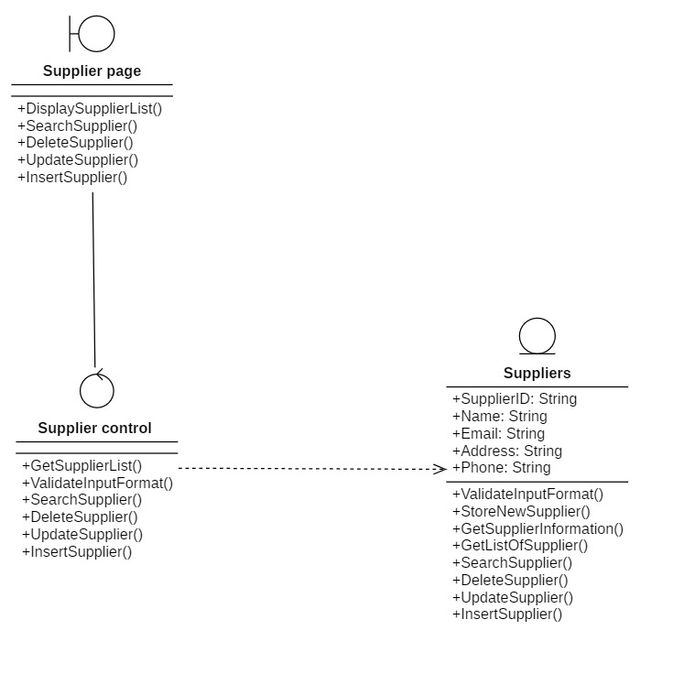

### **3.3.6 Customer management**

#### **3.3.6.1 Sequence diagram**

##### **3.3.6.1.1 Insert customer account**

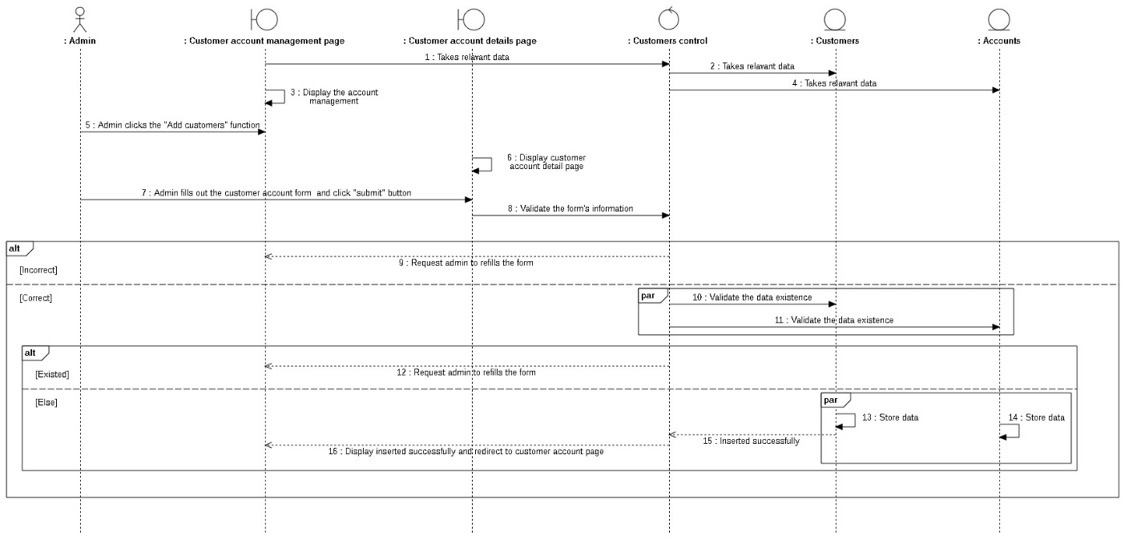

##### **3.3.6.1.2 View customer information**

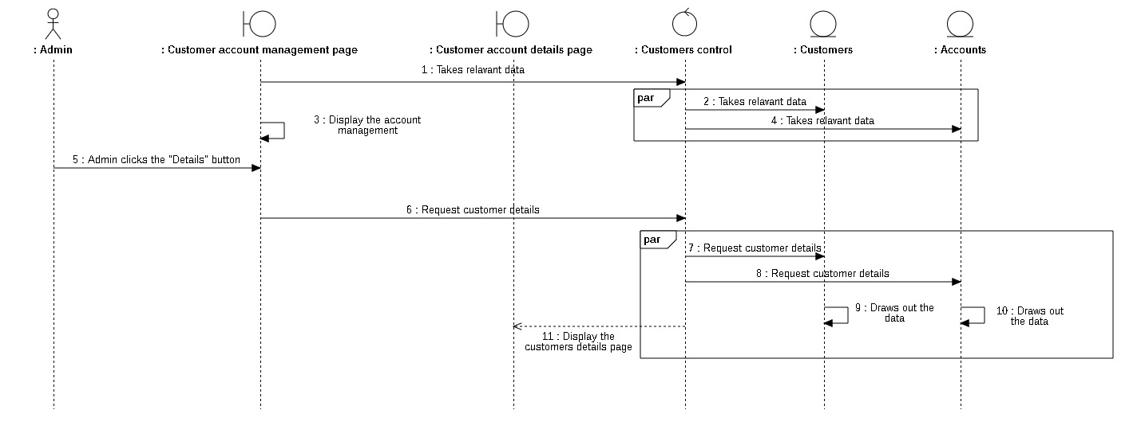

##### **3.3.6.1.3 Lock customer account**

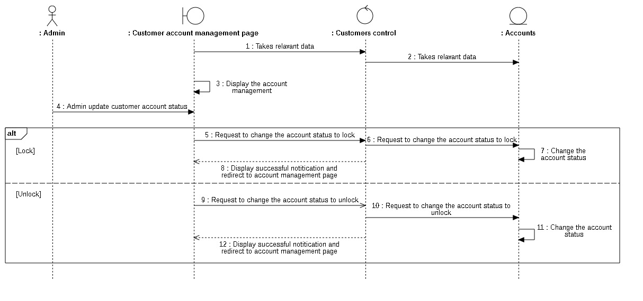

##### **3.3.6.1.4 Update customer account**

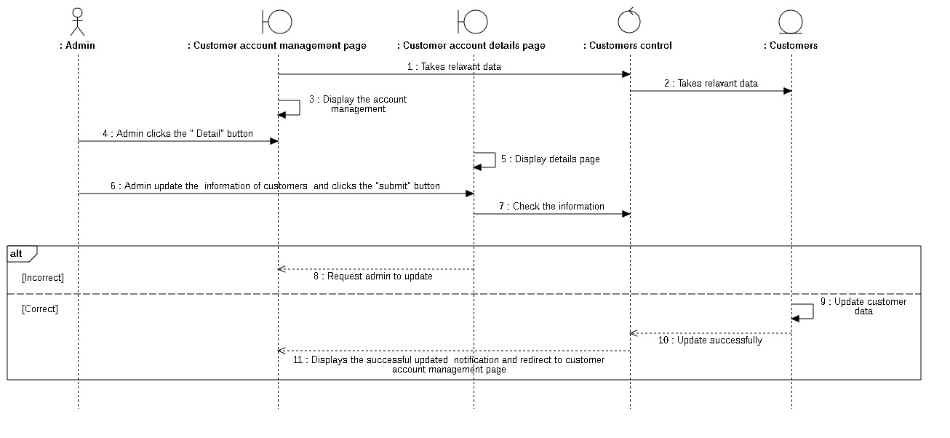

##### **3.3.6.1.5 Filter customer**

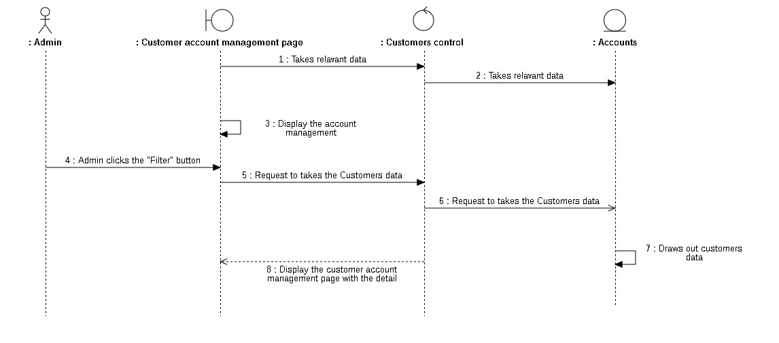

#### **3.3.6.2 Class diagram**

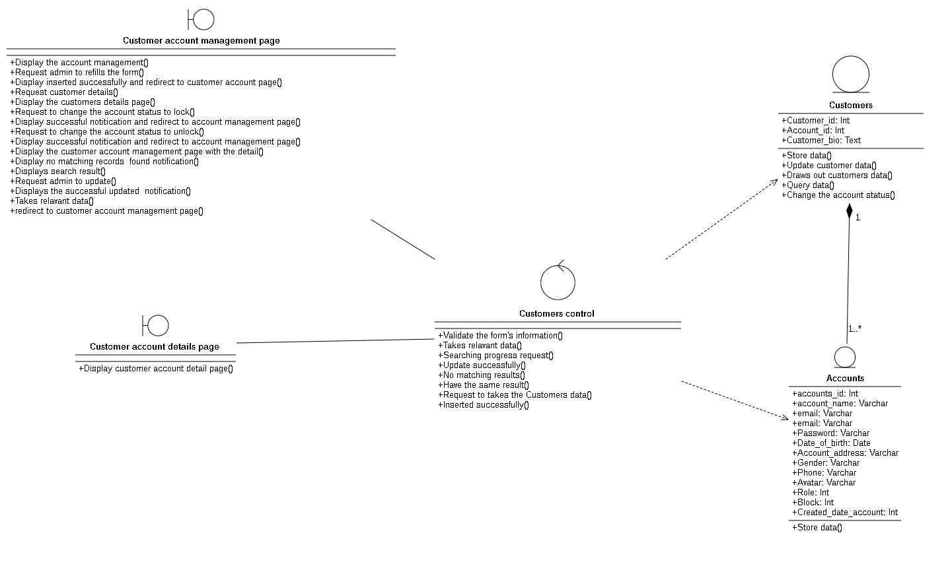

### **3.3.7 Order management**

#### **3.3.7.1 Sequence diagram**

##### **3.3.7.1.1 View order**

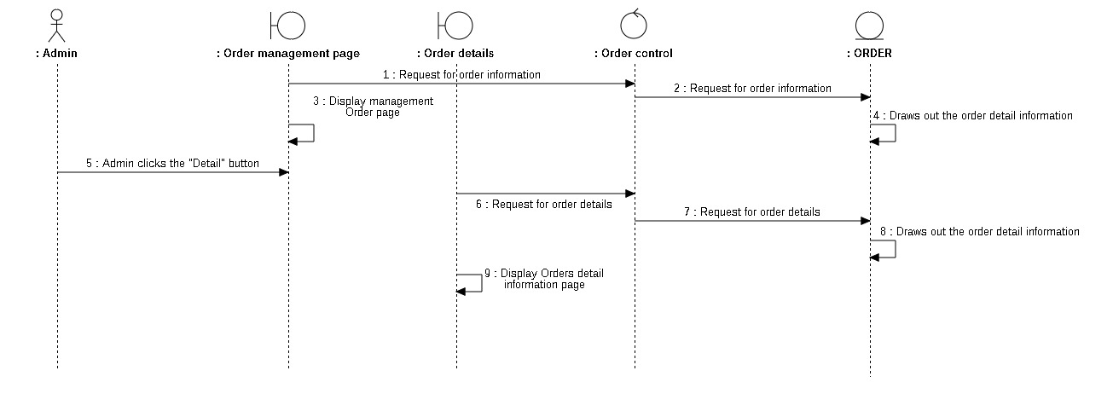

##### **3.3.7.1.2 Update order status**

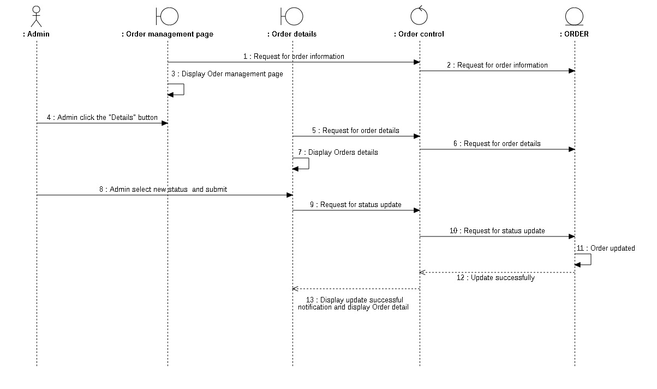

##### **3.3.7.1.3 Filter order**

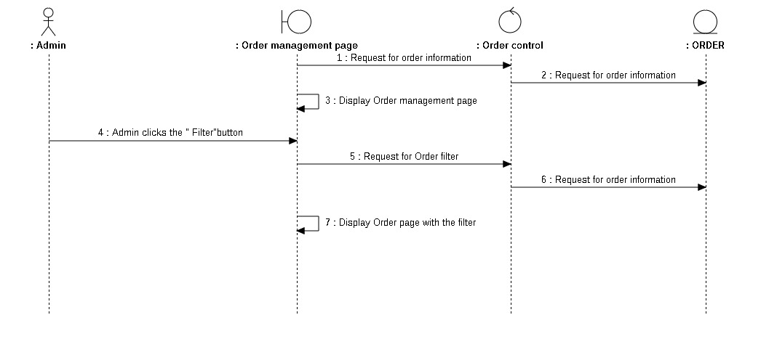

#### **3.3.7.2 Class Diagram**

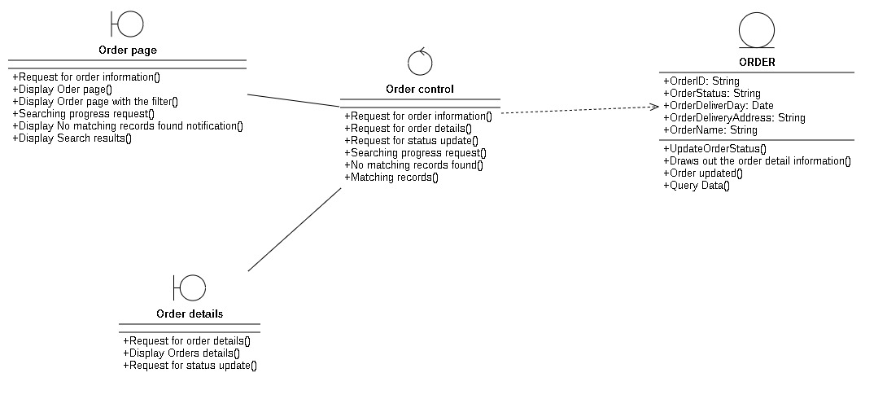

### **3.3.8 Product management**

#### **3.3.8.1 Sequence diagram**

##### **3.3.8.1.1 Insert product**

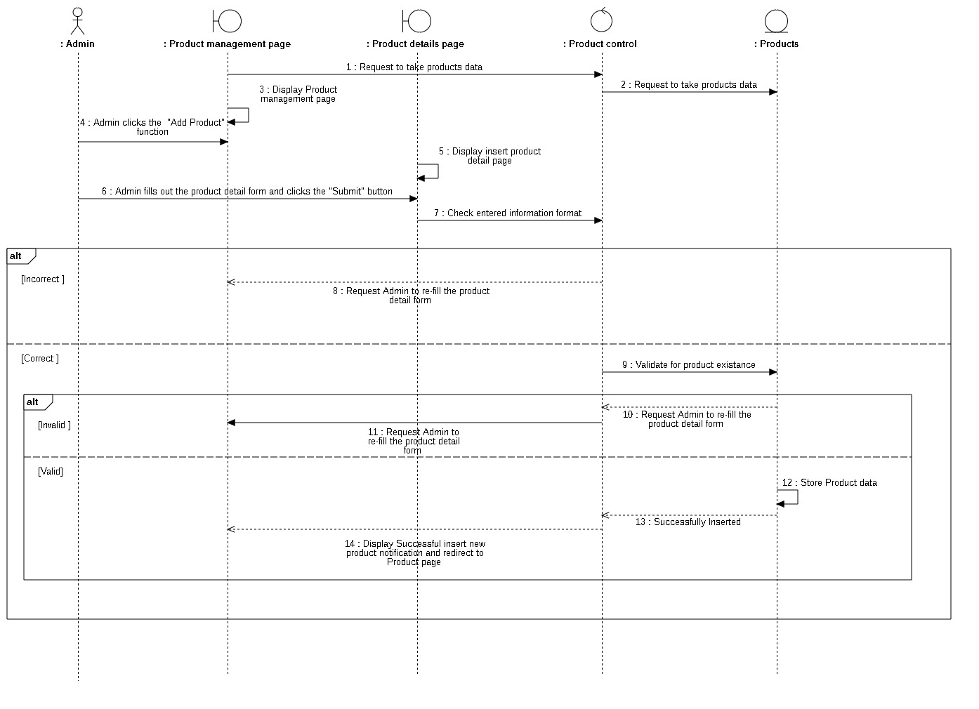

##### **3.3.8.1.2 Filter product**

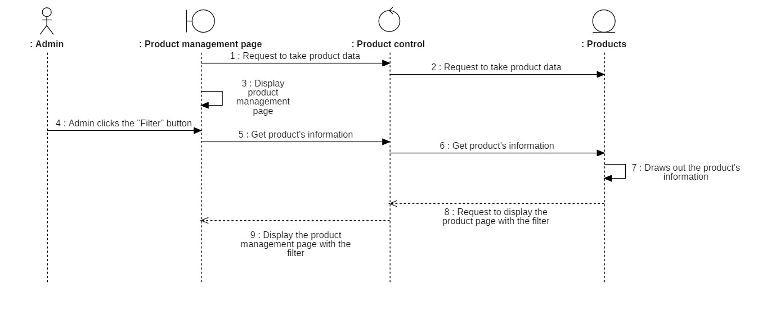

##### **3.3.8.1.3 Search product**

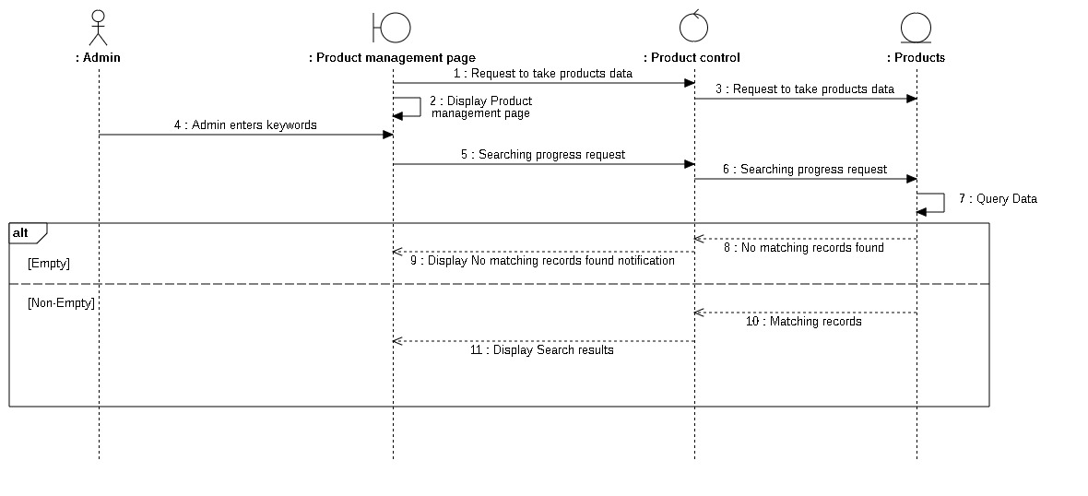

##### **3.3.8.1.4 View product**

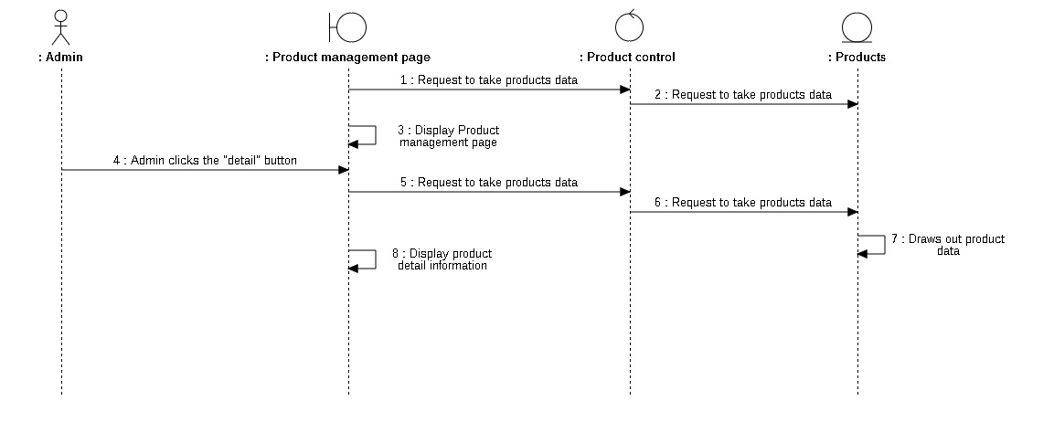

##### **3.3.8.1.5 Update product**

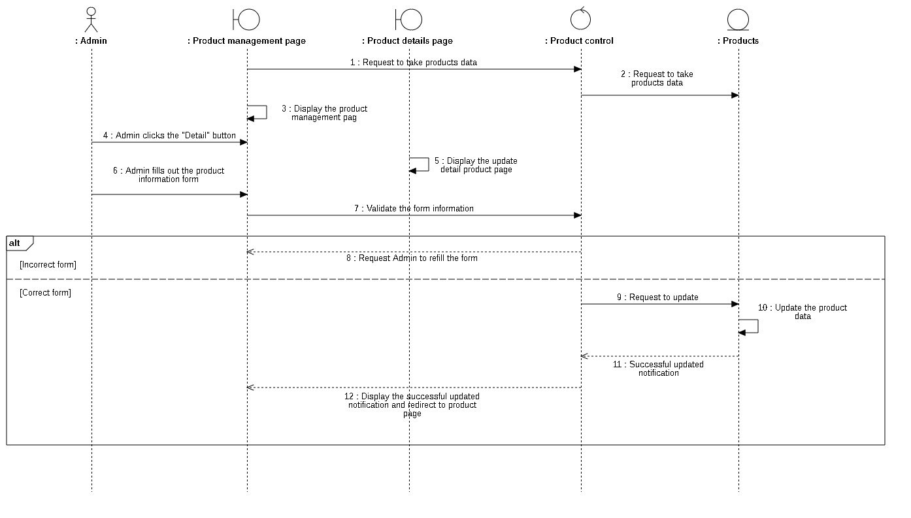

#### **3.3.8.2 Class Diagram**

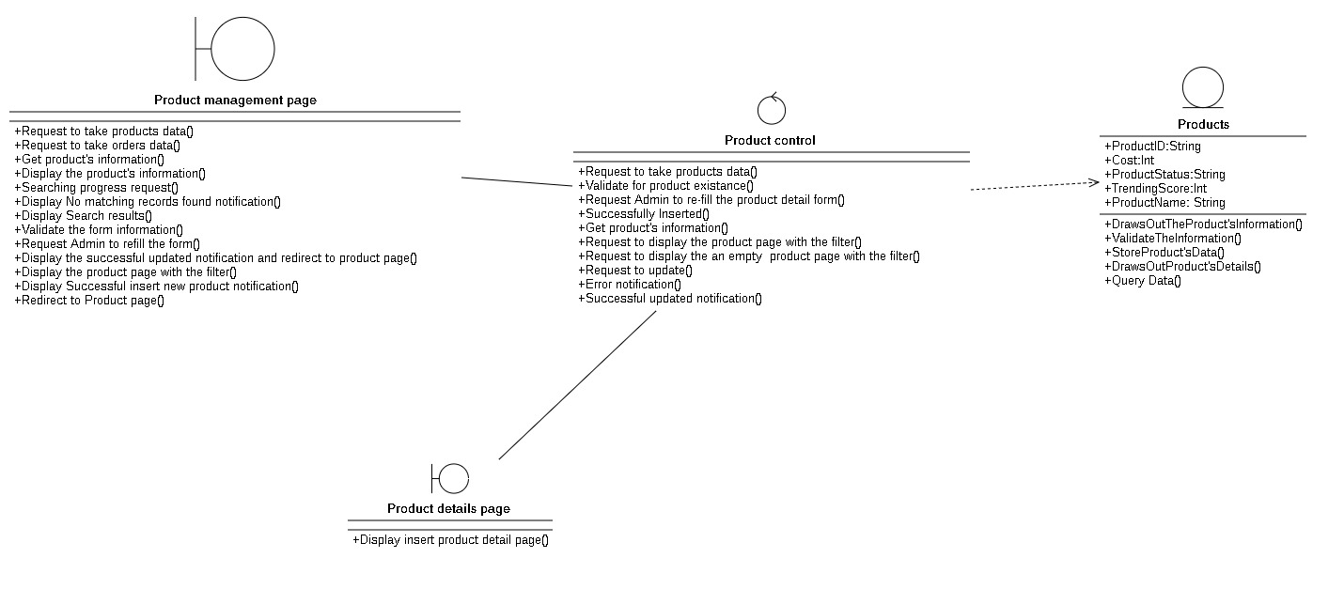

### **3.3.9 Employees management**

#### **3.3.9.1 Sequence diagram**

##### **3.3.9.1.1 Insert employee**

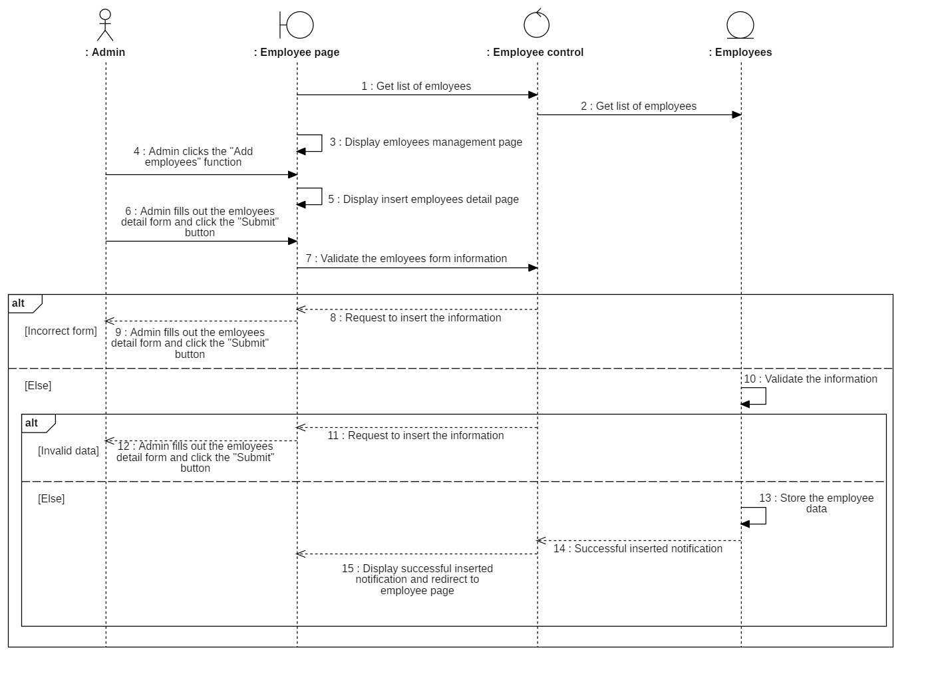

##### **3.3.9.1.2 Delete employee**

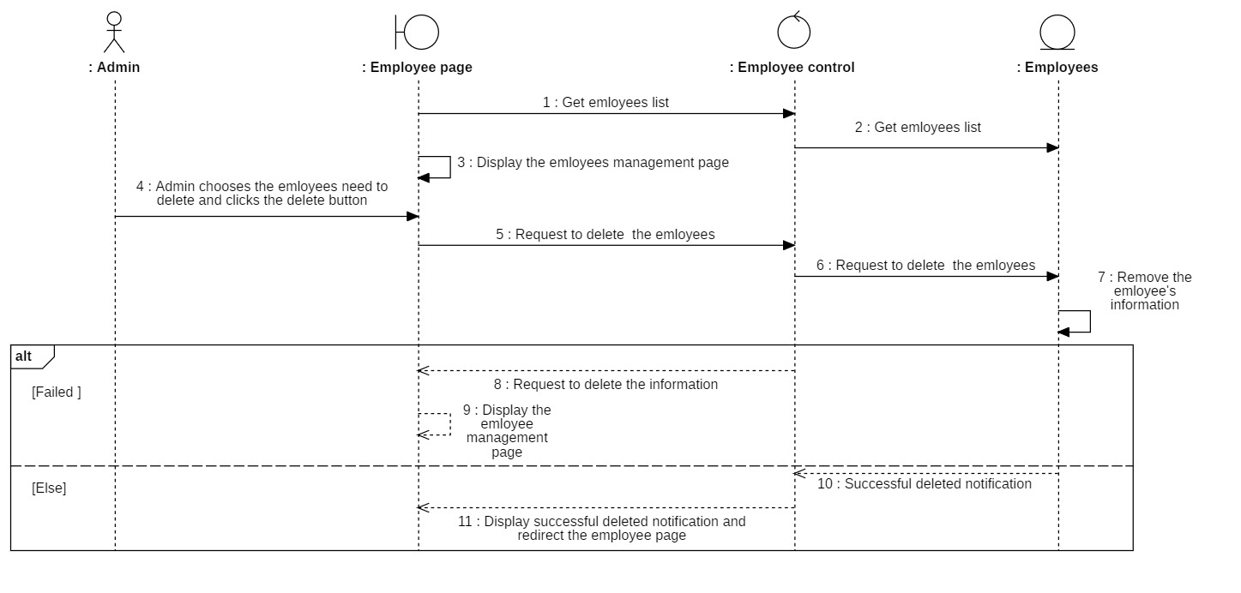

##### **3.3.9.1.3 Search employee**

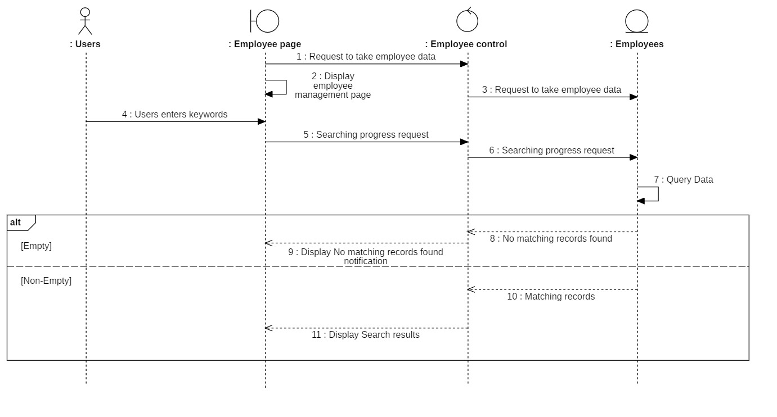

##### **3.3.9.1.4 Filter employee**

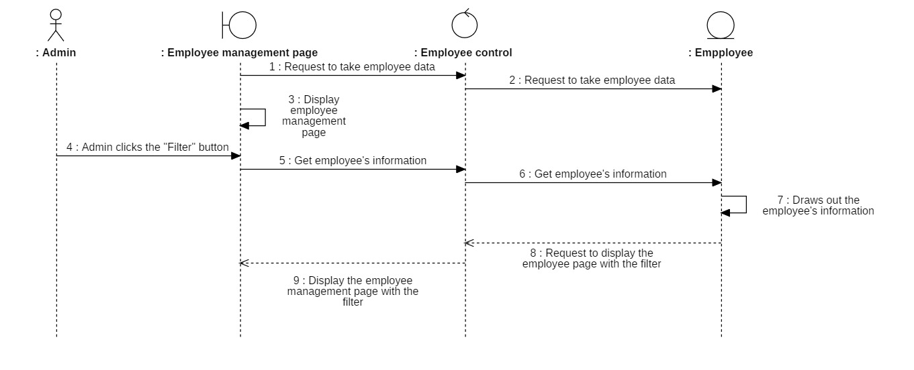

##### **3.3.9.1.5 View employee**

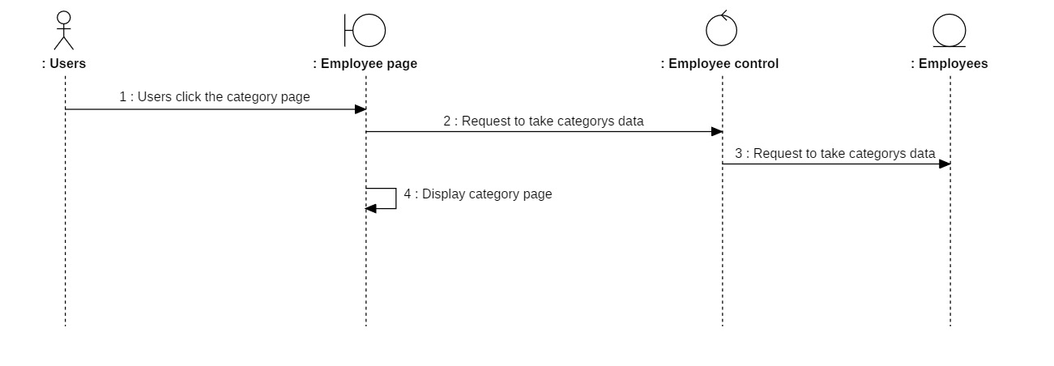

##### **3.3.9.1.6 Update employee**

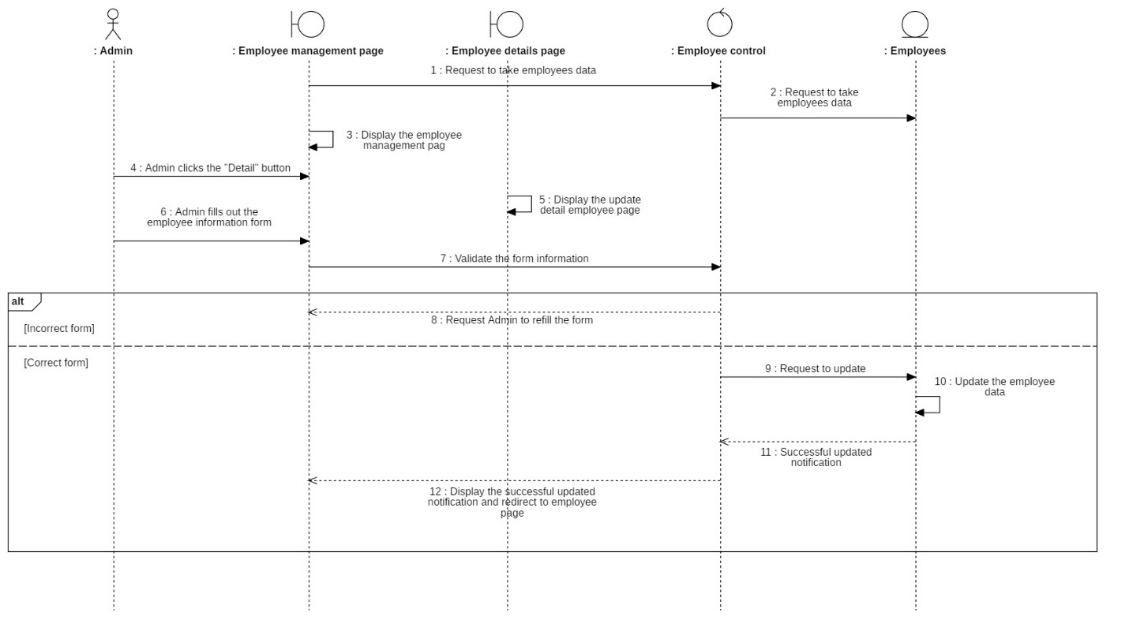

#### **3.3.9.2 Class diagram**

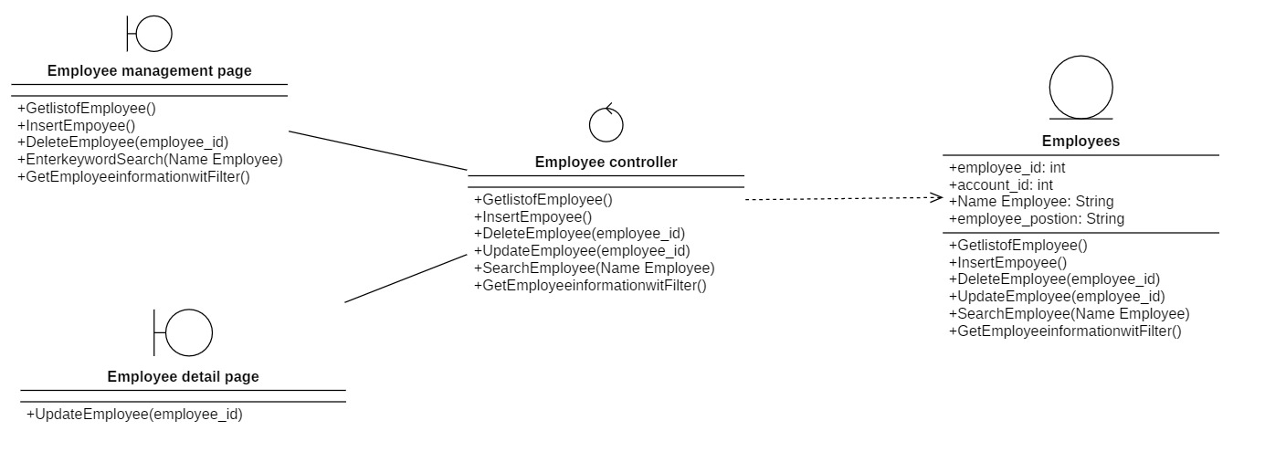

### **3.3.10 Statistical and report**

#### **3.3.10.1 Sequence diagram**

##### **3.3.10.1.1 Export revenue report**

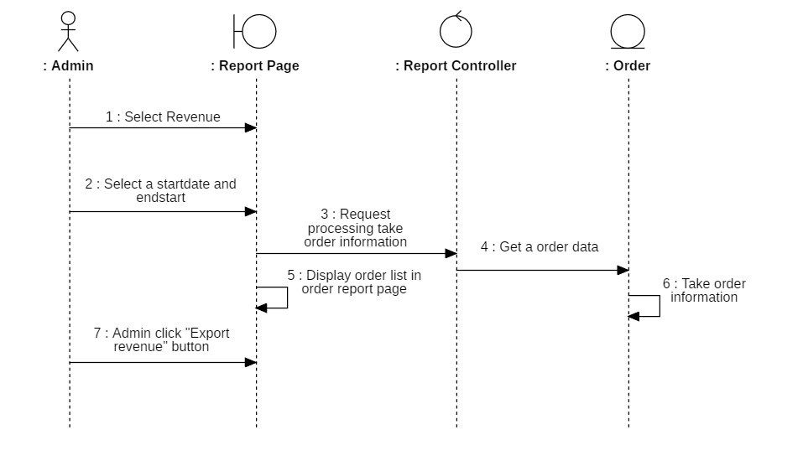

##### **3.3.10.1.2 Export products list**

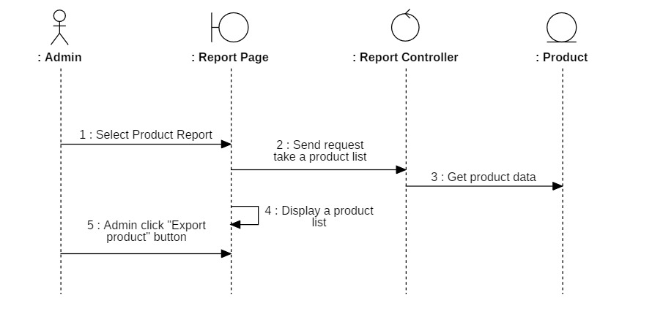

##### **3.3.10.1.3 Export customer product**

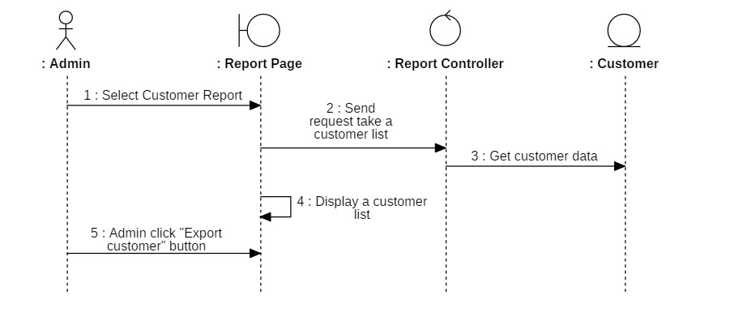

#### **3.3.10.2 Class of statistical and report**

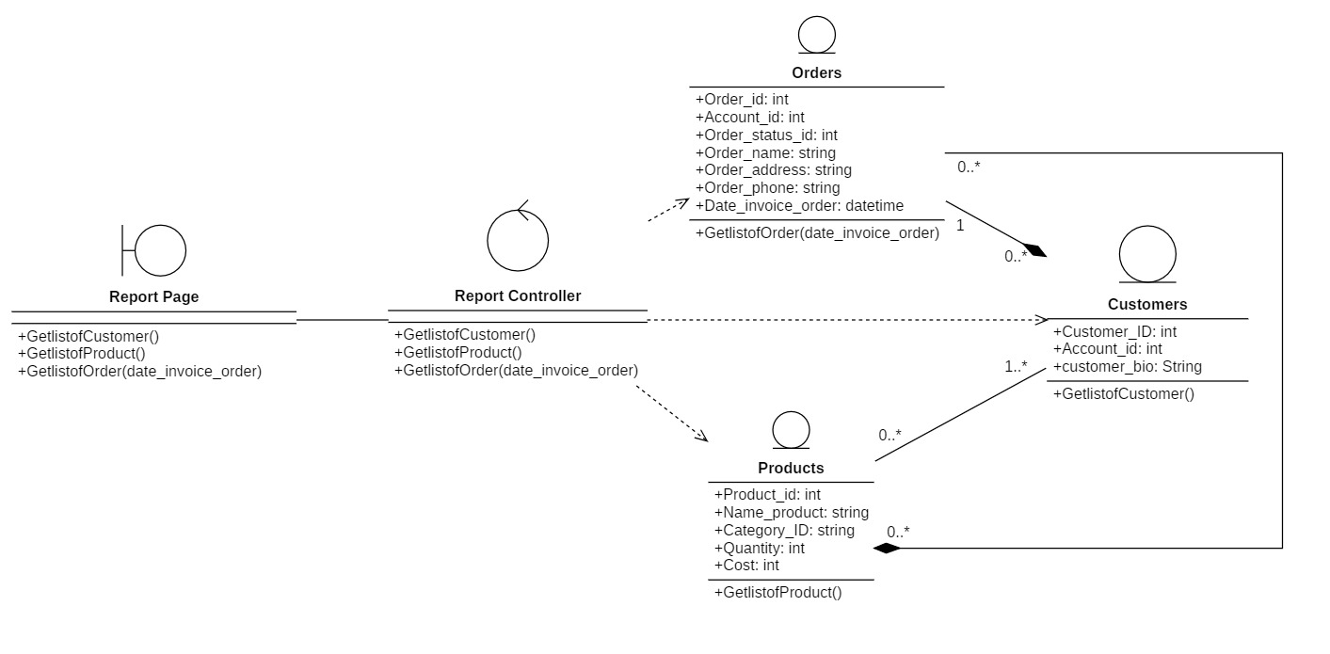

### **3.3.11 Log in (for users)**

#### **3.3.11.1 Sequence diagram**

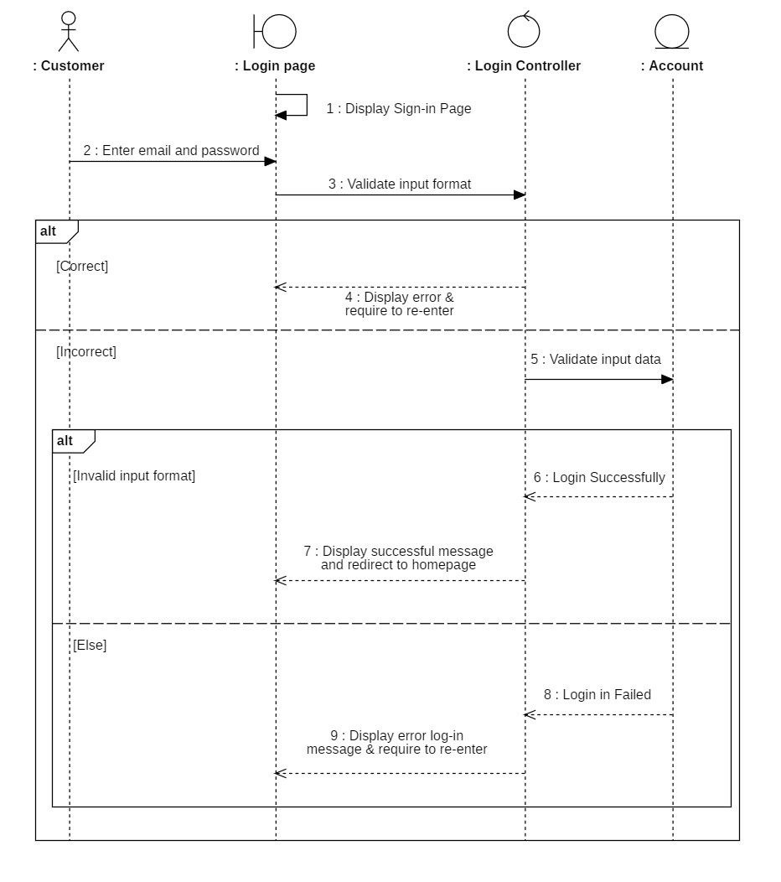

#### **3.3.11.2 Class diagram**

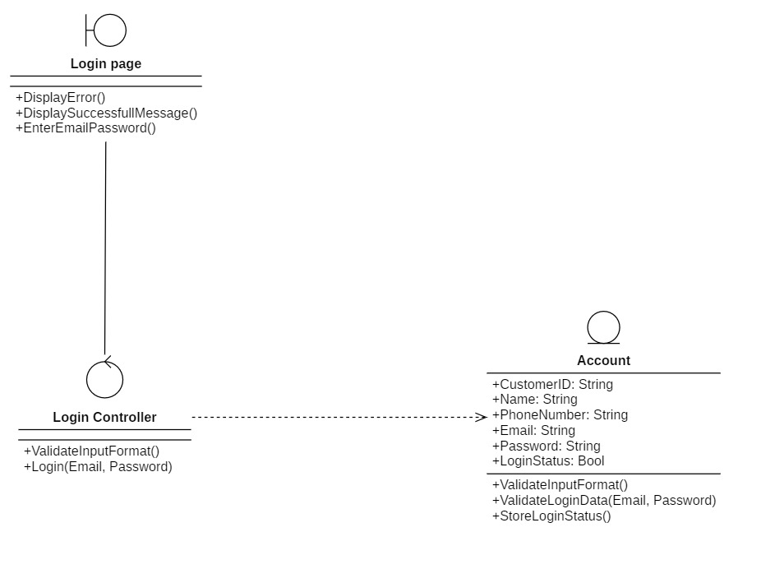

### **3.3.12 Log out (for users)**

#### **3.3.12.1 Sequence diagram**

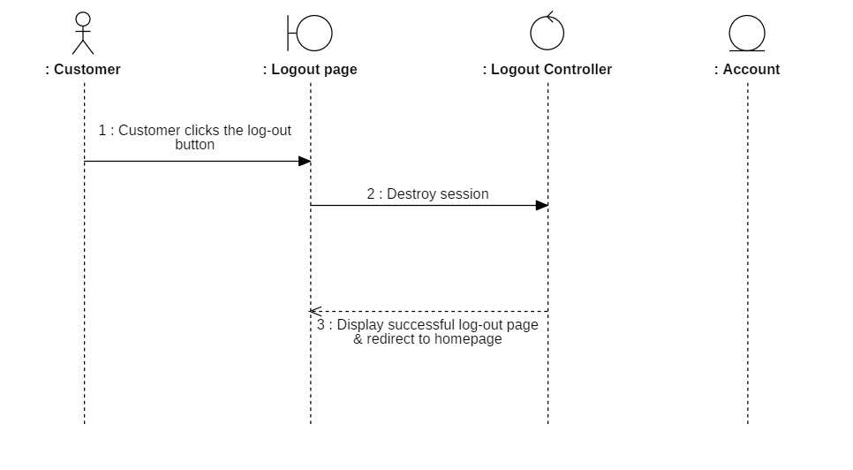

#### **3.3.12.2 Class diagram**

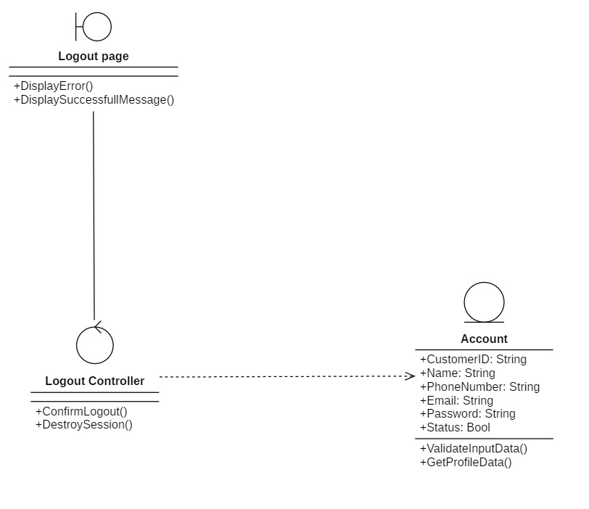

### **3.3.13 Register (for users)**

#### **3.3.13.1 Sequence diagram**

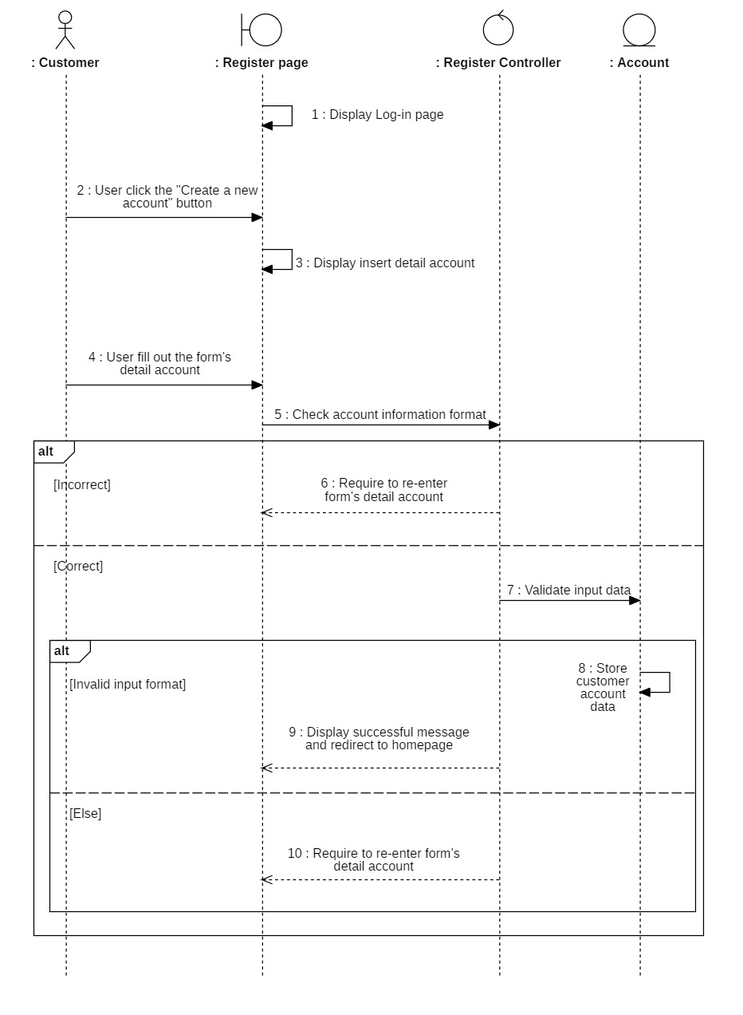

#### **3.3.13.2 Class diagram**

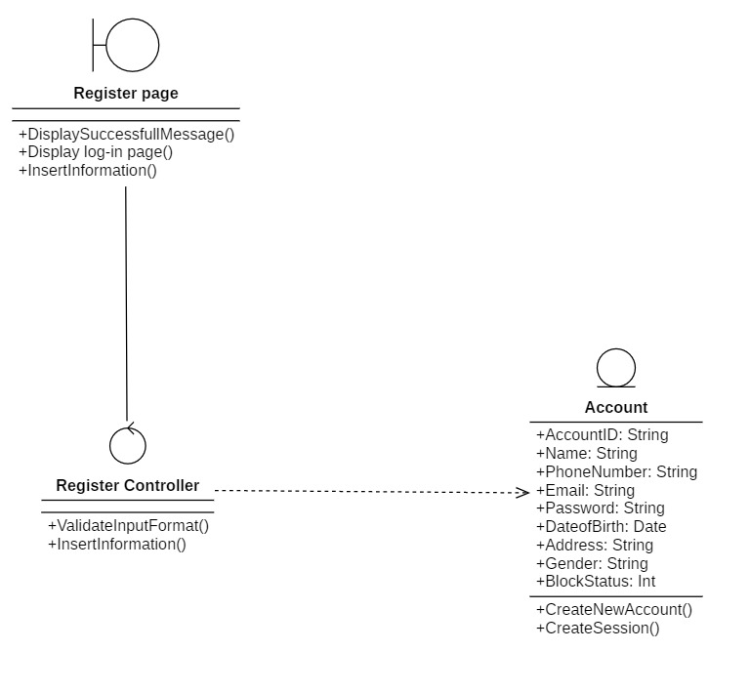

### **3.3.14 Personal account management**

#### **3.3.14.1 Sequence diagram**

##### **3.3.14.1.1 View account**

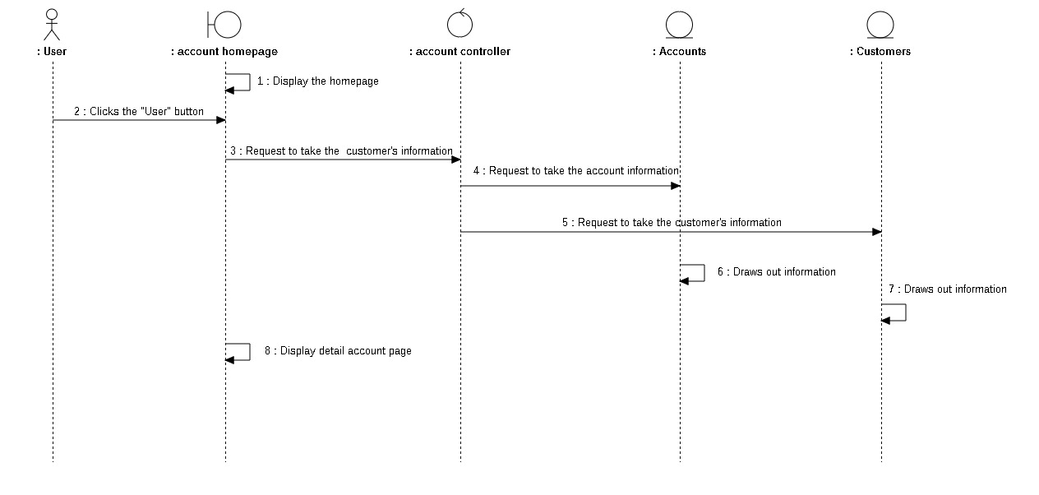

##### **3.3.14.1.2 Update account**

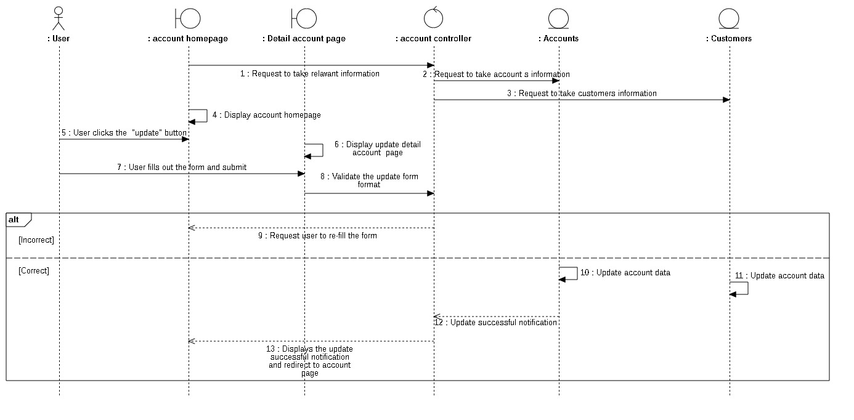

#### **3.3.14.2 Class diagram**

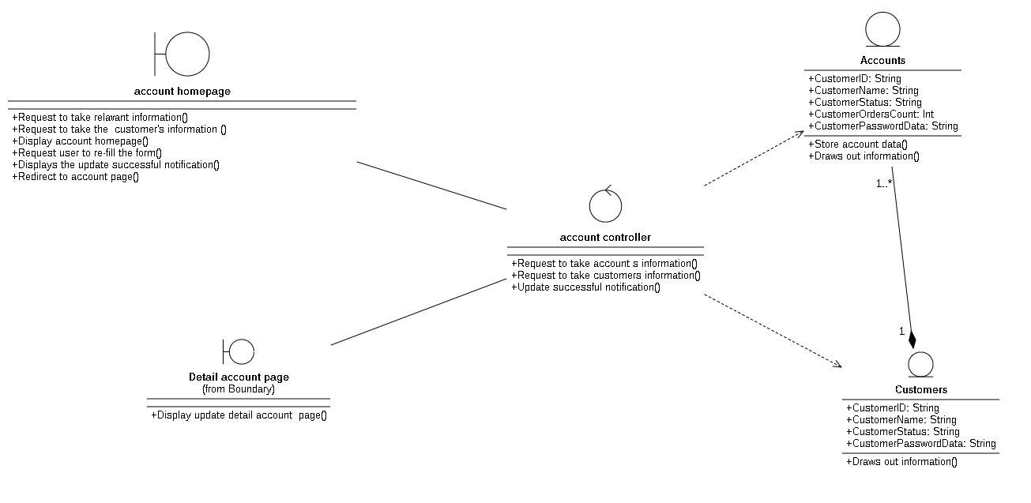

### **3.3.15 Cart management**

#### **3.3.15.1 Sequence diagram**

##### **3.3.15.1.1 View cart**

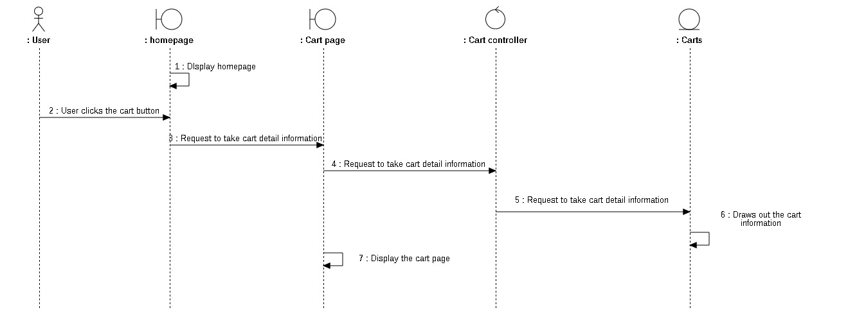

##### **3.3.15.1.2 Update number of cart**

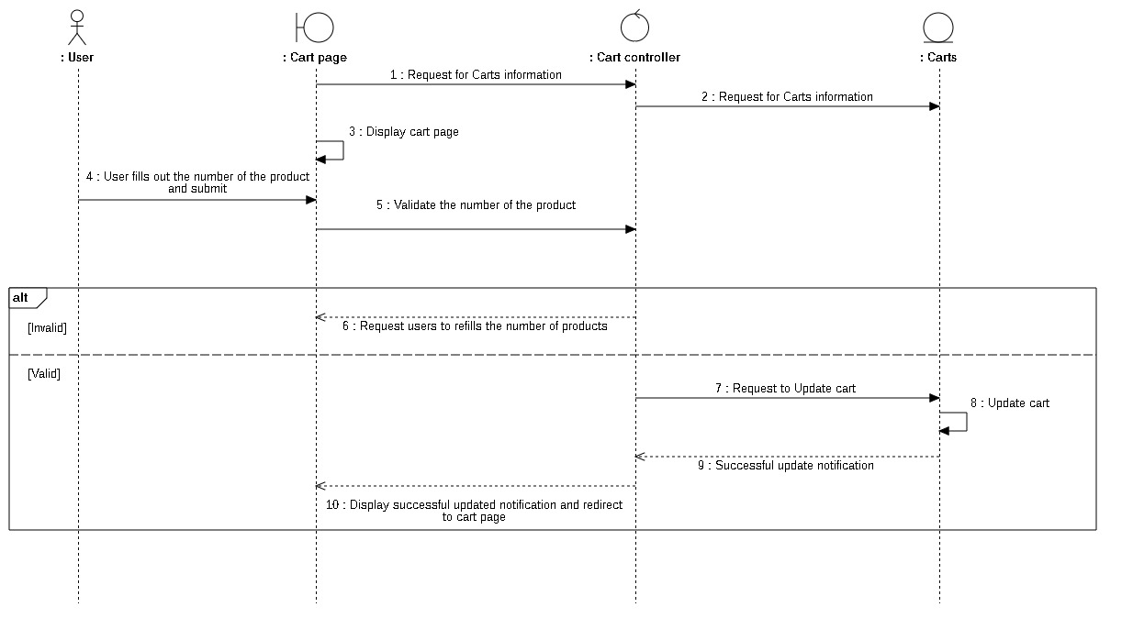

##### **3.3.15.1.3 Update cart**

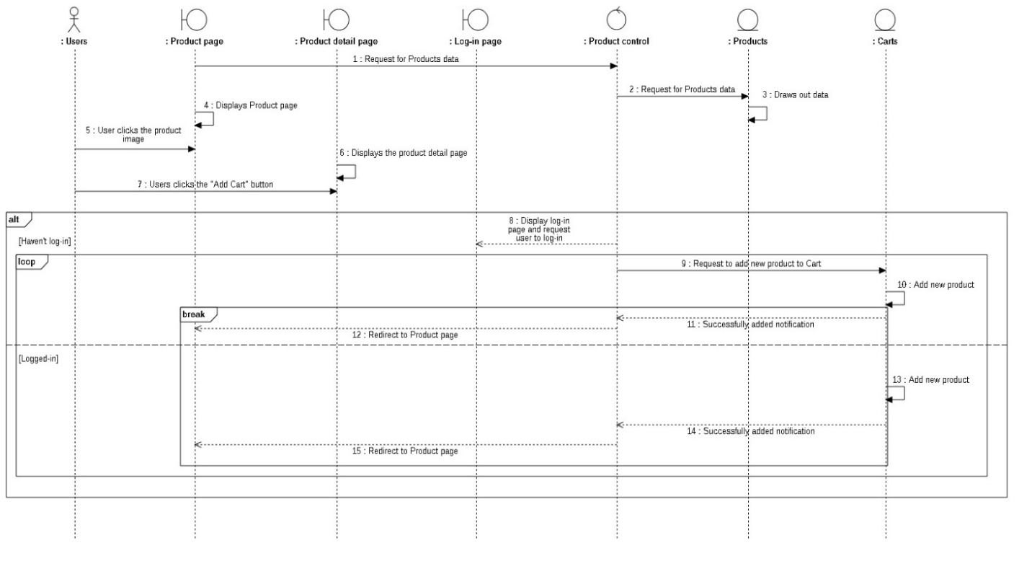

##### **3.3.15.1.4 Delete cart**

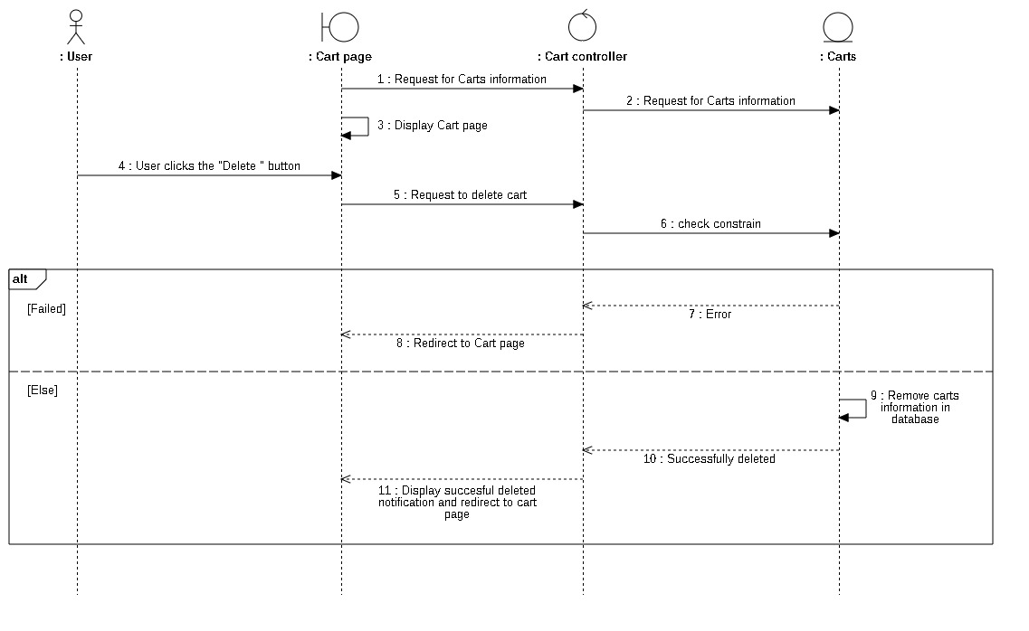

##### **3.3.16.1.4 Payment**

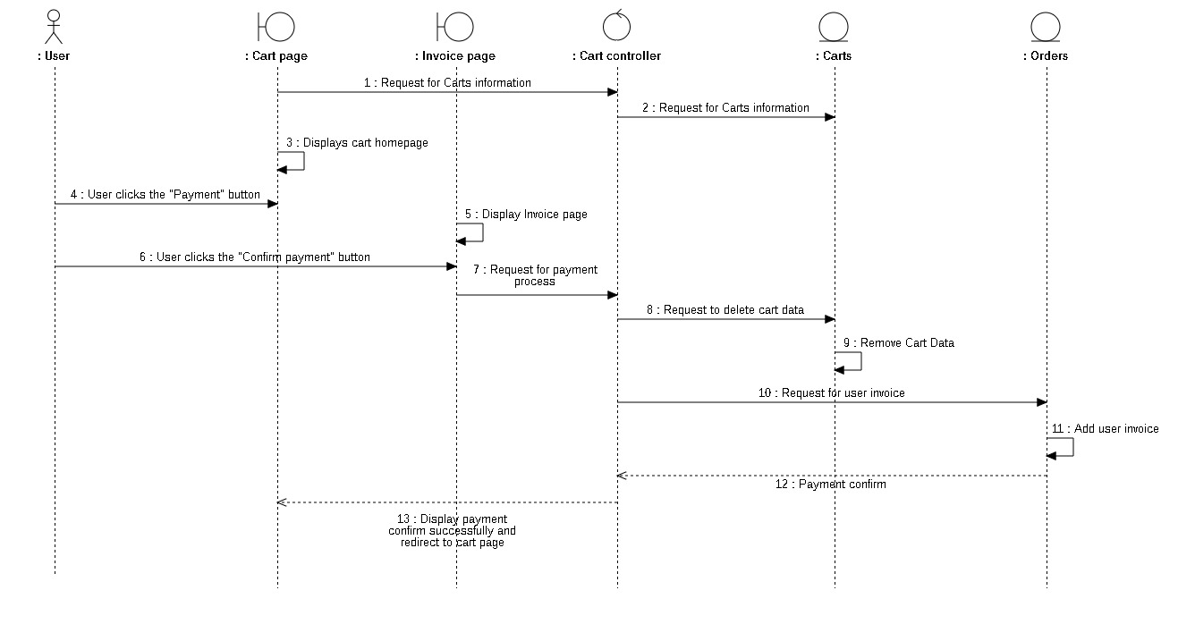

#### **3.3.15.2 Class diagram**

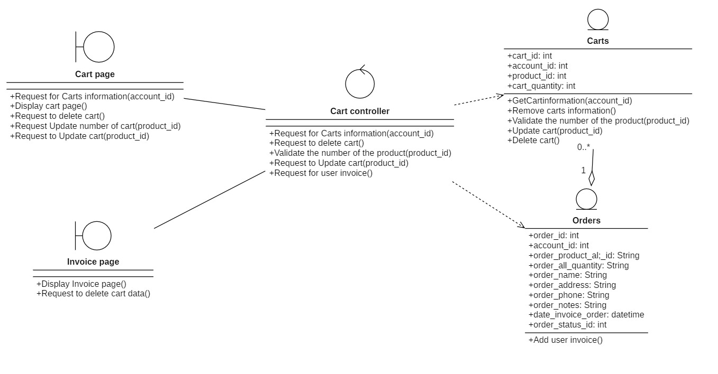

### **3.3.16 Orders management**

#### **3.3.16.1 Sequence diagram**

##### **3.3.16.1.1 View order**

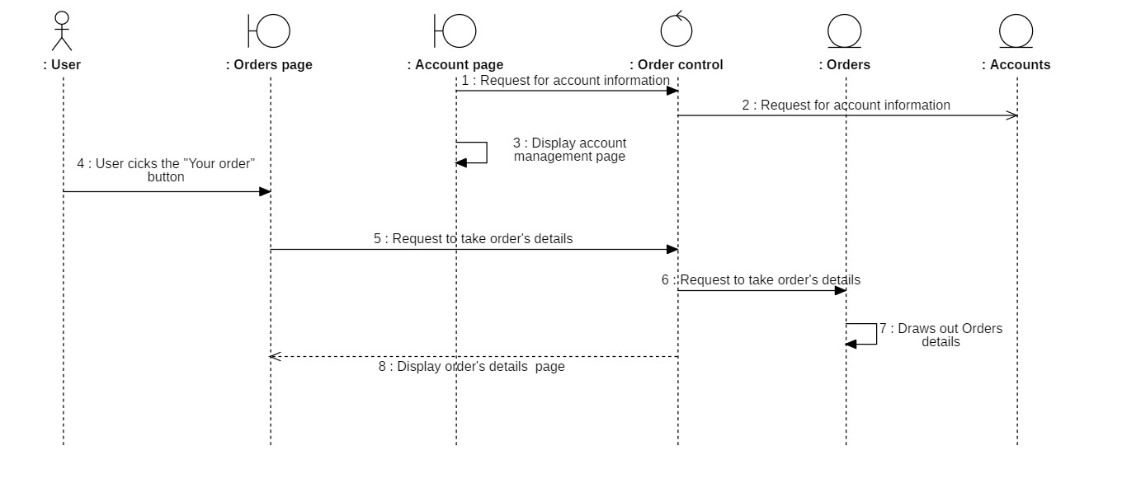

##### **3.3.16.1.2 Cancel order**

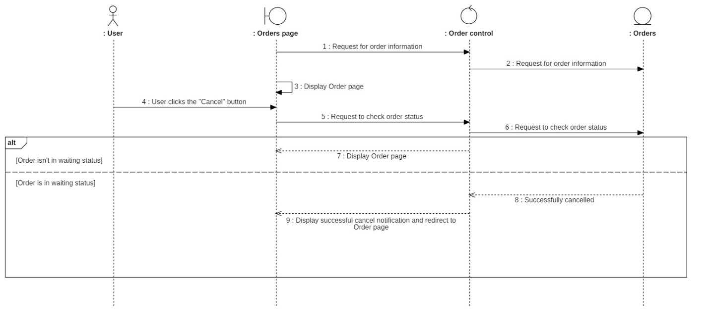

#### **3.3.16.2 Class digram**

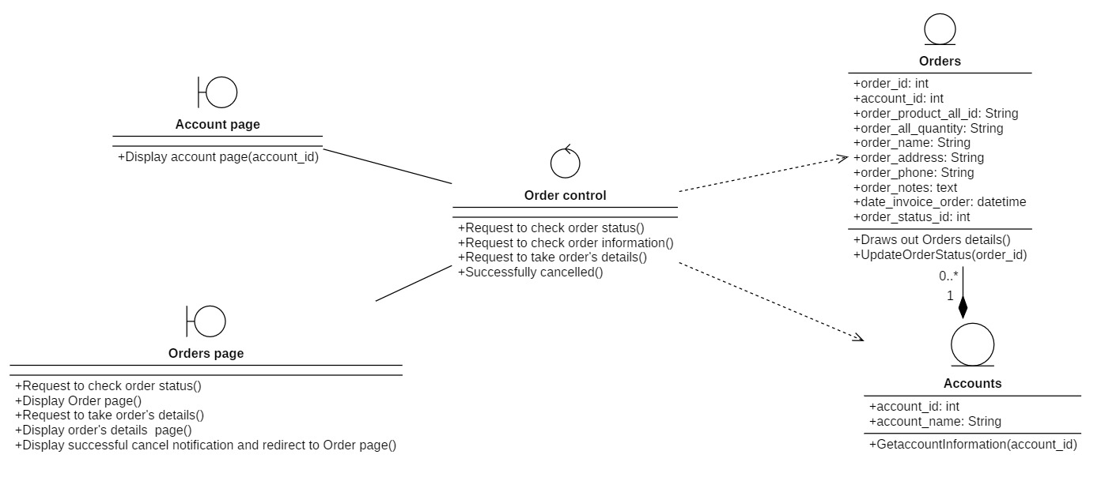

### **3.3.17 Purchase history management**

#### **3.3.17.1 Sequence diagram**

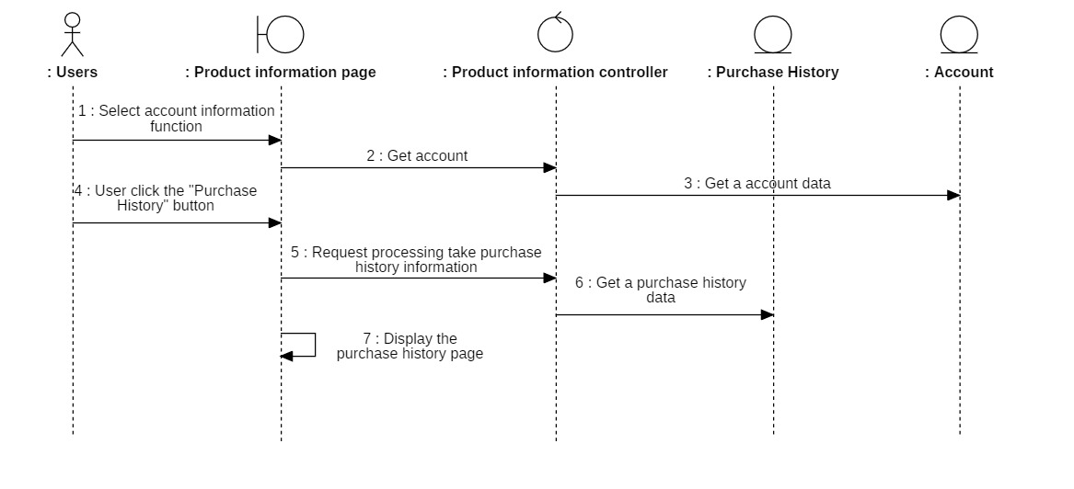

#### **3.3.17.2 Class diagram**

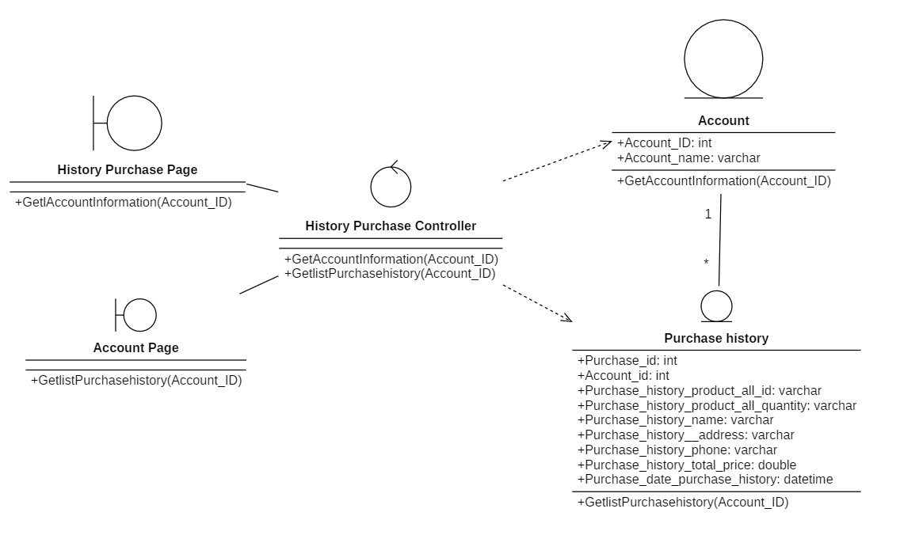

### **3.3.18 Product information**

#### **3.3.18.1 Sequence Diagram**

##### **3.3.18.1.1 Search products**

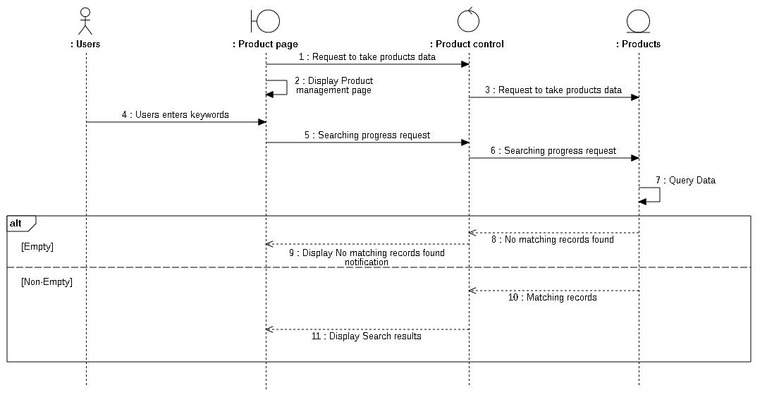

##### **3.3.18.1.2 View product**

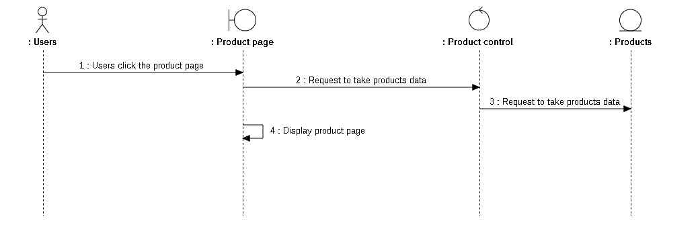

##### **3.3.18.1.3 View product detail**

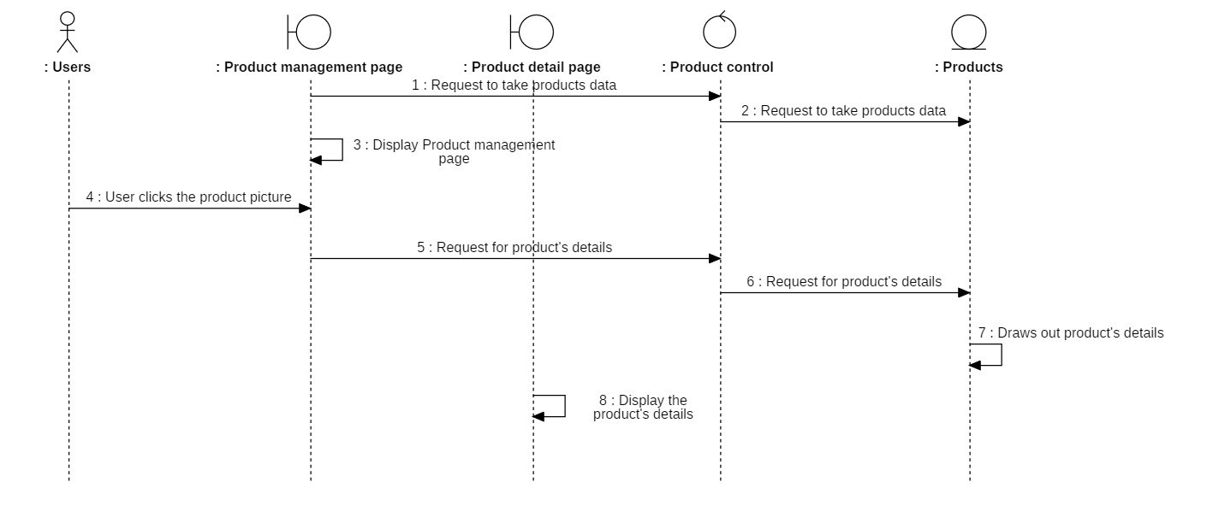

#### **3.3.18.2 Class diagram**

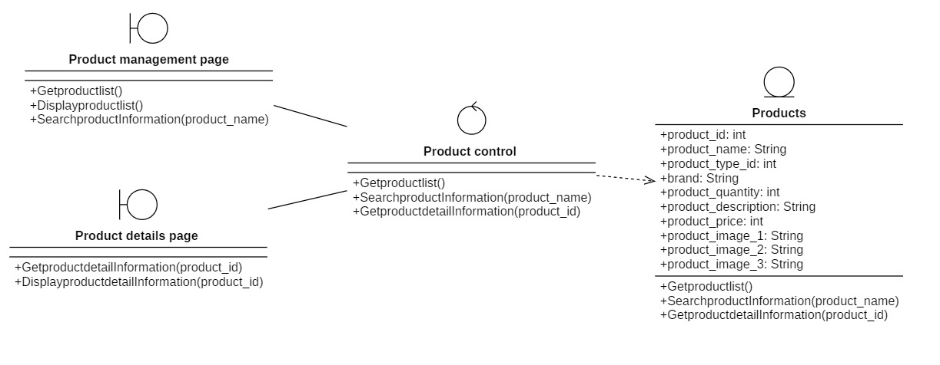

### **3.3.19 Checkout**

#### **Sequence diagram**

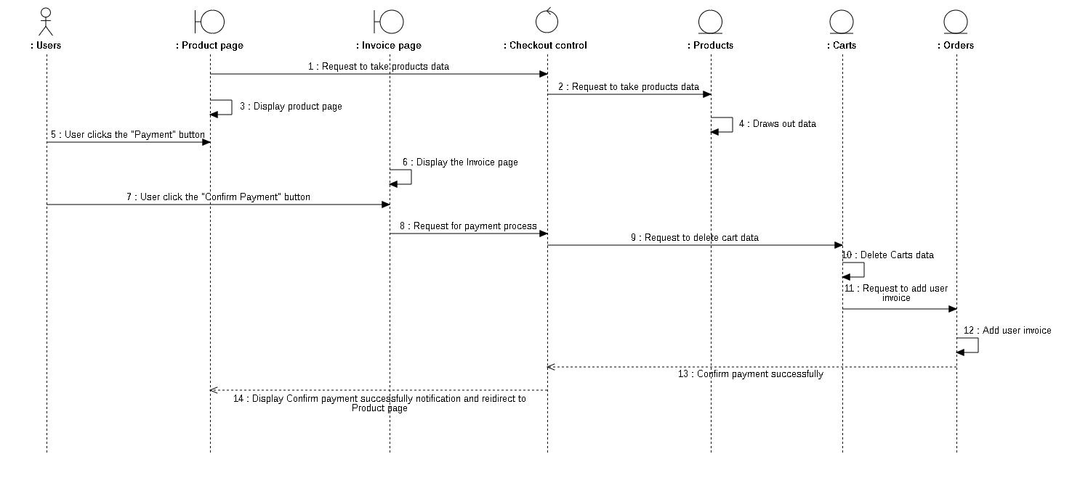

#### **3.3.19.2 Class diagram**

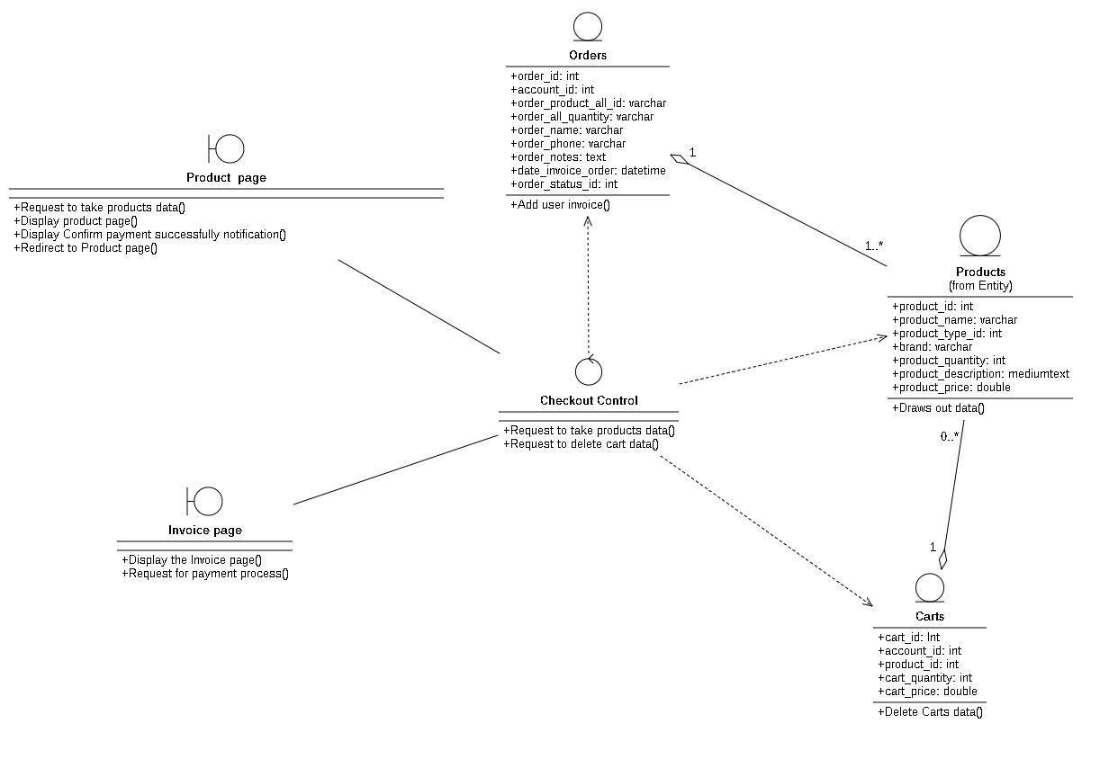

## **3.4 Class diagram and entity class diagram**

### **3.4.1 Customer overview class diagram**

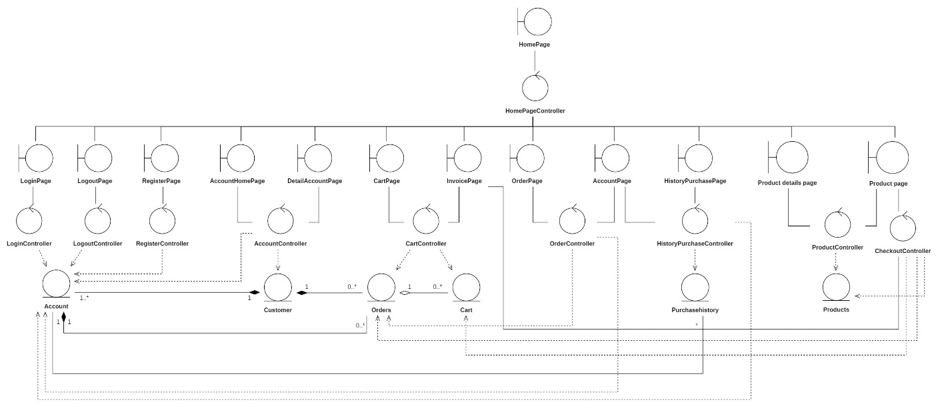

### **3.4.2 Admin overview class diagram**

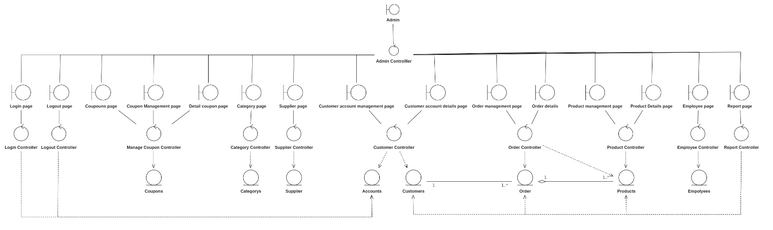

### **3.4.3 Entity class diagram**

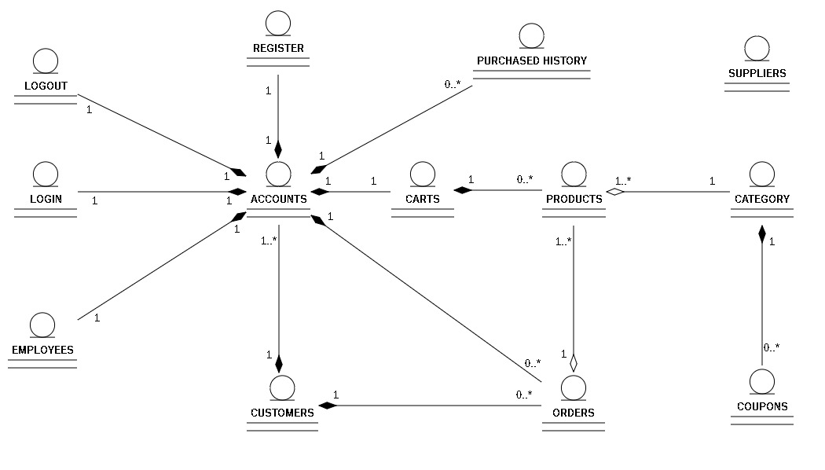

### **3.4.4 Class diagram specification**

#### **3.4.4.1 Admin login controller**

|  |  |  |
| --- | --- | --- |
| Login Controller | | |
| Operation | Funtion | Meaning |
| ValidateInputFormat(): Bool | Validate if the input information format is correct |
| Login (Email, Password): String | Request to login to the database |

#### **3.4.4.2 Admin logout controller**

|  |  |  |
| --- | --- | --- |
| Logout Controller | | |
| Operation | Funtion | Meaning |
| DestroySession(): Bool | Request to logout to the website and destroy session login |

#### **3.4.4.3 Coupon controller**

|  |  |  |
| --- | --- | --- |
| Coupon Controller | | |
| Operation | Funtion | Meaning |
| GestListOfCoupons():Array | Get list of coupons from database to system |
| SentInsertRequest(): Bool | Request insert new coupons |
| ValidateTheInformatioOfTheCoupons:  Bool | Check information of coupons |
| Error(): Bool | If coupons validate is error |
| SuccessfulAddedNotification(): Bool | Add successful new coupon. |

#### **3.4.4.4 Category controller**

|  |  |  |
| --- | --- | --- |
| Category Controller | | |
| Operation | Funtion | Meaning |
| GetsCategoryList():Array | Get list of categories from database to system |
| ValidateInputFormat(): Bool | Check information of category |
| InsertCategorys(): Bool | Request insert new category |
| UpdateCategory(): Bool | Request update category information to database |

#### **3.4.4.5 Supplier controller**

|  |  |  |
| --- | --- | --- |
| Supplier Controller | | |
| Operation | Funtion | Meaning |
| GetsSupplierList():Array | Get list of categories from database to system |
| ValidateInputFormat(): Bool | Check information of category |
| SearchSupplier():Array | Get supplier information with keyword |
| DeleteSupplier(): Bool | Request delete supplier to database |
| InsertSupplier(): Bool | Request insert new supplier |
| UpdateSupplier(): Bool | Request update supplier information to database |

#### **3.4.4.6 Customer controller**

|  |  |  |
| --- | --- | --- |
| Customer Controller | | |
| Operation | Funtion | Meaning |
| ValidateTheForm’sInformation():Array | Check information of customer |
| TakesRelavantData():Array | Take data have relavent of customer |
| SearchingProgressRequest():  Array | Get customer information with keyword |
| UpdateSuccessfully(): Bool | Request update customer information to database |
| NoMatchingResult(): Bool | Not found data with key word |
| HaveTheSameResult(): Bool | Found data match with key word |
| RequestToTakesTheCustomer’sData:  Array | Request take customer information from database |
| InsertedSuccessfully(): Bool | Add successful new customer. |

#### **3.4.4.7 Admin order controller**

|  |  |  |
| --- | --- | --- |
| Order Controller | | |
| Operation | Funtion | Meaning |
| RequestForOrderInformation(): String | Take order information |
| RequestForOrderDetails(): String | Take order detail information based on Order ID |
| RequestForStatusUpdate(): Strng | Update order status of customer |
| SearchingProgressRequest():Array | Get order information with key word |
| NoMatchingRecordsFound():Bool | Not found data with key word |
| MatchingRecords(): Bool | Found data match with key word |

#### **3.4.4.8 Product controller**

|  |  |  |
| --- | --- | --- |
| Product Controller | | |
| Operation | Funtion | Meaning |
| RequestToTakeProductsData(): String | Request take product information from database |
| ValidateForProductExistance(): Bool | Check product data is valid or invalid |
| RequestAdminToRe-FillTheProductDetailForm(): Bool | Insert new product |
| SuccessfullyInserted(): Bool | Successfully insert new product |
| GetProductsInformation(): String | Get product information data |
| RequestToDisplayTheProductPageWith  TheFilter(): Void | Get product information data with filter |
| RequestToDisplayTheAnEmptyProduct  PageWithTheFilter(): Bool | If not found product information is perform this operation |
| RequestToUpdate():Bool | Update product information |
| ErrorNotification():Bool | Update error |
| SuccessfulUpdatedNotification(): Bool | Update successful product information |

#### **3.4.4.9 Employee controller**

|  |  |  |
| --- | --- | --- |
| Employee Controller | | |
| Operation | Funtion | Meaning |
| GetListofEmployee():Array | Check information of employee |
| InsertEmployee(): Bool | Insert new employee in database |
| DeleteEmployee(employee_id): Bool | Delete employee data based on employee_id |
| UpdateEmployee(employee_id): Bool | Update employee information based on employee_id |
| SearchEmployee(Name Employee):  Bool | Search employee information with key word is name of employee |
| GetEmployeeInformationwithFilter():  Array | When admin use filter function is this operation will perform. |

#### **3.4.4.10 Report controller**

|  |  |  |
| --- | --- | --- |
| Report Controller | | |
| Operation | Funtion | Meaning |
| GetsListOfCustomer():Array | Get list of customers from database to system |
| GetListOfProduct():Array | Get list of products from database to system |
| GetListOfOrder(date_invoice_order):  Array | Get list of orders from database to system based on start date and end date |

#### **3.4.4.11 Customer login controller**

|  |  |  |
| --- | --- | --- |
| Login Controller | | |
| Operation | Funtion | Meaning |
| ValidateInputFormat(): Bool | Validate if the input information format is correct |
| Login (Email, Password): String | Request to login to the database |

#### **3.4.4.12 Customer logout controller**

|  |  |  |
| --- | --- | --- |
| Logout Controller | | |
| Operation | Funtion | Meaning |
| ConfirmLogout(): Bool | Confirm logout of accounts |
| DestroySession(): Bool | Request to logout to the website and destroy session login |

#### **3.4.4.13 Register controller**

|  |  |  |
| --- | --- | --- |
| Register Controller | | |
| Operation | Funtion | Meaning |
| ValidateInputFormat(): Bool | Check input format before inserting new account to database |
| InsertInformation(): Bool | Insert new account |

#### **3.4.4.14 Personal account controller**

|  |  |  |
| --- | --- | --- |
| Personal acocount Controller | | |
| Operation | Funtion | Meaning |
| RequestToTakeAccountA  Information(): String | Get of account information from database to system |
| RequestToTakeCustomer  Information(): String | Get of customer information from database to system |
| UpdateSuccessfulNotification(): Bool | When update successfully is notification |

#### **3.4.4.15 Cart controller**

|  |  |  |
| --- | --- | --- |
| Cart Controller | | |
| Operation | Funtion | Meaning |
| RequestForCartsInformation  (account_id): String | Get of cart information based on account_id |
| RequestToDeleteCart(): Bool | Delete product of cart |
| ValidateTheNumberOfProduct  (product_id): Bool | Check quantity of product in storage and update number of cart |
| RequestToUpdateCart(product_id): Bool | Add product to cart |
| RequestForUserInvoice: String | Take invoice of customer based on order |

#### **3.4.4.16 Customer Order controller**

|  |  |  |
| --- | --- | --- |
| Order Controller | | |
| Operation | Funtion | Meaning |
| RequestToCheckOrderStatus(): String | Check order status and get list order based on status |
| RequestToCheckOrderInformation():  String | Get of order information |
| RequestToTakeOrder’sDetail: String | Get of order detail information |
| SuccessfullyCancelled(): Bool | When cancel successfully is display this notification. |

#### **3.4.4.17 Purchase history controller**

|  |  |  |
| --- | --- | --- |
| Purchase history Controller | | |
| Operation | Funtion | Meaning |
| GetAccountInformation(account_id):  String | Get of account information based on account_id |
| GetListPurchaseHistory(account_id):  Array | Get of purchase history of account based on account_id |

#### **3.4.4.18 Product information controller**

|  |  |  |
| --- | --- | --- |
| Product information Controller | | |
| Operation | Funtion | Meaning |
| GetProductList(): Array | Get list of products |
| SearchProductInformation  (product_name): String | Search product based on product name and display result search with key word |
| GetProductDetailInformation  (product_id): String | Get of product detail information based on product_id |

#### **3.4.4.19 Checkout controller**

|  |  |  |
| --- | --- | --- |
| Check out Controller | | |
| Operation | Funtion | Meaning |
| RequestToTakeProductData(): String | Get of product information |
| RequestToDeleteCartData(): Bool | Delete product out of cart |

## **3.5 State diagram**

#### **3.5.2 Order state diagram**

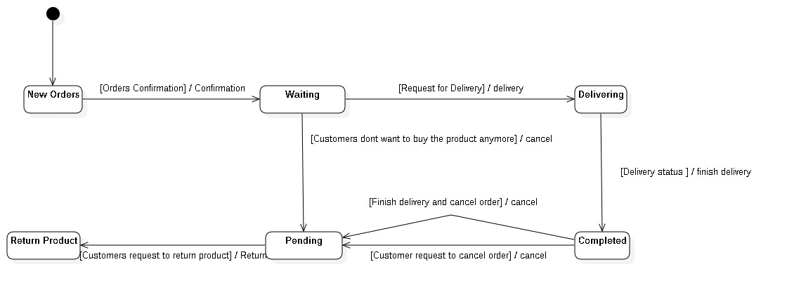

#### **3.5.1 Product state diagram**

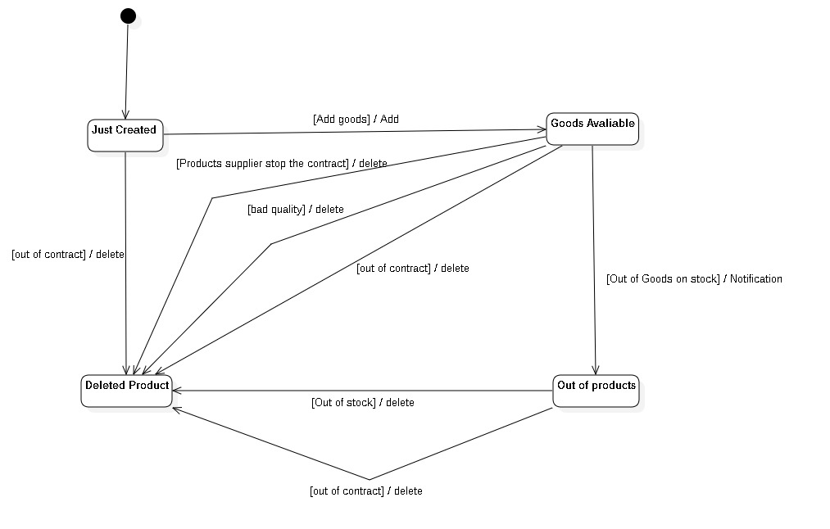

#### **3.5.3 User accounts state diagram**

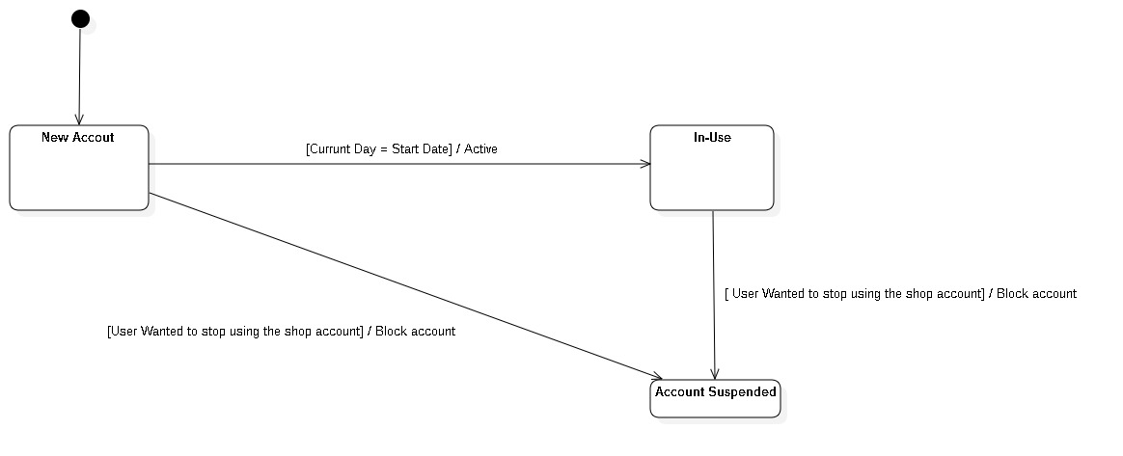

## **3.6 Mapping to Relational Model diagram from Entity class diagram**

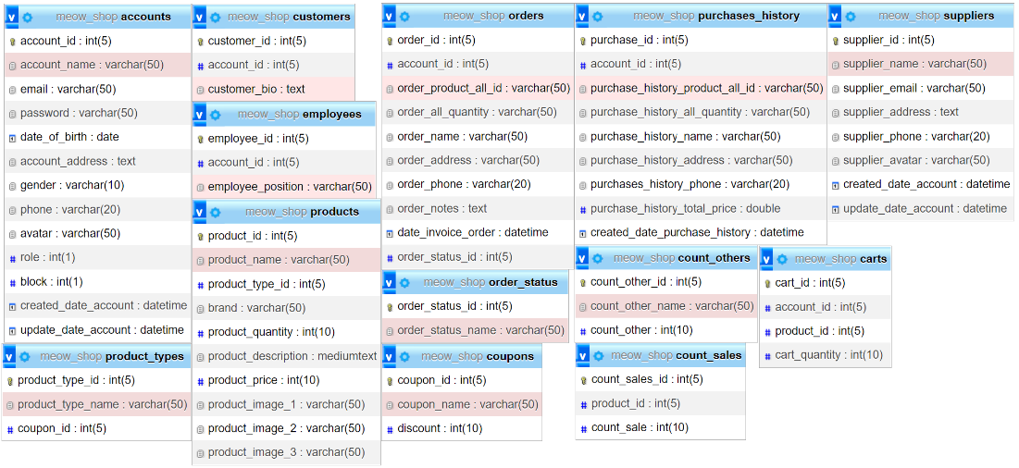

# **CHAPTER 4: IMPLEMENTATION AND TESTING**

## **4.1 Introduction to the implementation environment**

## **4.2 User Interface**

### **4.2.1 Customer interface**

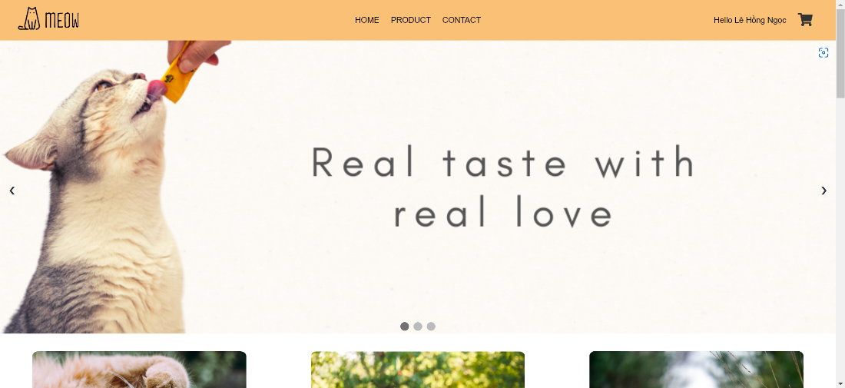

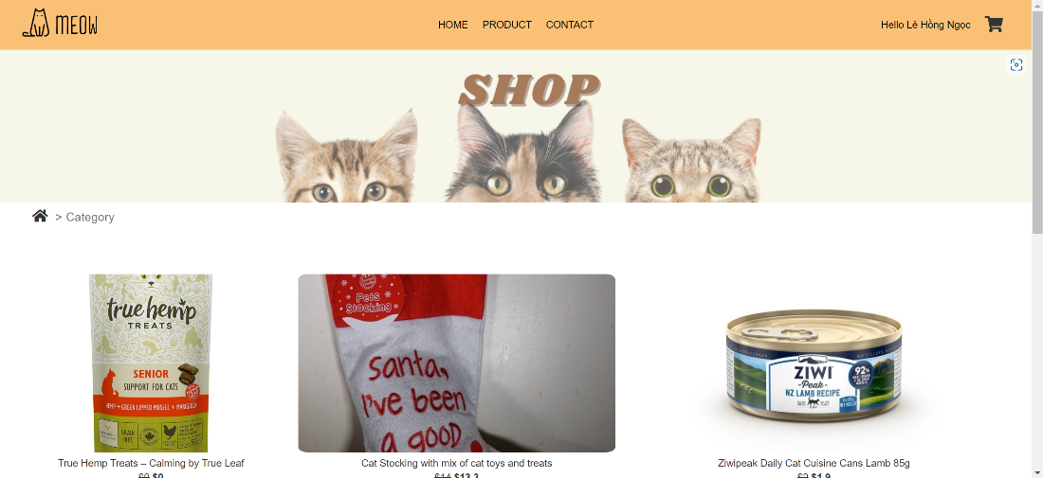

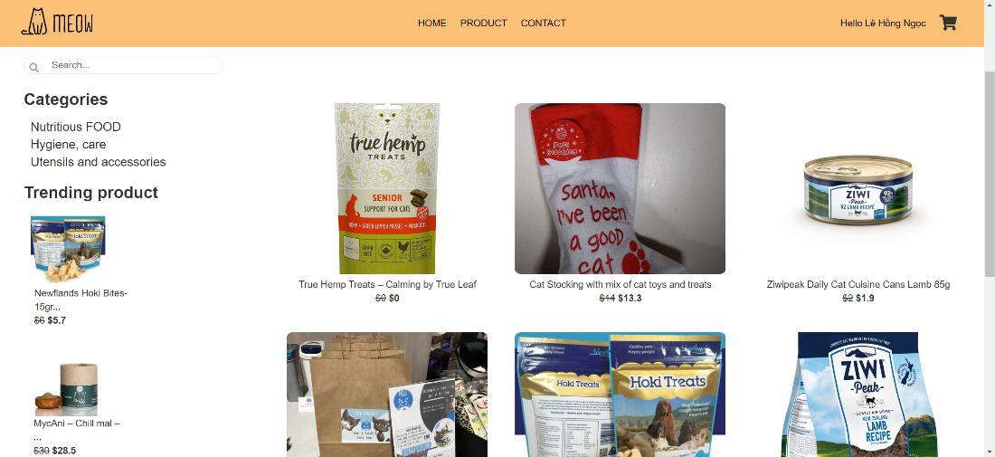

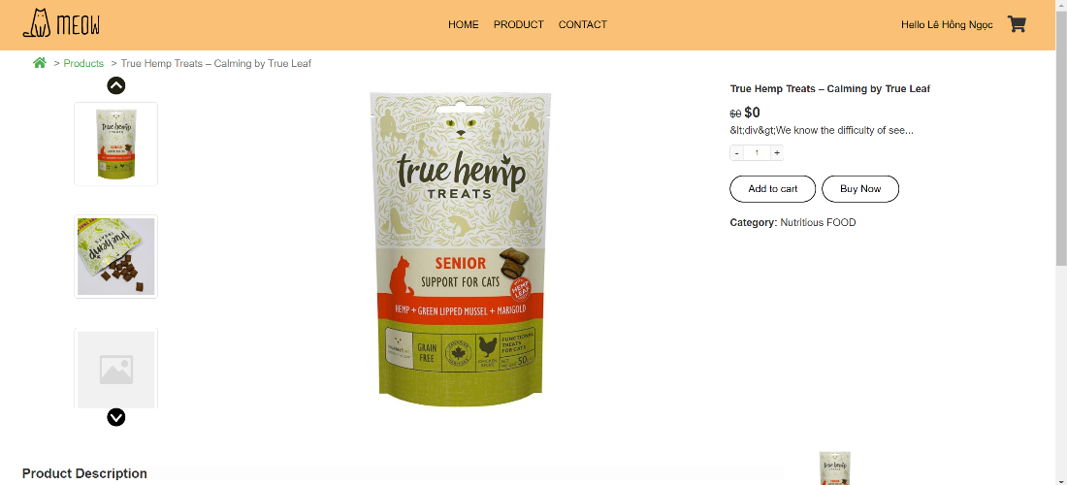

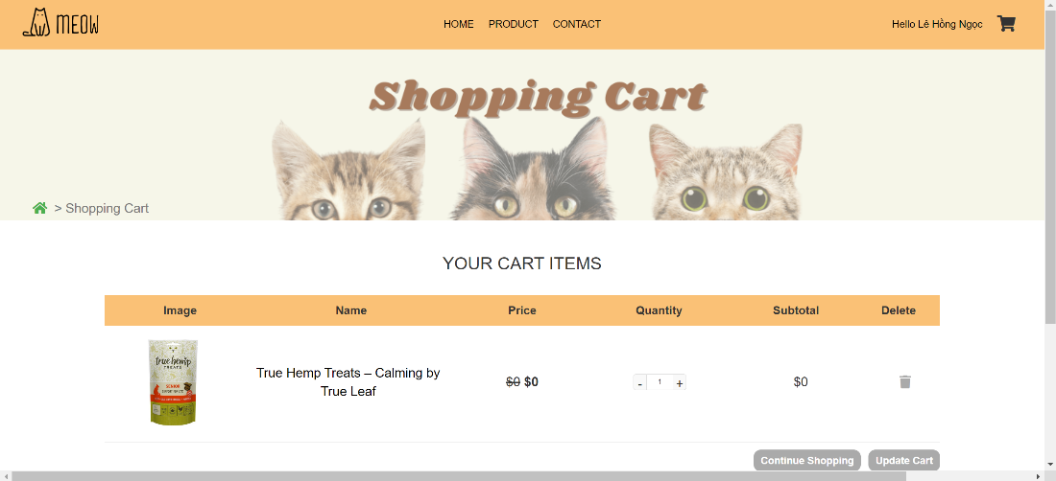

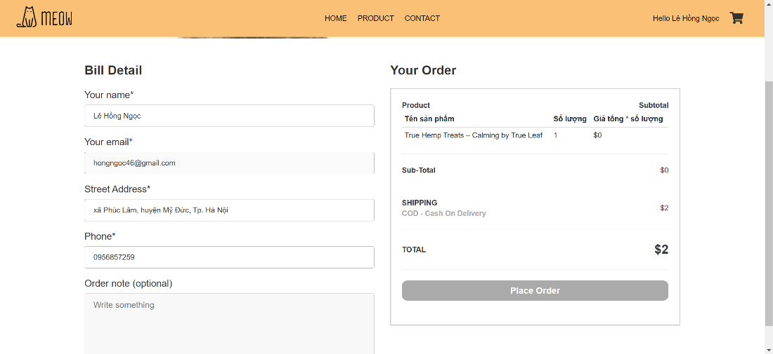

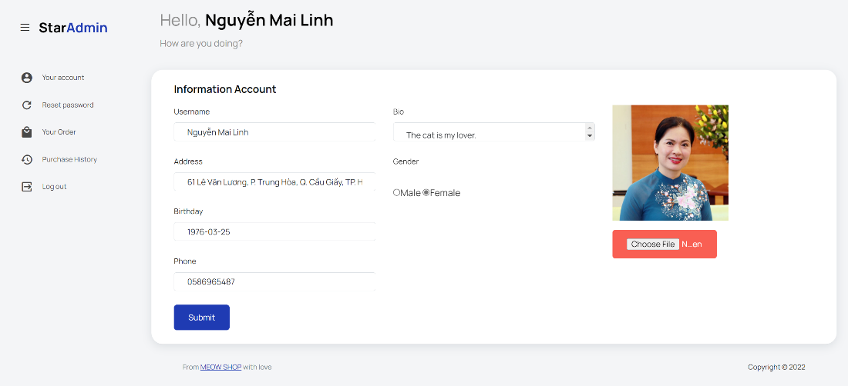

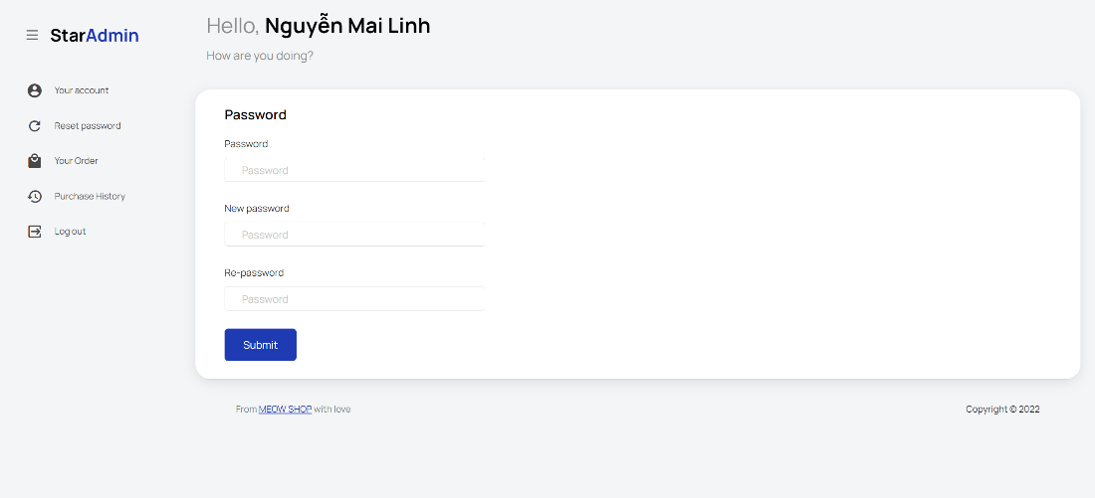

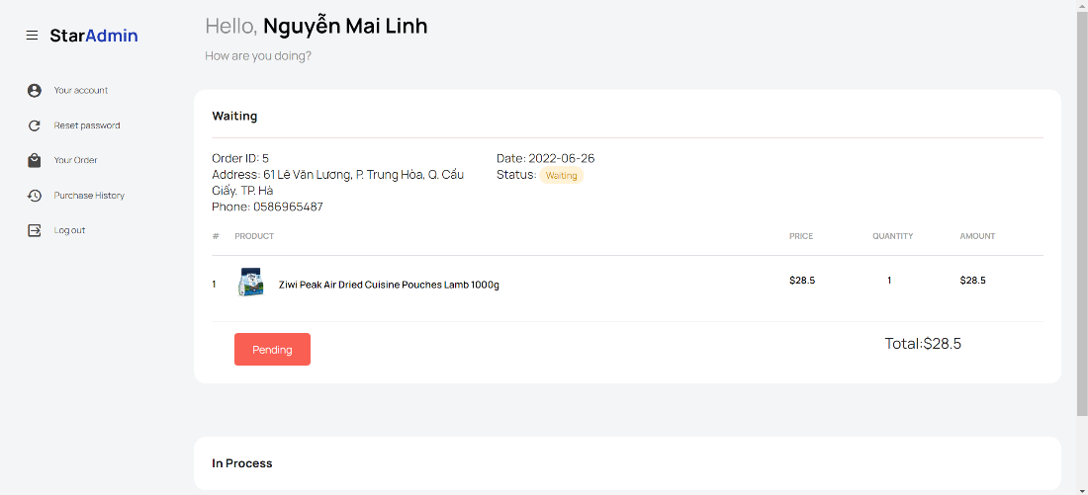

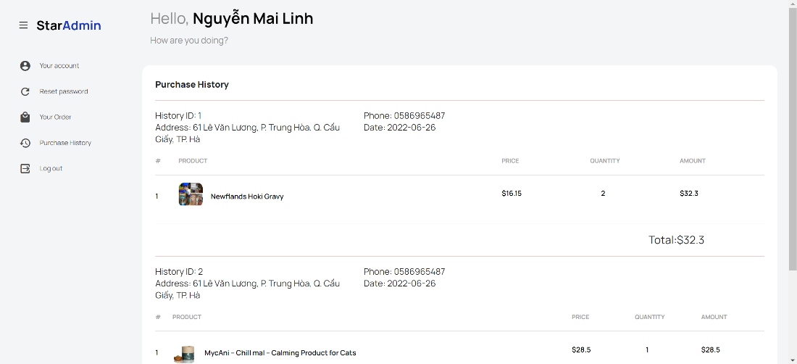

### **4.2.1 Admin interface**

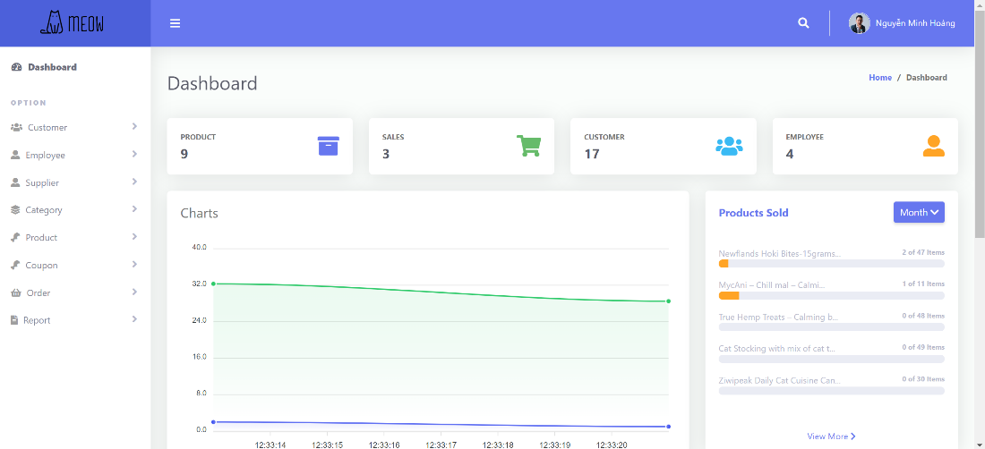

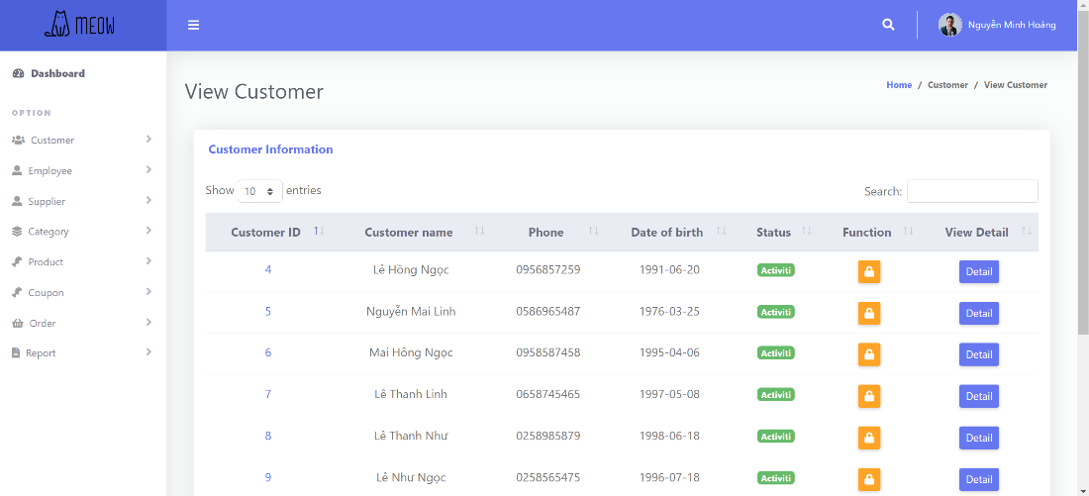

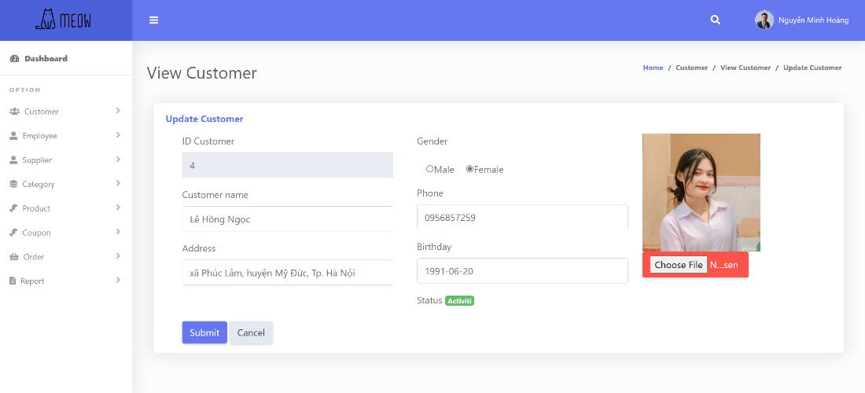

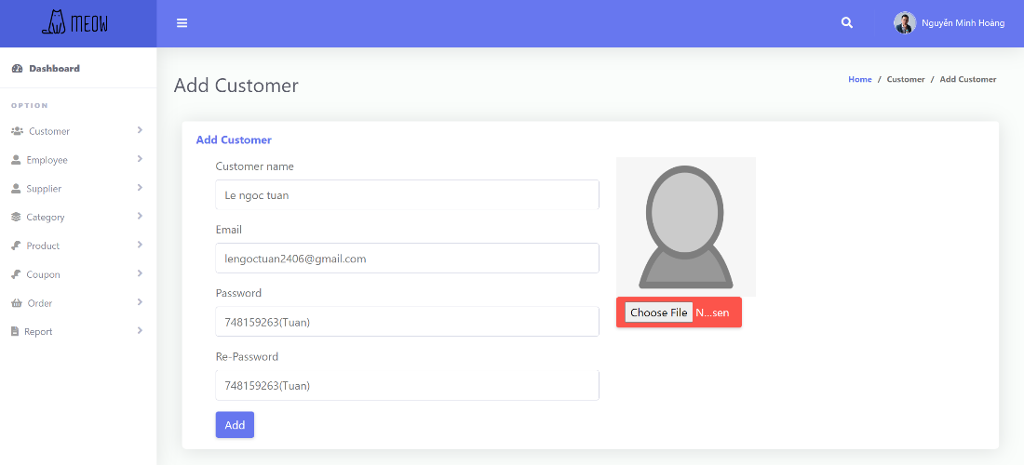

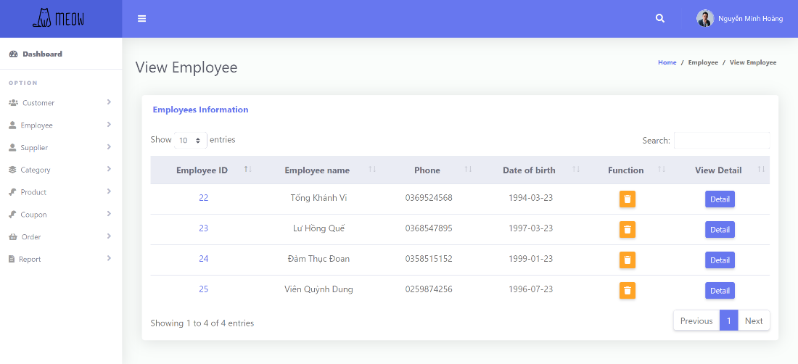

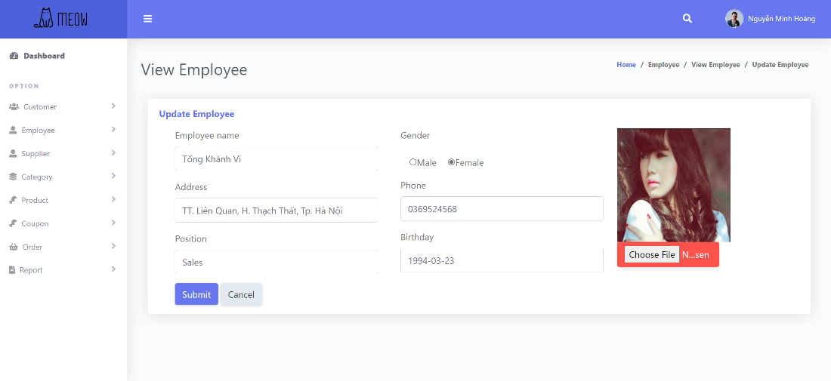

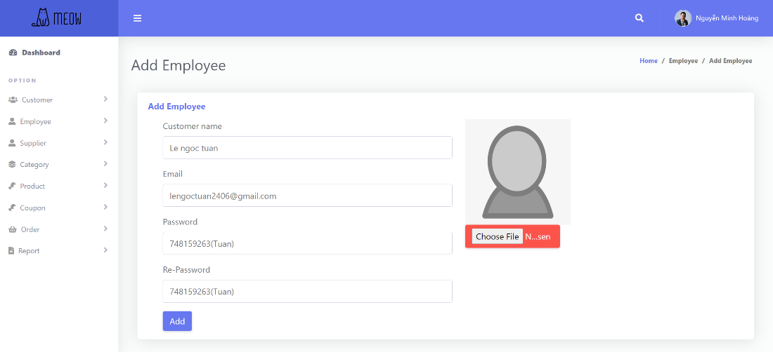

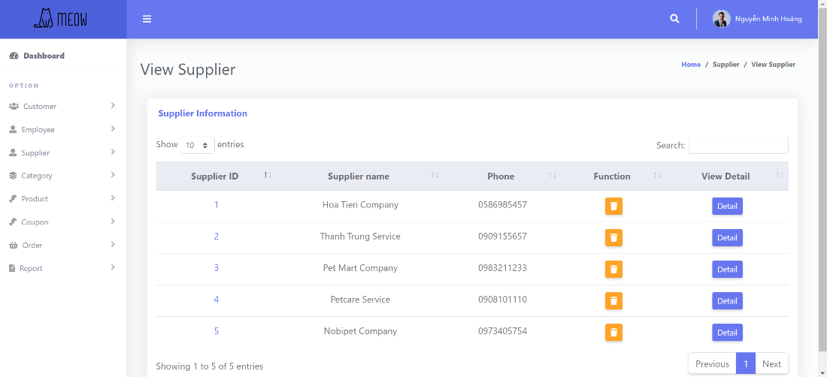

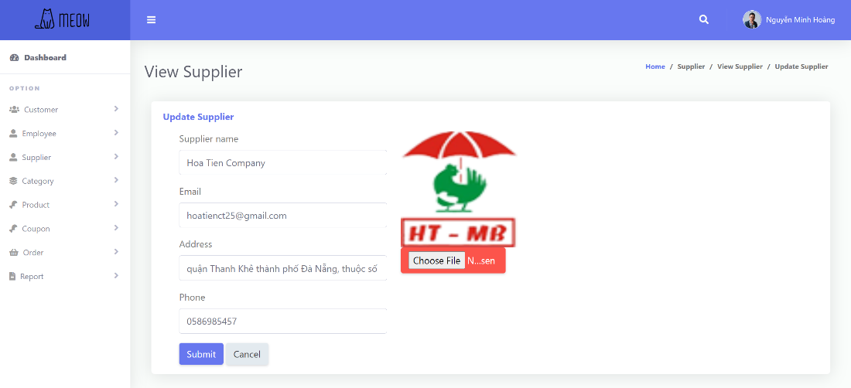

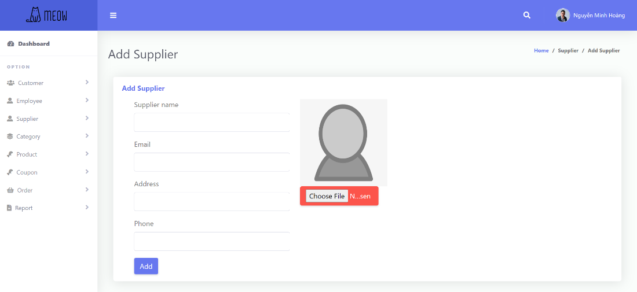

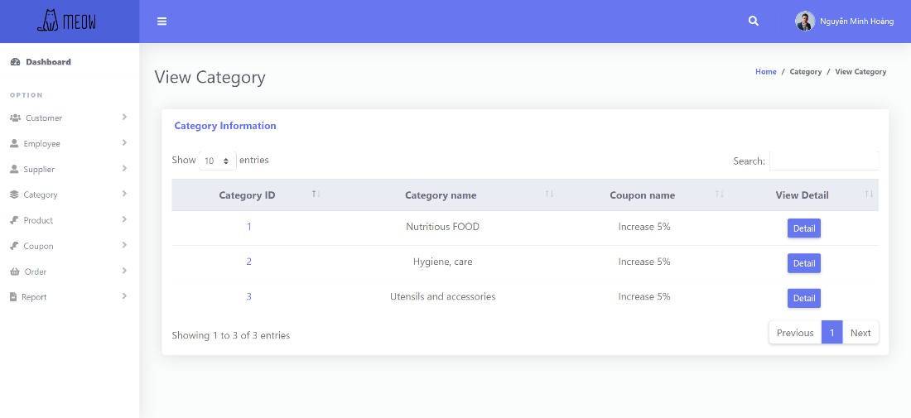

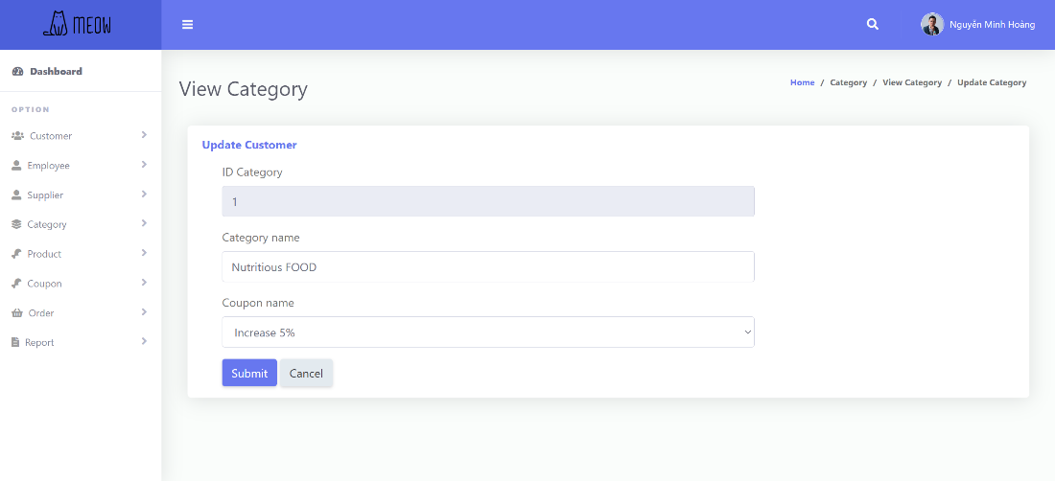

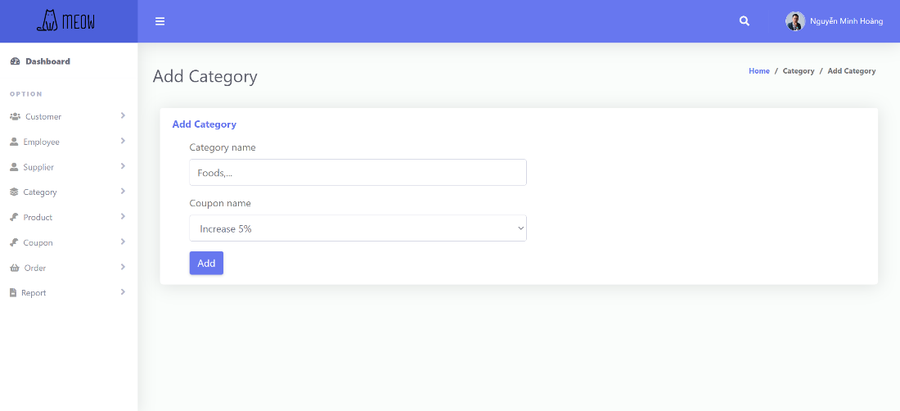

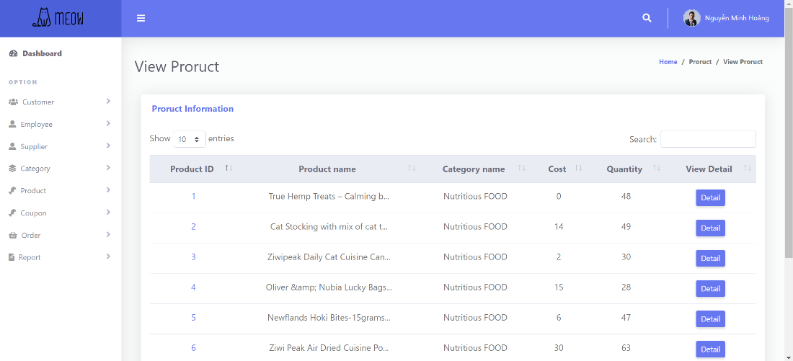

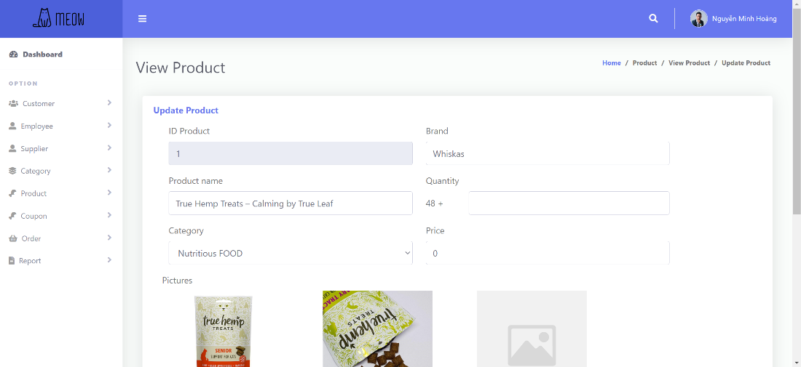

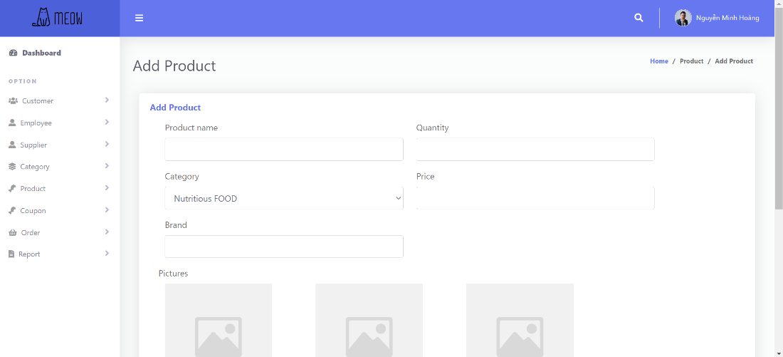

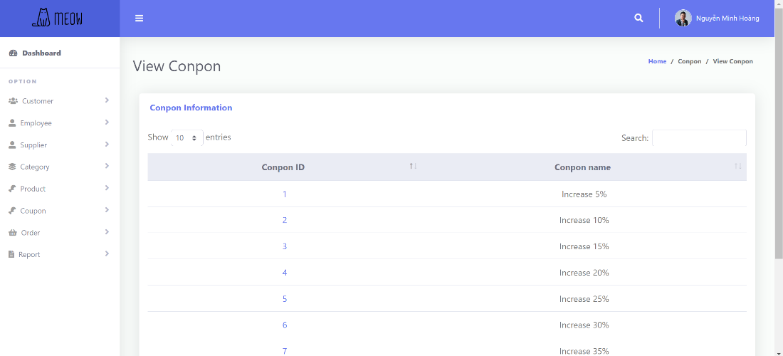

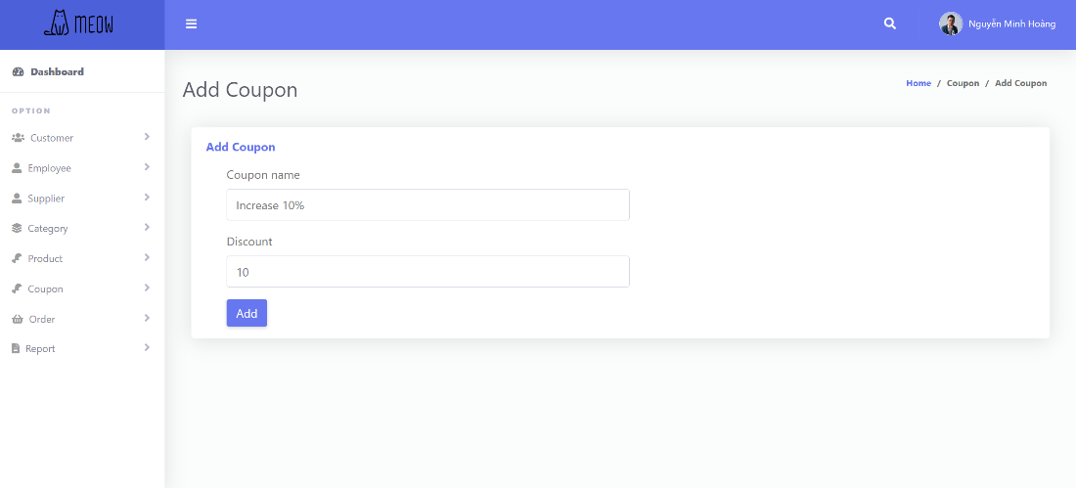

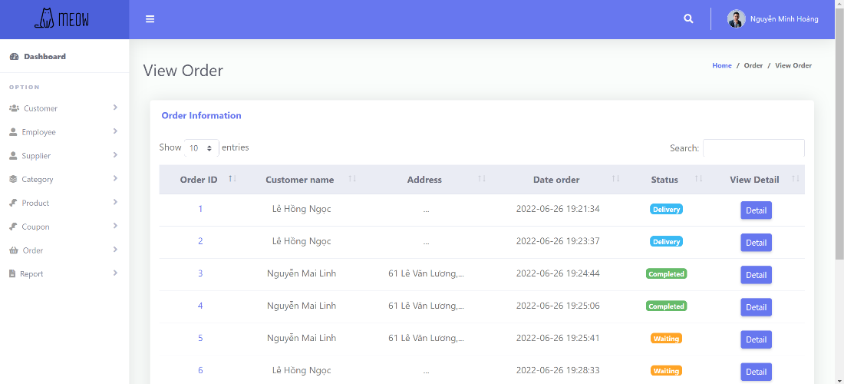

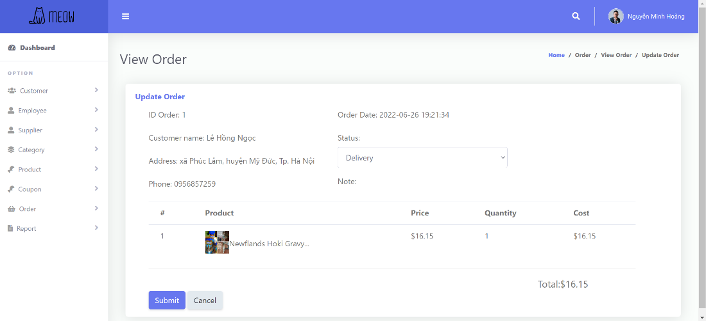

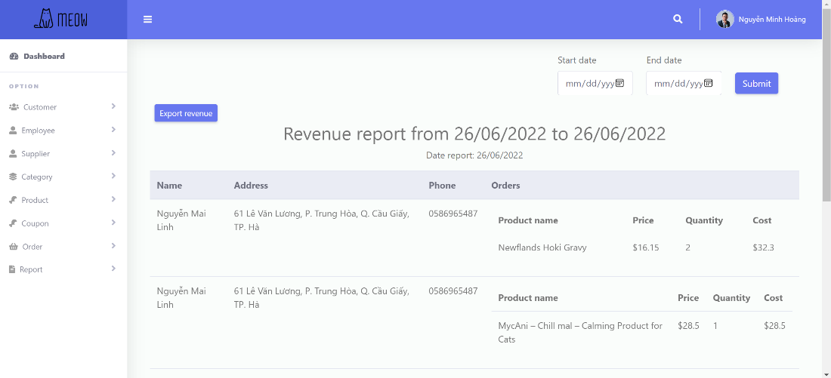

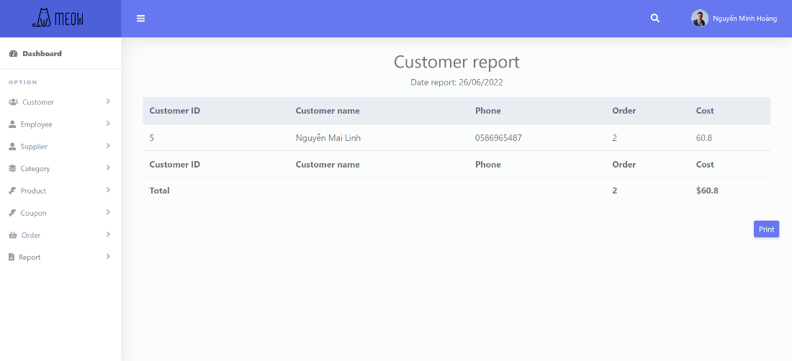

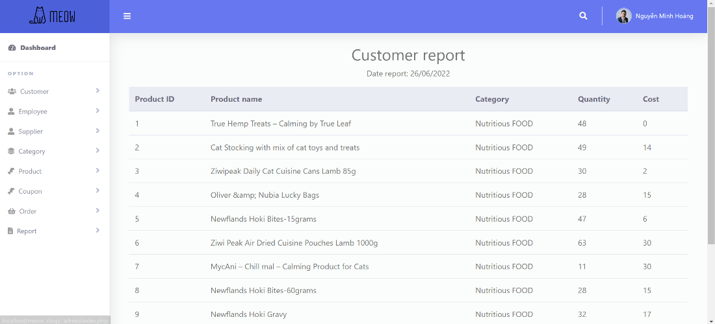

# **CHAPTER 5: CONCLUSION**

## **5.1 Project achievement**

Having pets nowadays is a common joy for families, despite of pet’s shape and kind, the owners always want the best for them just like how they treat the members of the family but some of them might not having a great time pool finding the best products for their pets. Acknowledge that problem our team had created a website which is a online store for our pet shop, which include the best products for pets on the market place. Our website which has lots of databases form the Admin to the Users as well as a easy interact interface, will assure to create the easiest approaching for our customer when they start their first account to their to their first payment on the website. Those tasks toke us a lot of time, but it is worth for us. Below this is our system primary functions:

* + Log-in /Log out management for both Users and Admin
  + Coupons management
  + Category management
  + Supplier management
  + Customer management
  + Order management
  + Product management
  + Employee management
  + Statistical and report
  + Personal account management
  + Cart management
  + Purchase history management
  + Product information

We used PhP, JavaScript, CSS,Html to build the systems

## **5.2 Limitations**

Due to the knowledge limitations, our website will not have such features :

There is no data recovery and backup function yet.

Can’t logged in with facebook, google.

Can’t send email.

## **5.3 Development direction**

In the future, our team will develop and complete the project, specifically as follows:

Build recovery and backup function

Allow Users to log-in with facebook, google

Will be able to send email

# **CHAPTER 6: SELF ASSESSMENT**

|  |  |  |
| --- | --- | --- |
| Name | Trần Nhật Khuê | |
| Role | Leader | |
| Contribution | Report | * Assign and check the work   **Chapter 2:**   * Interview * Servey of the organization/Current organizational situation   **Chapter 3:**   * Use case diagram * List of use – case * Employee management (activity, sequence, class diagram) * Statistical and report (activitym sequence, class diagram) * Purchase history management (activity, sequence, class diagram) * Product information (activity, sequence, class diagram) * Customer overview class diagram * Class diagram specification (Controller) |
|  | Demo Project | **Front end:**   * Product information page * Home page * Product detail page * Cart management page * Checkout page * Your order page * Account page * Dashbord – admin * Report page – admin * Customer management page - admin * Order management page - admin |
| Grade | 10/10 | |

|  |  |  |
| --- | --- | --- |
| Name | Nguyễn Thị Xuân Thủy | |
| Role | Member | |
| Contribution | Report | **Chapter 1:**   * Introduction * Problems of project * Developer tools & Technology   **Chapter 3:**   * Login – admin (activity, sequence, class diagram) * Logout – admin ( activiti, sequence, class diagram) * Category management (activity, sequence, class diagram) * Supplier management (activity, sequence, class diagram) * Login – user (activity, sequence, class diagram) * Logout – user (activity, sequence, class diagram) * Register (activity, sequence, class diagram) * Admin overview class diagram   **Chapter 5:**   * Project achievement |
|  | Demo Project | **Front end:**   * Login page * Register page * Reset password page * Purchase history page * Supplier management page * Product management page – amdin * Employee management page * Coupon management page * Category management page |
| Grade | 10/10 | |

|  |  |  |
| --- | --- | --- |
| Name | Lê Ngọc Tuấn | |
| Role | Member | |
| Contribution | Report | **Chapter 2:**   * Survey of business processes, major activities   **Chapter 3:**   * Order management – admn (activity, sequence, class diagram) * Coupons management (activity, sequence, class diagram * Order management – user (activity, sequence, class diagram) * Class diagram specification (Entity) * Mapping to Relational Model diagram from Entity class diagram   **Chapter 4:**   * User interface (customer and admin interface) |
|  | Demo Project | **Backend:** |
| Grade | 10/10 | |

|  |  |  |
| --- | --- | --- |
| Name | Lê Thanh Giang | |
| Role | Member | |
| Contribution | Report | **Chapter 1:**   * Objectives of project * Scope of project/Limitation of the study   **Chapter 2:**   * Software requirements   **Chapter 3:**   * Customer management (activity, sequence, class diagram) * Product management (activity, sequence, class diagram) * Personal account management (activity, sequence, class diagram) * Cart management (activity, sequence, class diagram) * Checkout (activity, sequence, class diagram) * Entity class diagram * State diagram   **Chapter 5:**   * Limitations * Development direction |
|  | Demo Project | **Backend:** |
| Grade | 10/10 | |